Warren County Career Center
Building Construction Program
House Building Project
Proposal
Objective: The objective of the Building Construction Program is to build a 1,400-1,600Sq.ft. Modular home that could be handicap accessible with 36” doors an accessible bathroom, and other such items.

Vision: To provide students with experiences to deal with Baby Boomers considering building new homes and remodeling existing homes.

The Plan:
Location: Lower parking lot behind the WCCC
Time Line: 2-3 years.
Competencies: The Building Construction, Others program is in Phase III of the State’s Program of Study and is currently working on the Competency list. Building a Modular Home will meet most of the competencies on the list with the exception of the masonry portion of the list.
Estimated Cost: $60,000-$75,000
The National Average cost of building a new house is $120.00 per square foot with crawl space and no garage. We are looking at approximately $40-$50 per square foot and the buyer will be responsible for the foundation.
Projected Sale: The projected sale of the home should be 15%-25% over the cost of building it, based on what other schools are able to sell their homes for.
Sales Agreement: Buyer Responsibility vs. WCCC Responsibility to be determined by:
OAC members, what other programs are doing and by Solicitor’s review.
Team:
Dr. Norbert Kennerknecht, Mrs. Amanda Hetrick, OAC members, Suppliers such as ACE, Carter, and Lowe’s, The Instructor and Instructors from other BCO programs.

Financial Support:
The requested range of the financial support for the initial project is $60,000-$70,000 over the 2-3 year duration of the project.
There is no anticipated budget request for a second home because the goal is to sell the first house for enough profit to offset the cost of rising prices. It may, however, be possible that financial support would be needed if the money, from the sale of the first house, did not come available in time for the start of the next house.
Standard Features

Interior:
- Drywall throughout
- Vaulted ceiling – throughout – spacious looking
- Smooth painted ceiling
- 7 ½” ceiling at sidewall
- 6-panel white interior doors
- entry foyer linoleum
- Upgrade trim package
- Ceiling paddle fan with light – Family Room and/or Living Room

Kitchen:
- Quality crafted oak cabinetry
- Flat panel cabinet doors with oak face frames
- Drawer over door cabinet construction
- 30” overhead cabinets with finished backs and 2 adjustable shelves
- Pot & pan roll out shelf in one base cabinet
- Under cabinet trim
- Refrigerator overhead cabinet
- Upgrade light over sink with separate switch
- Recessed and surface mounted lighting
- Fire extinguisher mounted under sink

Appliances:
- 22 CF 2-door frost free fridge with icemaker
- 30” deluxe electric cook top range
- built-in electric wall oven and microwave
- Potscrubber dishwasher
- 40 gallon electric water heater with drip pan
- auto ignition gas furnace with roof extension
- 32” LCD Flatscreen TV

Baths:
- 60” x 43” 1 seat shower – Bath #1
- 36” high cabinet – Bath #1
- Deluxe medicine cabinet – Bath #1
- 24” x 24” curbed skylight – Bath #2

Utilities:
- 200 amp electric service
- Rocker type light switches
- Furnace closet sprinkler
- Plumb and wire for washer and dryer
- In-house main water shut-off valve
- Water shut-off lavs, stools, sinks
- In-floor perimeter heating

Insulation:
- R-40 blown insulation in ceiling with sprayed vapor barrier
- R19 fiberglass in walls

Exterior:
- Two deluxe exterior lights at front entry
- Porch light at rear entry
- 15” vinyl raised panel shutters
- Vinyl low e thermopane windows with grids
- Residential 20’ double dormer with decorative louvered sunburst
- Box bay window
- Ridge vent
- Exterior frost proof faucet

Construction:
- 2x6 Sidewall studs 16” on center
- 2x10 floor joists 16” on center
- 5/12 roof trusses
- MH 15 roof underlayment

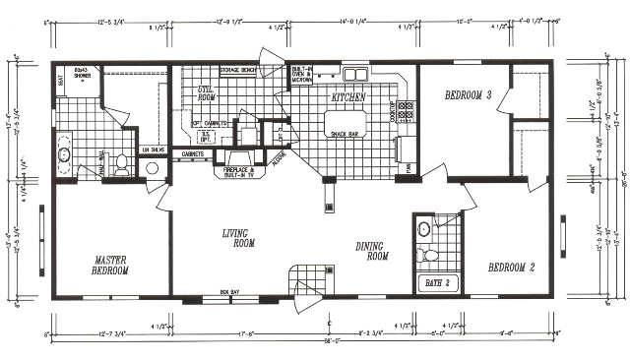

3 Bedrooms, 2 Bathrooms 26'8"x56' 1,493 Square Feet
