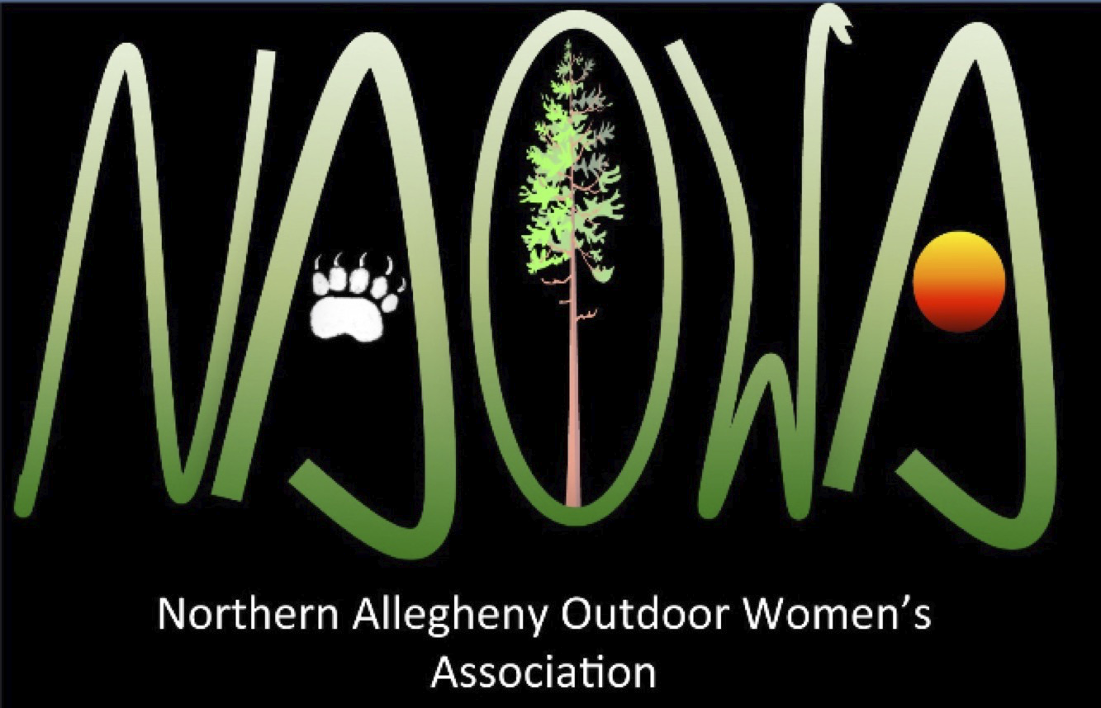

**The Northern Allegheny Outdoor Women’s Association (NAOWA) Funding Opportunity**

NAOWA announces its 2022-2023 Awards Program, which is designed to promote projects that

provide an understanding and appreciation of the outdoors. Activities may include, but are not limited to, funding for student activities pertaining to a specific outdoor/conservation project, recreation opportunities, educational supplies.

It is anticipated that up to four (4) projects will be funded; each project will be for no more than $250. Teachers/Club Advisors will need to have the project application approved by the Building Principal before it will be considered by the Awards Committee. A budget is required to be included with each application. Deadline for applications is December 2, 2022. Awards will be announced by December 21, 2022.

NAOWA 2022-2023 Awards Application

Name of Applicant or Club __________________________________________________________

Teacher/Advisor (if not listed above) __________________________________________________

School Building and Address _________________________________________________________

Teacher/Advisor Contact Information (phone and/or e-mail) _______________________________

Building Principal Name ____________________________________________________________

Description of Request for Funding (describe what the students will be doing, how they will benefit by the provision of the money, why it is important for the project to be funded):

How many students will be impacted by this award?

What is the timeline for this project? (Include beginning and ending dates)

What is the budget for this project? Include specific items and costs. This funding award may be used as part of a larger project and if so, please include the specifics of such project.

Statement of Accuracy

I hereby affirm that the above information is true and correct to the best of my knowledge. Upon notification by the Awards Committee of a successful application, I will work with the Committee to provide an invoice and/or receipts for the awarded amount.

(Applicant’s Signature) (Date)

(Building Principal’s Signature) (Date)

Applications are due no later December 2, 2022. Applications must be complete in order to be considered. They should be submitted to Mr. Matthew Jones, WCSD, Coordinator of Grant and Foundation Development. Questions regarding this application can be directed to the Northern Allegheny Outdoor Women’s Association at the e-mail listed below.

**Northern Allegheny Outdoor Women’s Association**

Administered by Warren County Development Association

*“Fostering an appreciation of the outdoors and our community through education,*

*recreation, conservation and wellness”*

Mailing Address: 8514 Route 27, Pittsfield, PA 16340

Find us on Facebook or [womensoutdoorworkshops@gmail.com](mailto:plester@atlanticbb.net)