**COURSE DESCRIPTION**

**Course Title:** Nutrition Virtual

**Course Number:** 10624

**Course Prerequisites:** None

**Course Description:** This course takes students through a comprehensive study of nutritional principles and guidelines. Students will learn about world-wide views of nutrition, nutrient requirements, physiological processes, food labeling, healthy weight management, diet related diseases, food handling, nutrition for different populations, and more. Students will gain important knowledge and skills to aid them in attaining and maintaining a healthy and nutritious lifestyle.

**Suggested Grade Level**: Grades 9-12

**Length of Course:** One Semester

**Units of Credit:** .5

**PDE Certification and Staffing Policies and Guidelines (CSPG) Required Teacher Certifications:**

CSPG 47

To find the CSPG information, go to [CSPG](https://www.education.pa.gov/Educators/Certification/Staffing%20Guidelines/Pages/default.aspx)

**Certification verified by the WCSD Human Resources Department:** Yes No

**WCSD STUDENT DATA SYSTEM INFORMATION**

**Course Level:** Academic

**Mark Types:** Check all that apply.

F – Final Average MP – Marking Period EXM – Final Exam

**GPA Type**:  GPAEL-GPA Elementary  GPAML-GPA for Middle Level  NHS-National Honor Society

UGPA-Non-Weighted Grade Point Average  GPA-Weighted Grade Point Average

**State Course Code**: 08099

To find the State Course Code, go to [State Course Code](https://nces.ed.gov/forum/sced.asp), download the Excel file for *SCED*, click on SCED 6.0 tab, and choose the correct code that corresponds with the course.

**TEXTBOOKS AND SUPPLEMENTAL MATERIALS**

**Board Approved Textbooks, Software, and Materials:**

**Title:** Nutrition

**Publisher:** **Accelerate Education**

**ISBN #:**  N/A

**Copyright Date:** N/A

**WCSD Board Approval Date:** N/A

**Supplemental Materials:** Word processing software and a pdf reader

**Curriculum Document**

**WCSD Board Approval:**

**Date Finalized:** 7/26/2023

**Date Approved:**  8/28/2023

**Implementation Year:** 2023-2024

**SPECIAL EDUCATION, 504, and GIFTED REQUIREMENTS**

The teacher shall make appropriate modifications to instruction and assessment based on a student’s Individual Education Plan (IEP), Chapter 15 Section 504 Plan (504), and/or Gifted Individual Education Plan (GIEP).

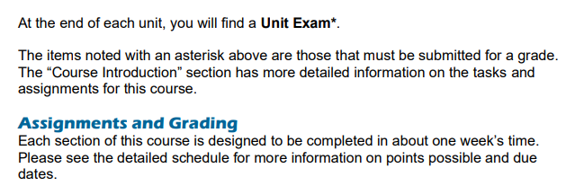

**ASSESSMENTS**

**PDE Academic Standards, Assessment Anchors, and Eligible Content:** The teacher must be knowledgeable of the PDE Academic Standards, Assessment Anchors, and Eligible Content and incorporate them regularly into planned instruction.

**Formative Assessments:** The teacher will utilize a variety of assessment methods to conduct in-process evaluations of student learning.

**Effective formative assessments for this course include:** quizzes and discussions

**Summative Assessments:** The teacher will utilize a variety of assessment methods to evaluate student learning at the end of an instructional task, lesson, and/or unit.

**Effective summative assessments for this course include:** projects, essays, tests, and exams