COURSE DESCRIPTION
Course Title: Health II Virtual
Course Number: 10627
Course Prerequisites: Health I

Course Description: Students learn about some of the more dramatic changes that the human body experiences from birth to death. They explore topics related to aging and sexuality and identify ways to remain healthy and safe throughout life’s major events and challenges. As in Health I, this course emphasizes what students can do to improve or maintain their own health and encourages them to be a positive influence on family and friends. Each lesson helps identify ways that students might use what they have learned in the lesson in their own lives.

Suggested Grade Level: Grades 9-12
Length of Course: One Semester
Units of Credit: .5
PDE Certification and Staffing Policies and Guidelines (CSPG) Required Teacher Certifications:
CSPG 47
To find the CSPG information, go to CSPG
Certification verified by the WCSD Human Resources Department: ☒Yes ☐No

WCSD STUDENT DATA SYSTEM INFORMATION
Course Level: Academic
Mark Types: Check all that apply.
☒F – Final Average ☒MP – Marking Period ☒EXM – Final Exam

GPA Type: ☐ GPAEL-GPA Elementary ☐ GPAML-GPA for Middle Level ☒ NHS-National Honor Society
☒ UGPA-Non-Weighted Grade Point Average ☒ GPA-Weighted Grade Point Average

State Course Code: 08051
To find the State Course Code, go to State Course Code, download the Excel file for SCED, click on SCED 6.0 tab, and choose the correct code that corresponds with the course.

TEXTBOOKS AND SUPPLEMENTAL MATERIALS
Board Approved Textbooks, Software, and Materials:
Title: Health II
Publisher: Accelerate Education
ISBN #: N/A
Copyright Date: N/A
WCSD Board Approval Date: N/A
Supplemental Materials: Word processing software

Curriculum Document
WCSD Board Approval:
Date Finalized: 7/26/2023
Date Approved: 8/28/2023
Implementation Year: 2023-2024

SPECIAL EDUCATION, 504, and GIFTED REQUIREMENTS
The teacher shall make appropriate modifications to instruction and assessment based on a student’s Individual Education Plan (IEP), Chapter 15 Section 504 Plan (504), and/or Gifted Individual Education Plan (GIEP).

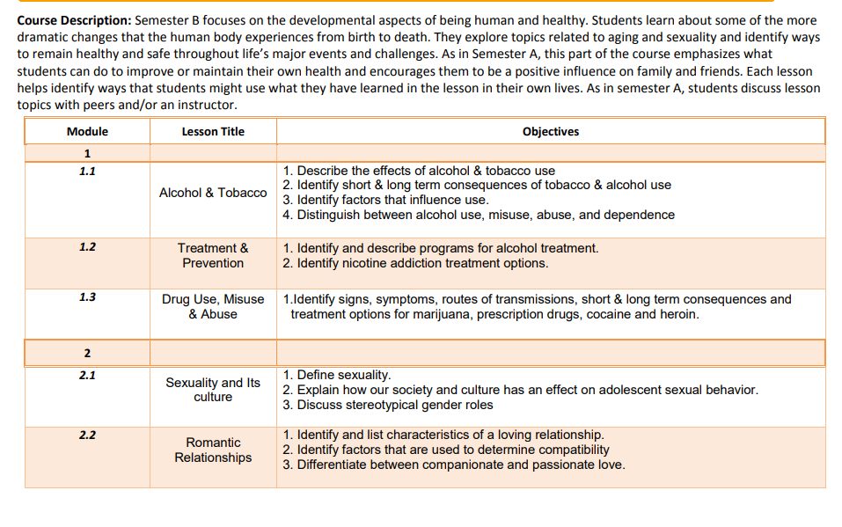
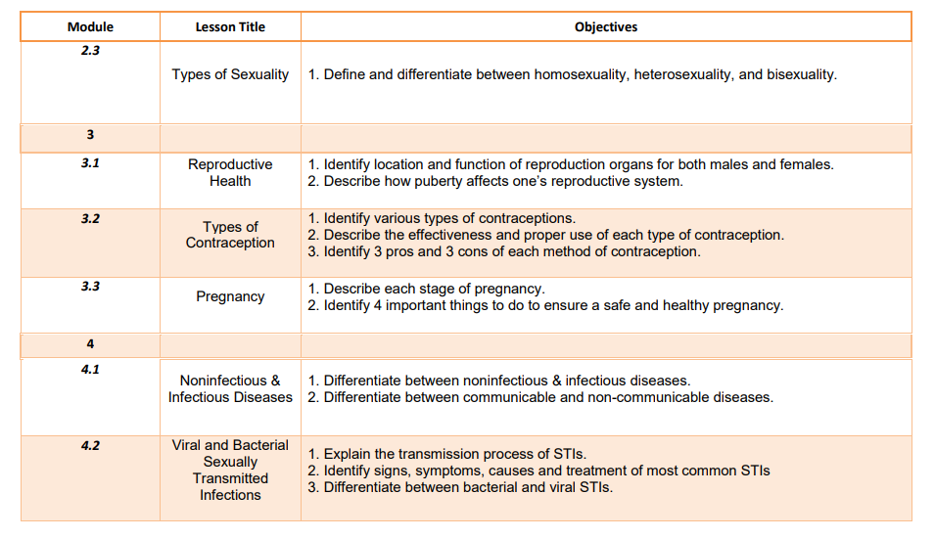
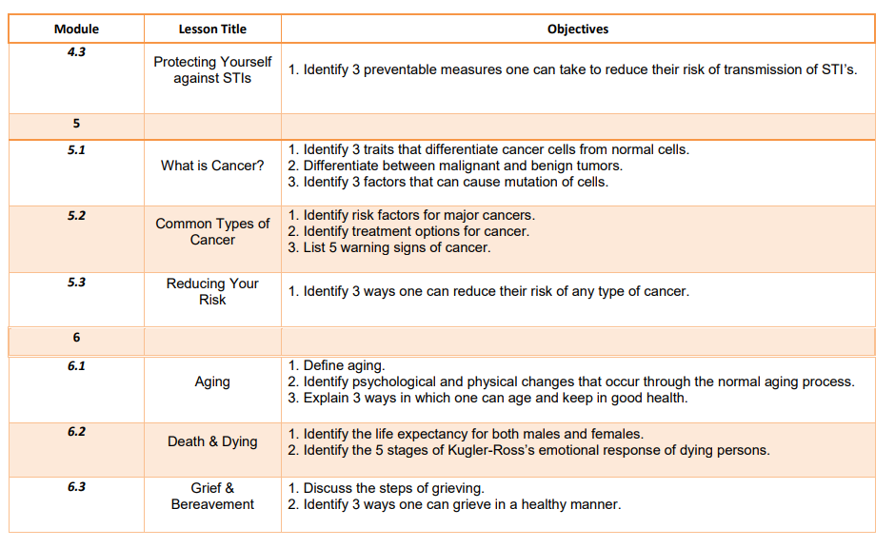
ASSESSMENTS
PDE Academic Standards, Assessment Anchors, and Eligible Content: The teacher must be knowledgeable of the PDE Academic Standards, Assessment Anchors, and Eligible Content and incorporate them regularly into planned instruction.

Formative Assessments: The teacher will utilize a variety of assessment methods to conduct in-process evaluations of student learning.
Effective formative assessments for this course include: quizzes and discussions

Summative Assessments: The teacher will utilize a variety of assessment methods to evaluate student learning at the end of an instructional task, lesson, and/or unit.
Effective summative assessments for this course include: projects, essays, tests, and exams

