**WCSD**

**Positive Happenings**

**Learning in Action**

**5/19/2025**

**Elementary**

**EES- Submitted by Mr. Reynolds**

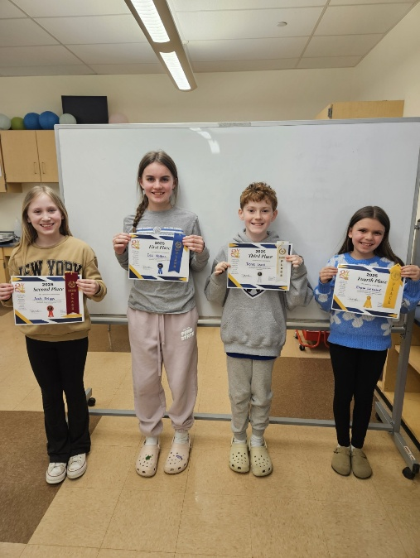Congratulations to our building level Challenge 24 winners who will be going to the District Challenge 24 Competition on May 7th!

1st Place: Ceci Wallace

2nd Place: Avah Briggs

3rd Place: Derek Leach

4th Place: Elyzza Linkerhof

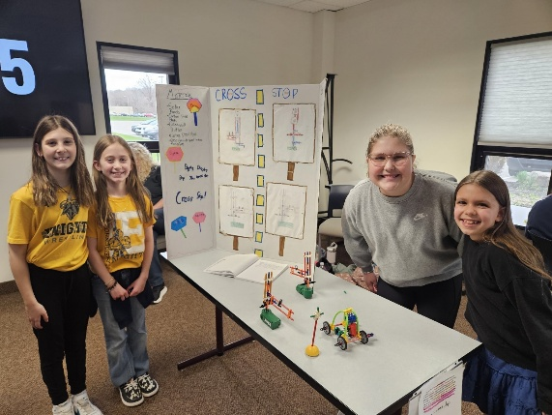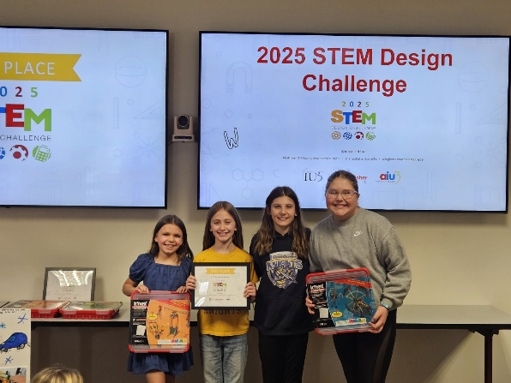

Congratulations to the following students for placing in the top 3 out of 19 teams at the K’Nex competition at the IU5 in Edinboro on April 1st. The team placed 3rd.

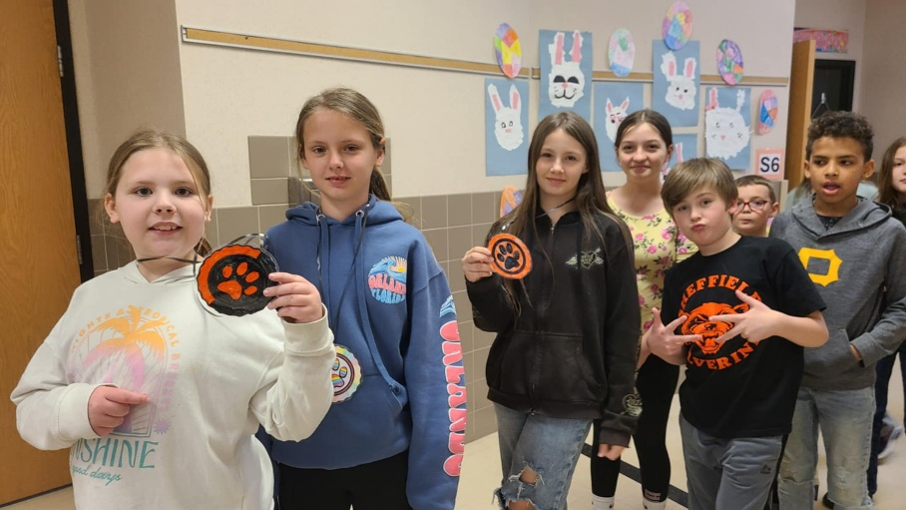Elyzza Linkerhof

Lydia Carlstrom

Kenzie Guiher

Autumn Waite

**SAES- Submitted by Mrs. Harris**

Mrs. Napolitan’s and Mrs. Stoddard’s second-grade classes have been busy writing and illustrating their very own book! These talented students are now officially published authors and illustrators. SAES couldn’t be prouder of their hard work and creativity!

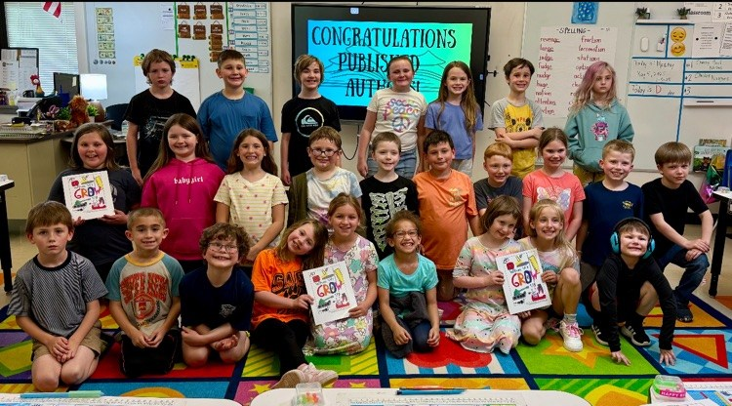

The month of April is dominated by PSSAs and related preparations. SAES is very proud of our grades 3 – 5 students’ participation in this mandatory testing as well as the kind, quiet, respectful, supportive behavior of our K-2 students during the testing days. On Wednesday, April 16th, the entire elementary school gathered in a special PBIS/PSSA Kickoff assembly to help them prepare for the state testing. This year’s PSSA Kick-Off theme was entitled, “Testing Like a Champion.” Students in grades 3-5 who were planning to complete the required PSSA testing battled it out in a competitive game of "Rock, Paper, Scissors Relay" while students in grades K-2 cheered from the sidelines. Following the game, students in grades 3-5 discussed test taking strategies with their teachers and school counselor while grades K-2 began to line the halls to celebrate all the test taking students with individually prepared medals, encouraging them to "Test like Champions!" The sharing of a piece of “good luck” from the younger to the older students has truly become a cherished tradition among the grade levels:

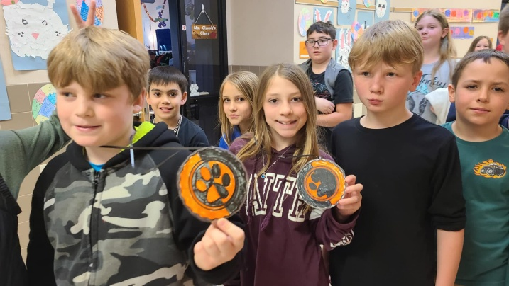

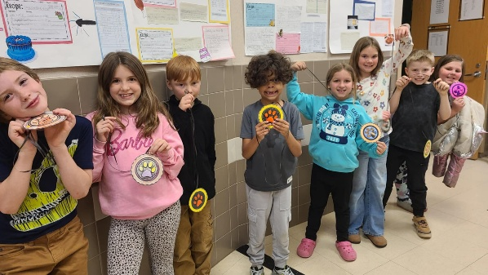

**WAEC- Submitted by Mr. Bedow**

Students in Mrs. Downey's 3rd and 4th grade English Language Arts Enrichment groups wrote essays for the annual American Legion Americanism Essay Contest for the city of Warren. The prompt that students wrote about this year was "What Does America the Beautiful mean to You in regard to our Military and Veterans?" The 150–250-word essays prompted the students to give their opinions and spark their connections to our country while also stating how they appreciate those who have served and protected our country.

There were six winners from WAEC in the 3rd and 4th grade Division I for Warren.

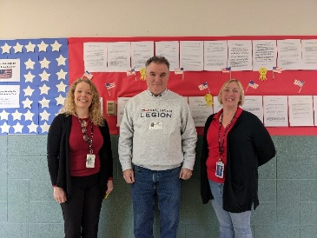Congratulations to the following winners:

Third grade winners:

1st Chloe Campbell, 2nd Ethan Bradley, 3rd Brooke Clark

Fourth grade winners:

1st Elliette Fralick, 2nd Isabella Bennett, 3rd Damian Bailey

We also want to recognize the other students who submitted essays. Great job, everyone!

3rd grade:

Oliver Mohr, Shane Lent, Jemma VanOrd, Adelaide Anthony, Olivia Bailey, Mack Letko, Symphony Weber, Taylor Hendrickson, Caleb Helman, Jayce Mainor, Kasen Winkels, Everlee Ackley, Carly Bigelow, Charlie Domer, Abigail Szymczyk, Sophia Zivkovich

4th grade:

Chloe Lucas, Joel Banuelos, Selena Blue, Grayson Zapel, Draedon Gnage, Bo Winkels, Emily Campbell, Aria Carlson, Brynen Hufnagel, Elizabeth Rockwell, Adrya Prettyman, Raegan Moore

Lydia Malczyk, Hanna Thompson

In addition, we want to thank the contest organizers and supporters (pictured left to right in the photo): Rebecca Downey, Gifted and Enrichment Instructor, Ben O'Neil, Adjutant Post #135, Pam Colvin, American Legion Treasurer and Essay Committee Volunteer

We are so proud of all the students for their hard work, creativity, and patriotism and for the American Legion who support our military and veterans in our community!

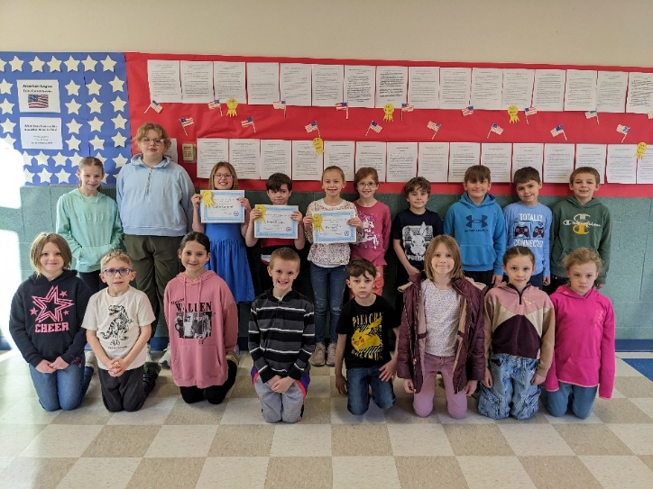

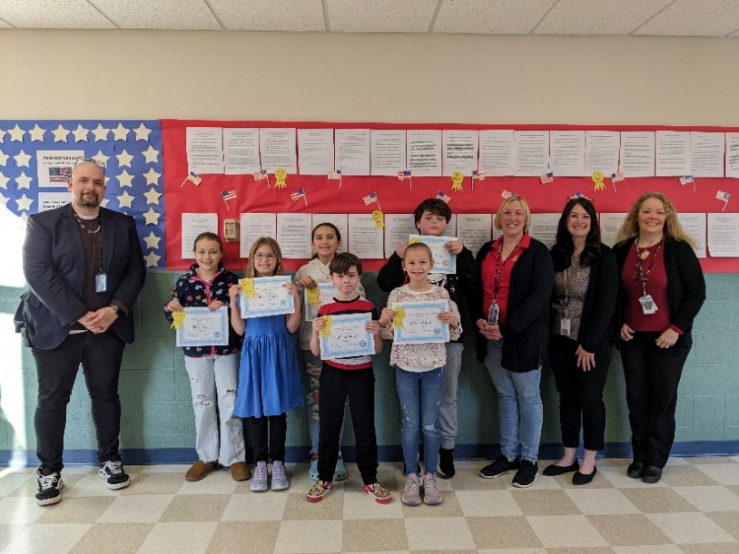

We also want to shout out Mr. Neal, our music teacher, for putting on an amazing performance for our 4th grade concert. About ¾ of our students participated, did an outstanding performance, and were so well behaved!

**YES- Submitted by Amy Stimmell**

Math 24competitions were recently held throughout the school district. Winners from each school then went to the district competition led by the Gifted Support Program at WAHS on Wednesday, May 7th. The school winners from YES in the 4th/5th grade band were Neola Harrington, Braelyn Kent, Sydnie Wyman, and Beck Hollis pictured below. School winners from YMHS in the 6th grade band were Ian Lewis, Hayley Northrop, Mason Gentz, and Rylynn Scott. The winners in the 7th/8th grade band were Jayden Harrington, Logan Lauger, Sophia Scott, and Ryder Chase.

Sydnie Wyman, Hayley Northrop, and Jayden Harrington will be representing Youngsville in the Regional competitions on May 19th and 20th at the IU5 in Edinboro!

**Middle/Secondary**

**EMHS- Submitted by Jason Markiewicz**

On May 9th, 2025, a group of students from Eisenhower Middle/High School paired up with a group of students from Eisenhower Elementary School to hold a Science Fair. Projects were dreamed up by 3rd-5th grade students from Eisenhower Elementary that completed a project proposal. Some students continued to work entirely at home, outside of school, others worked entirely in school with assigned high school partners and some in combination for several weeks starting at the beginning of April. Some projects were genuine scientific investigations and others were sharing what they had learned by reading and researching a topic they are interested in, ranging from mass extinctions to mass conservation. EMHS hopes to continue to make this an annual positive happening and thanks Mr. Chip Hayes, one of our own Science teachers, for enthusiastically seeing this idea through when presented with the opportunity.

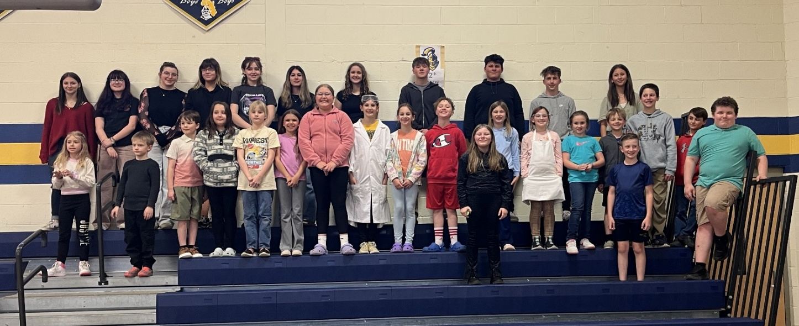

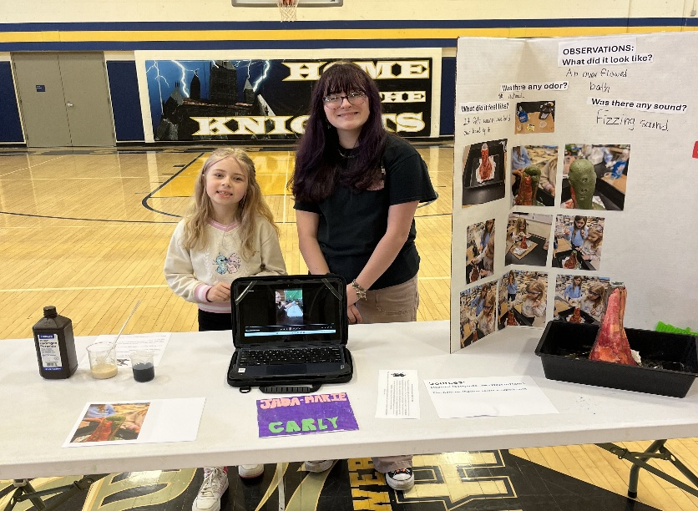

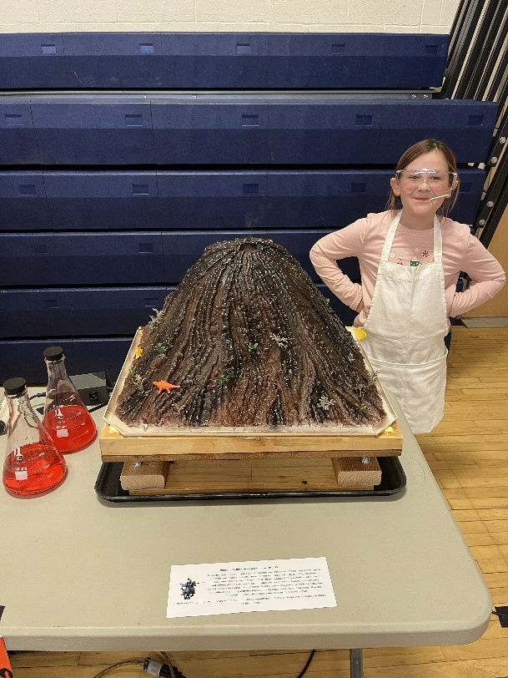

**SAMHS- Submitted by**

**SAMHS – submitted by Natalie Black**

On May 13, 2025, students from Sheffield Area Middle School attended the 30th annual Math Options Career Day at Penn State Behrend. This event is designed to inspire seventh- and eighth-grade students to explore careers in science, technology, engineering, and mathematics (STEM) through interactive, hands-on workshops led by professionals from academia, industry, and government agencies.

Throughout the day, students engaged in activities that demonstrated real-world applications of math and science. They built model roller coasters to learn about momentum and kinetic energy, wired circuits, and experimented with coding to move robots. These experiences highlighted the relevance of STEM concepts in everyday life and various professions.

The event also featured a STEM activity fair, where students explored exhibits such as 3D printing, chemical analysis, and mathematical art projects. These activities aimed to broaden students' understanding of the diverse opportunities available in STEM fields and encouraged them to consider pursuing advanced courses in math and science during their high school years.

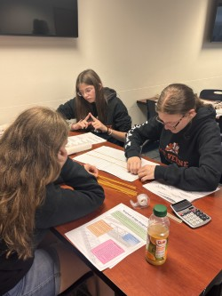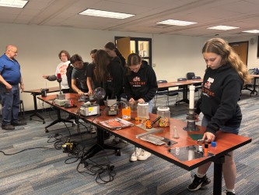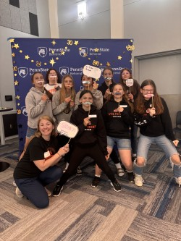

Sheffield Area Middle High School will celebrate its 2025 Prom on May 17th with a dinner, dance, and post-prom lock-in, all sponsored by the junior class. The evening will include the crowning of Prom King and Queen from the court:  
 **King Candidates** – Colby Barr, Jayden Garris, Andrew Hoden, Mark Lewis, Alex Marfink

**Queen Candidates** – Madison Connolly, Emily Davidson, Lily DiPenti, Madison Hackley, Sarah Hoffman

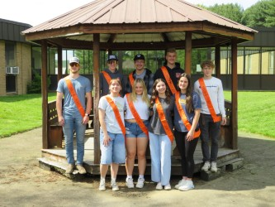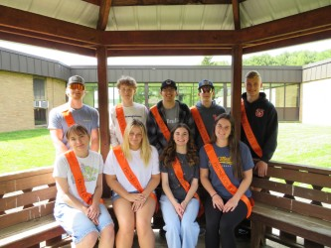

At the end of April, Sheffield Middle School students completed PSSA testing with 100% participation. Students showed great focus and determination throughout the assessments, and staff were proud of their positive attitude and strong effort during testing days.

**Virtual Academy Services and WCSD Virtual Academy:**

We are actively preparing for both summer programming and the upcoming 2025–2026 school year, ensuring we continue to deliver high-quality virtual learning opportunities.

* **Vendor Contracts Finalized for 2025–2026**: We have officially finalized contracts with our top-tier virtual curriculum vendors for next school year, including Accelerate Education and Edynamic Learning. These partnerships ensure that our students will continue to have access to rigorous, engaging, and standards-aligned coursework across all grade levels.
* **Summer School Preparations Underway**: Planning is well underway for our Summer School program, which offers both credit recovery and initial credit options to help students stay on track or get ahead. We are working to ensure all courses are loaded and ready to go so students can start their summer learning without delay.
* **Staff Preparing for 2025–2026**: Our staff is already preparing for the year ahead by reviewing and updating curriculum content to ensure it continues to meet student needs and district expectations. This proactive approach helps us maintain a strong instructional foundation and a seamless experience for both students and educators.

These efforts reflect our ongoing commitment to continuous improvement, high-quality instruction, and strong partnerships with our districts as we plan for another successful year in virtual education.

**WAHS- Submitted by Mr. Vincent**

Students from Warren and Sheffield went to a local riparian area in need of ecological restoration. We, combined with other schools on Wednesday the 30th, will be planting over 600 trees in a watershed that was converted into a pasture. The trees planted will assist in the local restoration of the Conewango Watershed. The groups organizing the efforts and grants are the Warren County Conservation District and DCNR.

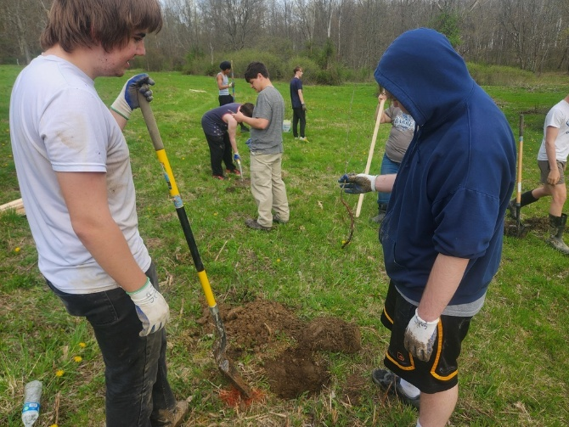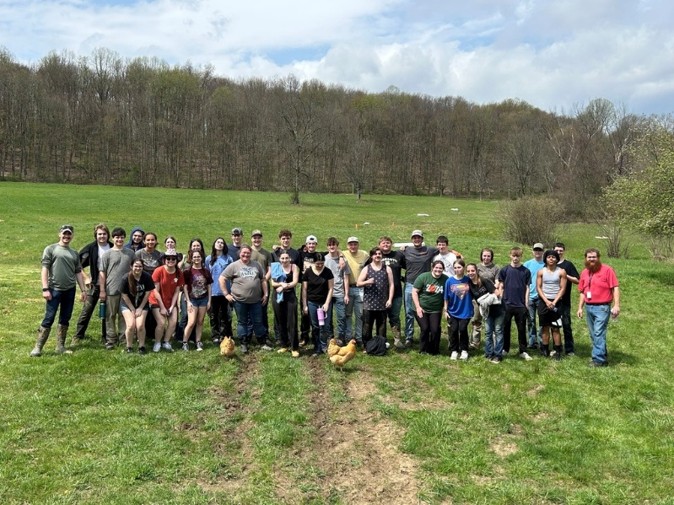

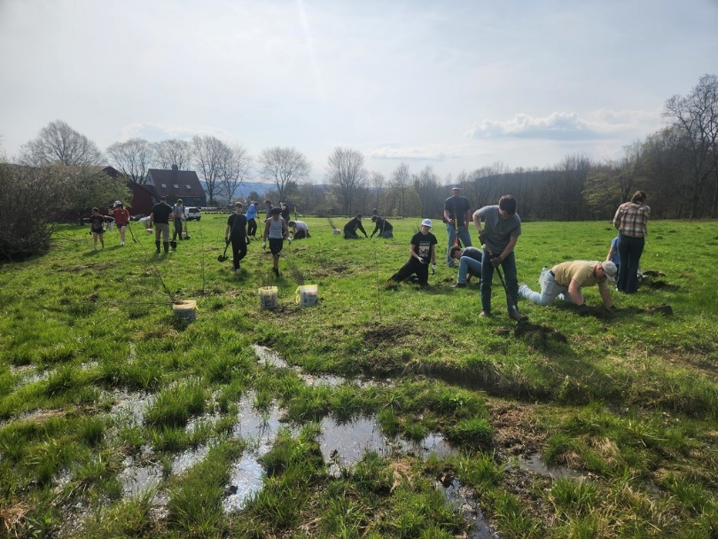

Students from WAHS recently visited the Warren City Fire Department to learn about community resources and the use of social skills in the public setting.

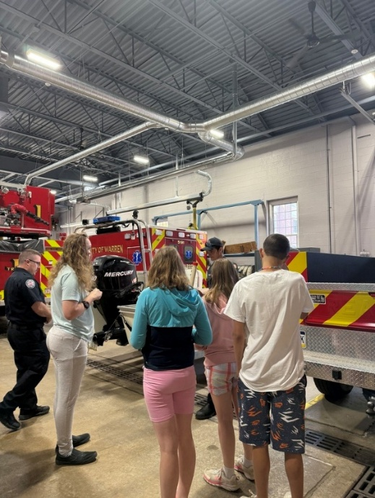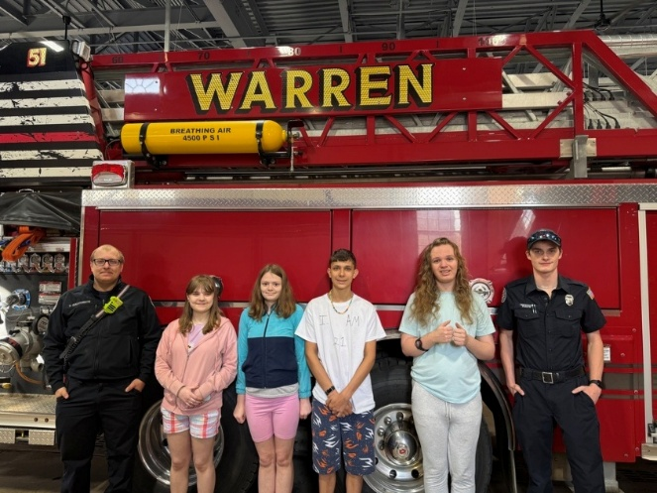

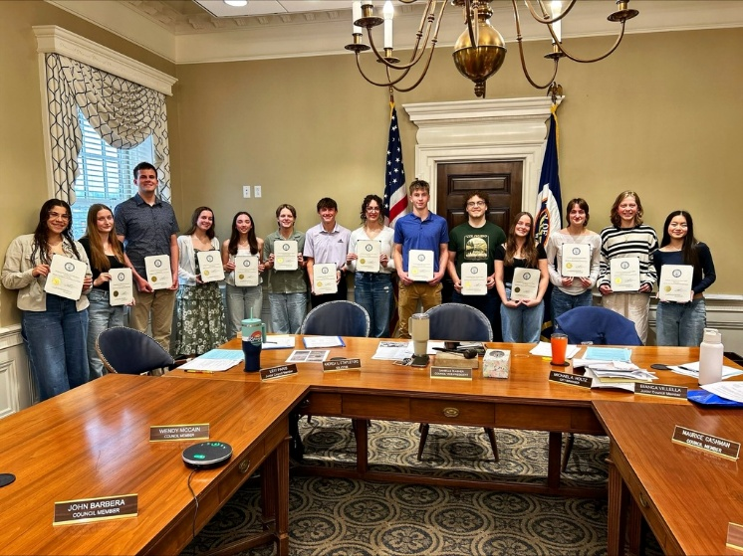Senior members of the WAHS National Honor Society were recently recognized at the City Council meeting for April.

**WCCC- Submitted by Mr. Evers**

Early Childhood Development: The ECD program has three (3) students taking a dual enrollment class through PennWest (Edinboro) beginning May 12. This is the first time this dual enrollment opportunity has been available to our ECD students.

Information Technology: Mr. Scott Burroughs reported that 11 students will earn dual enrollment credit through the PennNOW program at Penn State University. 9 students will earn credit for Game Design and 3 students will earn credit for Networking.

The WCCC 3rd annual Completion Ceremony is scheduled for May 15, 2025, at Warren Area High School. The event starts at 5:30 pm and all School Board Directors are invited to attend.

Mr. John Papalia has organized our 2nd annual “Industry Sign-on" Day. This event honors those students who have committed to full-time employment in the Warren County area. The event will begin at 8:30 am in the Large Group Instruction at the Career Center.

The WCCC has completed all the end of program assessments (NOCTI testing). Special thanks go out to all the volunteers who assisted with proctoring the exams for the various programs.

The WCCC will be celebrating the retirement of 2 long-time staff members who are retiring at the end of this year: Mr. Dan Passmore (Pre-Engineering) and Mrs. Jena Albaugh (former special education liaison). We also want to extend our best wishes to Mr. Michael Smith (Power Equipment). Mr. Smith has taken another position closer to his home.

**Gifted**:

The Gifted Support Program held the district-wide Math 24 Challenge at WAHS on Wednesday, April 7th at WAHS! Below are the tops winners for each age bracket. These winners will go on to the Math 24 Regional Competitions held on May 19-20. Congratulations to our top winners!

**4/5 Grade**

1st Place Triston Lord – Sheffield

2nd Place Carson Lord – Sheffield

3rd Place Daxter Irons – Beaty

4th Place Elyzza Linkerhof - Eisenhower

**6th Grad**

1st Place Kaylee Gray – Beaty

2nd Place Liliana Sandagata – Beaty

3rd Place Bristol Fuller – Beaty

4th Place – Hayley Northrop Youngsville

**7th/8th Grade**

1st Place Peyton Vincent – Beaty

2nd Place Ashton Carrington – Beaty

3rd Place Mathew Mobley – Eisenhower

4th Place RJ Frederick – Eisenhower