
January 9, 2009


Long Distance Proposal prepared for:
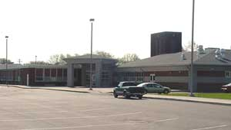

Warren County
School
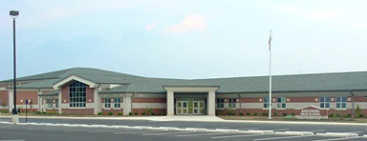
District

Respectfully submitted by:

Leyticia Corpuz
Inside Account Manager

Government and Education
Qwest Services Corporation
1600 7th Ave, Floor 13
Seattle, WA 98191
Office: 877-804-7127
FAX: 800-532-2395
Leyticia.Corpuz@qwest.com
Mr. Brian Collopy
Coordinator of Technology/Information Management
North Warren, PA

January 8, 2009

Subject: Proposal to migrate all of Warren School District’s Long Distance Services to the Qwest / MiCTA Contract pricing

Dear Mr. Collopy,

Qwest is pleased to respond to your request to compare the Qwest / MiCTA Long Distance Rates with those of your current provider AT&T and One Communications.

Methodology

Normally a direct comparison between inter-state long distance rates, intra-state long distance rates and additional fees and charges would be between the approved methods for comparing the two carriers. Since AT&T and Qwest both bill a flat rate for inter or intra state rates, it was decided to compare total long distance minutes.

The methodology settled on was total long distance minutes, not including 411 information calls.

Comparison

In the November 29, 2008 billings a total of 7394 minutes of long distance was used by Warren County School District; as per your email October and September also approximately the same usages. The corresponding Qwest rate is $.06 per minute. To restate that is .06 cents per minute verses the various price per minute from your current carriers.

Please see attachment one.

Comparison (continued)

AT&T bills for a full minute and then in 6 second increments thereafter. Qwest bills for the first 18 seconds and then in 6 second increments thereafter. This is very significant since many phone calls are less then a minute.
Conclusions

The current carriers AT&T and ONE Communications rates which varies per minute. MiCTA contract price with Qwest of $.0603 per minute. The cost saving by moving Warren County School Districts long distance to Qwest would be approximately $70 monthly savings and $5,300 per year; saving you $828 yearly.

The transition to Qwest long distance is very easy and will be seamless. Warren County School District will fill out a Letter of Authorization (LOA) with all the phone numbers that are being transferred to Qwest. Qwest then submits this and works out a cutover date with AT&T. Warren County can also custom tailor their long distance charges by department, by school or in almost any other grouping.

The Qwest Education Team looks forward to working with the Warren School District to reduce costs and increase service.

One Attachment

