AT&T Preliminary Quote for Service
Warren County School District

January 21, 2008
Meredith Coffey Doris Phillips
Government Sales Representative Government Account Executive
AT&T Mobility AT&T Mobility
610-906-4207 412-327-0621
Meredith.Coffey@att.com Doris.Z.Philllips@att.com


AT&T Offer Overview
AT&T is pleased to provide Warren County School District this quote for wireless telecommunications services and equipment.
With our experience providing wireless solutions to federal, state and local governments, and from our previous discussion, we understand that Warren County School District wishes to procure the leading value in a wireless provider, and provide to your workers:
- Wireless synchronization of email, calendar, and contacts using BlackBerry devices
- A wireless network that is robust, reliable, and provides the best coverage in the country
- Superior account management and customer support
AT&T has assembled an offer that leverages the advantages of our Pennsylvania WSCA Agreement. Through the WSCA program, we are able to provide you with aggressive government pricing via the Commonwealth contract. Benefits include 20% service discount, special voice pooling rates, employee sponsorship (15% service discount), enterprise-class fulfillment processes, and easy management of corporate liability wireless usage.
AT&T provides the following tangible benefits to Warren County School District:
1. Voice service airtime discount. 20% Discount
2. National Business Ordering: (800) 388-3235 for ordering equipment and wireless service
3. National consistent equipment pricing on GSM phones with $50.00 off BMG 2 year pricing and accessories are discounted at 20%.
4. Employee sponsorship (IRU): Employees receive a 15% service discount on their personal accounts. Warren County School District has no liability for the employee sponsorship lines.
5. Enhanced Premier Customer Portal: On-line access to manage wireless policy, order placement and tracking, bill management, and sponsorship hyperlink to the most current offers. Also offers the ability to view corporate phone policy for corporate users.
6. Customer care that fits your needs: National Business Account Support from NBS (800) # support 24/7, and Business Care Manager (BCM).
7. Purchase Blocker: Option to block users’ ability to download ringtones, games, and other features that add unnecessary charges on your bill.

Equipment

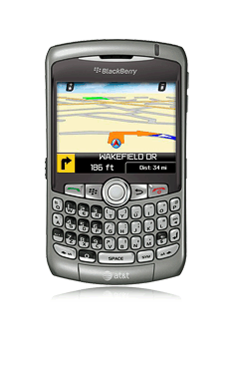  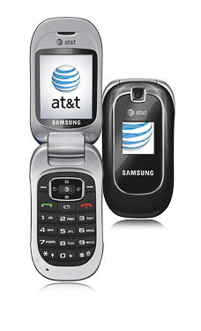 | BlackBerry Curve 8310  Overview  The next-generation Curve has arrived, now with built-in support for Telenav® Maps and Telenav® GPS navigator! The BlackBerry Curve 8310 is the smallest, lightest BlackBerry ever with a QWERTY keyboard. It features clean lines, curved edges, and easy-to-use trackball navigation. The sleek design balances both personal and work needs with the perfect blend of performance and usability. The Curve is the first BlackBerry to support AT&T Mobile Music, an enhanced media player, and stereo Bluetooth® headset capabilities. Snap crisp photos on the 2 MP camera with 5x zoom and flash. Need more storage? It has a microSD(TM) expandable memory slot to store music, videos and more. The Curve comes with BlackBerry's first email spellchecker, TeleNav Maps, and the AT&T Mall to shop for ringtones and downloads. Go global, the Curve has everything you ever needed or wanted in a BlackBerry.  Samsung a237  Overview  Talk easily and conveniently with the Samsung a237 camera phone. It has messaging and entertainment capabilities plus a camera - all in one compact flip that's attractively priced. The a237 offers Bluetooth® wireless capabilities, mobile email, MEdia(TM) Net browsing, plus both text and instant messaging. Now in three colors. Choose black, blue or red. | New Activation Price:  $49.99
New Activation Price:

FREE

Device Quote

Description | Price | Total
BlackBerry Curve x 5 | $49.99 | $249.95
Samsung a237 x 60 | FREE | $0
Total |  | $249.95

Monthly Service Quote

Description | Minutes | Monthly Price | Total
- 200 Pooled Minutes/User (65 users)  - Unlimited Night & Weekend  - Unlimited Mobile to Mobile | 13,000  (buffer of approx. 2,000 min/mth) | $34.00/user | $2,210.00
- BlackBerry Enterprise (5 users)  - Unlimited web and email | N/A | $45.00/user | $225.00
Pennsylvania WSCA Discount |  |  | -20%
Total Monthly Charges |  |  | $1,948.00

Top 10 reasons to choose AT&T

  - Cost Savings – 20% savings off monthly recurring charges with AT&T

  - Fastest 3G Network – The AT&T network uses HSPA/UMTS technology which makes it possible to get download speeds up to 1.7mbps and upload speeds up to 1.2mpbs

  - Single bill for services – no need to manage multiple bills

  - GPS – ability to pull GPS data directly from your device for turn-by-turn directions

  - Shared minutes – Users share minutes, eliminating costly overages and the need to manage individual plans

  - Simultaneous Voice & Data – talk, use the internet and check email at the same time when using 3G.

  - Superior customer service – Multiple redundant points of contact, Select Care customer service, Enterprise Technical Support

  - GSM Technology – Economies of scale with the global standard means more device choices, the ability to roam internationally, and lower cost for devices

  - Unlimited Mobile to Mobile and Unlimited Night and Weekend Minutes at no additional cost

  - Employee benefit – Your employees will receive a 15% discount on their personal accounts

