Warren County
School District

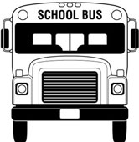

Transportation Contractor’s Handbook

Revised June 2010

Table of Contents

Transportation Staff and Phone Numbers 4
District Facilities and Contacts 5
Introduction 6
Frequently Asked Questions 7-8
Warren County District School Board Responsibilities 9
Building Principal Responsibilities 9
Transportation Office Responsibilities 10-11
Contractor Responsibilities 12-14
Driver Responsibilities 15-18
Driver Position, Description & Functions 19-20
Extra-curricular /Field Trips 21
Accidents 22
Severe Weather Procedure 23
Bus Evacuation Drills 24
Disturbance on the Bus 25
Students with Special Needs 26

Appendix
A Bus Regulations
B Seating Chart
C Bus Behavior Referral
D Sport/Activity Trip Work Sheet
E Bus Transportation Request for Payment
F Van Transportation Request for Payment
G Preliminary Accident Report
H Daily Inspection Chart
I School Bus Evacuation Report
J School Bus Evacuation Chart
K 2010-2011 School Calendar
L Pa Diesel-Powered Motor Vehicle Idling Act (Act 124 of 2008)
M On Board Inspection Form
N Driver Identification Form
O PA State Police Request for Criminal Record Check
P School Bus Driver’s Physical Examination Form
Q Transportation Work Sheet & Odometer Readings Form
R Transportation Work Sheet & Odometer Readings Cover Sheet Form
S Pupil Transportation Gasoline Accounting Report
T SBAP Student Special Transportation Tracking Log
U Late Afternoon Activity Bus Request for Payment form
V Pupil Transportation Requirements

Transportation Staff and Numbers

Transportation Office:
Fax: 814-723-8062
Manager Kimio Nelson Office: 814-723-6903 X2190
Cell: 814-730-4837
Home: 814-723-2358
Secretary: Sonja Couse 814-732-6903 X2189
Amy Henry 814-723-6903 X2201

Contractors:
Susan & Jack Barnes 723-4235
D&R Transport 436-7658
Decker Transport 757-8339
Johnson Transport 563-9738
Lewis Busing 968-3471
Small Tyme Busing 489-7768
Henry Rutsky 489-3193
Kevin Rutsky 489-3193
Shellhouse Transportation 489-3122
Specialty Transit 723-8800
Suppa Transportation 489-3231
Taraska Bus LLC 726-3833
Warren Bus Lines 723-8800
Pamela Wimer 723-6205
Jeffrey York 757-8744

Important Numbers:
Warren City Police 723-2700
Conewango Twp. Police 726-0725
Pa. State Police 728-3600
Pa. D.O.T. 723-3500
Warren DPW 723-6300
Warren Co. Sheriff Office 723-7553
Sheffield Police 968-5610
Youngsville Police 563-7555
Tidioute Police 484-7424
911 Non-emergency 563-3500

District Facilities
School Principal Tel Fax
Allegheny Valley Elem Steve Parinella 723-4119 726-7832
Beaty Rhonda Decker 723-5200 723-8861
Eisenhower Gary Weber 757-8878 757-8516
LEC Amy Stimmell 723-0574 723-0580
Russell Elem Deborah Doyle 757-4507 757-8776
Sheffield Amy Beers 968-3720 968-4233
Sheffield Elem Steve Parinella 968-3778 968-3027
South Street Early Learning Ann Buerkle 723-9340 723-9275
Sugar Grove Elem Marcia Madigan 489-7851 489-0205
Warren Area Elem Ruth Nelson 723-9061 726-1785
Warren Area High Jeff Flickner 723-3370 726-3126
Warren County Career Delores Berry 726-1260 726-9673
Youngsville Elem Eric Mineweaser 563-7207 563-9032
Youngsville High Darrell Jaskolka 563-7573 563-4459

Others Contact Tel
Barber Center, Erie Julie Karsznia 453-7661
BEI 723-8431
Bethel Baptist 716-484-7420
BOCES Ashville 716-763-1801
BOCES Chautauqua Barb 716-753-5843
Calvary Chapel Jeff York 757-8744
St. Joes Mary Ann Kirsh 723-2030
Tidioute Comm Charter Mr. Craig 484-3550
WCCS 563-4457

After School Programs Address Tel Contact
1st Presbyterian Market & 3rd, Warren 723-9200 Karen
1st United Methodist(LOGOS) 200 Market St., Warren 723-4930 Heidi Ketzko
Grace United Meth (GAP) Pa Ave & Prospect 723-9440 Ariel
Jefferson DeFrees 207 Second Ave. Warren 723-6350 Sue
North Warren Presbyterian 3 Church St. N. Warren 723-6441 Emily Jones
Salvation Army 311 Beech St. Warren 723-8950 Jamie Stright
YMCA Lexington Ave., Warren 726-0110 Kathy
Rouse Day Care 18 2nd St. Youngsville 563-2890 Wendy
Introduction

Public School Transportation is a cooperative program performed by the various agencies, which regulate the operation of school buses in the Commonwealth of Pennsylvania. The entire transportation program must be constantly reviewed by each of these agencies to determine what changes are needed to provide reasonable service, which will assure safe, efficient, and economical operation. Public school systems must recognize their responsibility, not only in providing satisfactory transportation services for children to and from their assigned schools, but also, by selecting well-qualified school bus drivers. The school bus driver has the responsibility of complying with the laws, regulations, and policies established by the following agencies of the Commonwealth of Pennsylvania.
- The State Board of Education prescribes and adopts standards and regulations, including minimum standards for school buses and qualifications for school bus drivers, to govern the transportation of public school pupils.
- The Department of Education administers the laws as adopted by the General Assembly of the Commonwealth of Pennsylvania; rules, regulations, and policies as adopted by the State Board of Education; and confer with public school officials in establishing transportation systems that will establish safe and efficient transportation service.
- The Local Board of School Directors adopts and enforces such reasonable rules and regulations as it deems necessary to establish safe and efficient service for public and non-public school pupils eligible for transportation.
- The Department of Revenue certifies school buses and operators and administers certain provisions of the Vehicle Code pertaining to the operation of school buses in the Commonwealth of Pennsylvania.
- The Pennsylvania State Police enforce traffic laws and regulations pertaining to school buses; inspect buses for compliance with minimum standards; administers examinations for school bus operators to establish their competency to operate school buses.
- The Public Utility Commission establishes rules and regulations for public transportation which operate under a franchise approval. The routes and schedules of such services are planned with public requirements as the basic consideration. Where such transportation service is provided, which at the same time meets public/non-public school needs, the board of school directors may arrange to utilize this service for transportation of pupils on a fare basis.

The District appreciates the service you provide and wants to ensure the smooth and efficient operation of the routes and transportation needs of the County School District.
With this in mind, this handbook is intended to provide you with information concerning the Warren County School District, its policies, the students it serves, legal considerations and what is expected from you as a contractor and driver of the district.
This handbook cannot cover all the conditions or circumstances you may encounter but is intended to give guidance with respect to normal circumstances you may encounter or can be expected in the transportation of our students. This handbook also sets forth guidelines for normal and emergency operations. Deviations from this hand book may occur during an unusual or emergency circumstance or situations.
Periodically, due to the changing needs of the School District, changes and amendments to policy will be issued. Contractors will be notified in a timely manner when possible of the change. Contractors are expected to implement any changes as soon as possible or when directed.
Again, thank you and I hope we can work together towards the safe transportation of our students. Please feel free to contact my office any time you have question or concern.

Kimio Nelson, Transportation Manager
Frequently asked questions

- Are school districts required to transport students?
A. No. Pennsylvania law does not require a school district to provide transportation for its students.

Q. When transportation is provided by a district, who is responsible?
A. The board of directors of a school district is responsible for all aspects of pupil transportation programs. The school board may ask their solicitor (an attorney) to interpret educational laws and regulations for them.

Q. How long may a child be required to ride on a bus?
A. This is a local decision (based on geography, population distribution, etc.). There are no time limits set by law or regulations.

Q. How far may a child be asked to walk to a school bus stop?
A. The law allows a district to ask a child, regardless of age, to walk up to a mile and a half to a bus stop. The mile and a half is measured by public roads and does not include any private lane or walkway of the child’s residence.

Q. May a fee be charged to pupils who ride a school vehicle?
A. No. Section 1361 of the School Code states that when transportation is provided, it is to be free and paid for out of district funds. Additionally, Section 1365 prohibits districts from demanding, requesting or accepting compensation for transporting students.

Q. I think the road my child has to walk along is hazardous. What can I do?
A. The law provides for the Pennsylvania Department of Transportation to review potentially hazardous walking routes. The request for this review must be made by the school district to the local PennDOT engineering district office. PennDOT regulations do not address hazards other than road or traffic conditions. The local district may assess conditions such as bad neighborhoods, secluded wooded areas, snow removal, etc., when developing transportation routes.

Q. I think the bus my child rides on is overloaded. What can I do?
A. Address your concern to the school district. All questions relating to school vehicle regulations, such as seating, aisle clearance, warning devices, etc., should be addressed to the Pupil Transportation Section of the Pennsylvania Department of Transportation at 717-787-9671.

Q. May a district suspend busing services for a child?
A. Yes. Transportation is a privilege, not a right.

Q. When does a school district have to provide transportation to a nonpublic school?
A. When a district provides transportation for its public pupils, it must provide transportation services to nonpublic pupils of the same grade level that it is providing for its own pupils. The nonpublic school must be nonprofit and located within ten miles of the district’s boundary, measured by the nearest public highway. If the school is not located within the ten-mile distance, the nonpublic pupil is not eligible for transportation, nor are his parents eligible for payment towards transportation costs.

Q. Is the local school district that transports my child to a nonpublic school required to transport her on days when the nonpublic school is in session and the public school is closed?
A. Yes, unless the closure is due to weather conditions.

Q. May a district ask a child going to a nonpublic elementary school to ride on a vehicle with public high school students?
A. Yes.

Q. If the teachers are on strike, must the district still provide transportation for eligible nonpublic pupils to their schools?
A. Yes.

Q. Must transportation be provided for exceptional children?
A. Transportation must be provided as required by a child’s individualized education program (IEP). An intermediate unit may provide this transportation for the district.

Q. When does a district have to provide transportation to a charter school?
A. The law requires school districts to provide transportation to resident students attending a charter school on the same terms and conditions as transportation is provided to students attending the schools of the district if:
The charter school is located within the district, or
The charter school is located not more than ten miles by the nearest public highway beyond the district boundary, or
The charter school is a regional charter school in which the district is participating.

Q. What can I do about transportation problems such as (1) the bus was late, (2) the bus never came, (3) the bus stop location seems dangerous, (4) the bus driver is speeding, and (5) another child hit my child on the bus?
A. You must work with your school district to address such problems.

Q. Does the state provide funds for pupil transportation?
A. Yes. On a statewide average, the pupil transportation subsidy covers approximately half of districts’ transportation costs.

Responsibilities of the District Board of School Directors
The board of directors of a school district is responsible for all aspects of pupil transportation programs, including the following:
- The selection of means of transportation in conformance with the law and regulations.
- The selection and approval of appropriate vehicles for use in district service and eligible operators who qualify under the law and regulations.
- The establishment of routes, schedules and loading zones which comply with laws and regulations, together with a provision of planned instruction for school bus drivers serving in the district.
- The adoption of policies and establishment of criteria and procedures governing:
  - The eligibility of resident pupils for free transportation services.
  - The discipline related to transportation for both public and nonpublic school pupils.
  - Field trips, including the number of chaperones and whether the chaperones may be accompanied on field trips by their minor children.
- The furnishing of rosters of pupils to be transported on each school bus run and trip.
- The maintenance of a record of pupils transported to and from school, including determination of pupils’ distances from home to pertinent school bus loading zones.
- The negotiation and execution of contracts or agreements with contractors, drivers of district’s vehicles and common carriers and submission of pertinent documents to the Department for approval of operation.
- Assuring that vehicles used in transporting pupils have adequate public liability insurance coverage

Building Principals Responsibilities

- Principals shall have available to the contractor bus rosters, seating charts and time schedules for any activity runs.
- Principals shall give the driver a bus roster for all activity buses before the bus departs.
- Principals shall be responsible for providing students with a clear understanding of the rules and regulations involved in riding buses and other school vehicles
- Principals are responsible for the discipline of students.
- The Principal shall place on file in Transportation copies of the Bus Behavior Referral (Appendix C) and the action taken for any infractions on the bus.
- Principals or their designee are authorized to ride any vehicle to evaluate the circumstances involved in a complaint or concern brought to their attention.
- Principals are responsible for contracting school buses for extra-curricular activities and authorizing payment from the contractor (Appendix D, E & F).
- Principals will maintain a contact person at their schools during normal busing times in the event of an emergency or event.

Responsibilities of the Transportation Office

Transportation Services
- Transportation, at District expense, will be provided to all students who live the following distances from their assigned school or stop. The distance from the school or stop does not include the length of the driveway but from the intersection of the driveway and main road. Elementary students who live one and a half miles or more and secondary students who live two miles or more from their assigned school or stop are provided transportation.
- School bus and vehicle routes and stops shall be developed by the Transportation Office with consultation with and the approval of the Superintendent of Schools and the Board of School Directors.
- The Transportation Office after consultation with the Superintendent of Schools shall have the authority to advertise and negotiate with contractors to provide transportation services.
- The Superintendent or the Transportation Manager shall be the only persons authorized to change transportation routes or stops.
- The school transportation system will be maintained by the District’s Transportation Office
  - The Office shall keep accurate, current records for all contractors, vehicles, drivers, route descriptions, stop locations, and bus rosters including student seat assignments.
  - Each contractor will be provided with complete route descriptions and students assigned to each bus prior to the start of the school year.
  - The Transportation Office shall insure that each driver has the proper clearances, training and documentation before allowed to drive students. Any discrepancies, such as an existing criminal record, shall be approved by the Superintendent.
- The District provides student transportation to and from schools via private contractors who enter into annual transportation contracts with the District.
- The relationship between private transportation contractors and the District, while engaged, is that of an independent contractor and not as an agent, officer or employee of the District.
- Transportation shall provide a copy of the School Bus Regulations (Appendix A) to the Contractors and Building Principals.
- Transportation shall maintain a contact person in the Office during normal busing hours in case of an emergency or event. Transportation Manager shall also maintain a cell phone and home phone for notification purposes (814-730-4837 cell/723-2358 home)

Assignment of Students
- Prior to the start of the school year, transportation schedules will be developed by the Transportation Office and approved by the School Board.
- Students to be transported will be assigned a vehicle, route, and stop designation where the student will be picked up for school or dropped off from school.
- All changes in student route, vehicle or stop must have prior approval of the Transportation Office.
- After the transportation schedules have been approved, minor changes may be made by the Building Principal after approval of the Transportation Office to ensure a safe and efficient transportation system.
- Changes may also be made by the Transportation Department to accommodate changes in the family’s status throughout the school year.

Permanent Open Runs
- The District reserves the right to announce the opening of a run(s).
- Any contractor meeting the criteria established by the District may submit a letter of interest and consideration.
- In the event more than one contractor submits a letter, the normal procedure of the lottery system will be used to choose a contractor to fill the run.

Establishment of bus routes and stops
- Bus routes and stops will be established in the best interest of the safety and welfare of the students, drivers and the general public.
- Bus stops are not permanent and may be changed following proper written notification to the parents.
- The number of bus stops will not normally exceed five per one mile section or be less than two tenths of a mile from one another. Consideration will be made for hazardous, medical, IEP, or other exceptional reason.
- Special requests by parents shall be considered only when the change is temporary in nature and when the change meets the special needs or circumstances of the child. Special requests shall be made to the Building Principal and will be approved providing there is space available on the vehicle.
- Career Center Runs: The District provides transportation for students attending the Warren County Career Center.
  - Students shall ride their normal bus/van to their schools.
  - A bus will then take them to the Career Center
  - Buses are not to make any unauthorized stops to and from the Career Center.
  - Drivers are to wait at the Career Center while the students are at the Center unless permission to leave is given by the Building Director or the Transportation Office.
- Contractors may not change buses, routes or stops without getting permission from the Transportation Office.
- If a route or stop changes is required for safety or other reasons, the contractor should submit this change to the Transportation Office. The change is not to be made without prior approval of the Transportation Office.
- The Transportation Office will issue bus routes, rosters and seating charts to each building principal in a timely manner after the start of the school year.

Contractor Responsibilities

- The contractor shall fulfill the duties imposed in the proceeding and succeeding sections of this handbook
- Contractors shall insure that Transportation has all current information on their drivers and vehicles (training, licenses, rosters, bus numbers, vehicles being used or substituted, routes, odometer sheets, etc). These will be submitted as requested by Transportation in a timely manner. Failure to comply may result in the suspension of the driver to transport students.
- The contractor is required to have current, accurate route descriptions including turns and times of pickups on the bus while in operation. They will issue a copy to each building Principal and the Transportation Office.
- Contractors shall submit a Monthly Mileage Sheet (Odometer Sheet) to the Transportation Office documenting current mileage and any mileage changes, students, stop locations and route taken.
- Contractors will develop a seating chart (Appendix B) for each vehicle once they receive a roster from the Transportation Office. They will then issue a copy to each building Principal and the Transportation Office within two weeks from the start of school. A new chart shall be made whenever changes occur and distributed.
- If a substitute bus or driver is used, it is the responsibility of the contractor to notify the schools of the change via phone call and or post a sign in the window.
- School phone numbers should be listed in the heading information at the top of each school bus roster.
- Route Bus number cards are to be displayed on the front, rear and both sides of the bus. Route numbers are issued and approved by the Transportation Office.
- Contractors shall comply with all Pennsylvania vehicle laws, Pennsylvania Department of Transportation and Bureau of Driver Licensing provisions.
- Contractors are to insure that each driver has a mode of communication available to them in the event of an emergency or need to contact the driver, parents, Principals or contractor.
- Contractors shall have a mode of communication that enables the Transportation Office to immediately contact the Contractor in the event of an emergency or special event or the ability to leave a message. Contractors shall immediately contact the caller upon receiving the message. Contractors shall provide the Transportation Office the numbers to use in these events.
- In the case of any special occurrence or emergency, the Contractor is to call or contact the building principal and a member of Transportation immediately and report the incident.
- Contractors must demonstrate the ability to provide safe transportation for the students of the District.
- Contractors must assure that all drivers meet the regulations of the Pennsylvania Department of Education and the Warren County School District in regard to application, age, fitness, competence, conduct, licensing, current clearances and annual physical examinations by a licensed Physician.
- Contractors shall take all steps necessary to insure that all drivers fulfill the following requirements and procedures before being approved to drive a vehicle with students aboard.
  - Satisfy all pre-employment requirements and clearances for all drivers
    - Act 34 PSP Criminal History Check (required for all drivers no matter of hire date)
    - Pa Child Abuse History Check (required for all drivers no matter of hire date)
    - FBI Fingerprint Check
    - Annual Physical Exam
    - Clear Pa. driving record
    - Completion of the twenty hour state required training course for yellow buses
    - Completion and passing of the Federal required CDL licensing course for Yellow Buses.
- Contractors shall insure that all drivers fulfill the following requirements on an ongoing basis:
  - Successful completion of an annual physical examination and submittal of any waivers
  - In addition to yearly evaluations, all regular and substitute drivers must complete the ten hour state required driver training course every four years for yellow buses.
  - Substitute Drivers: Contractors shall insure that all substitute drivers meet the following requirements:
    - Substitute drivers meet all the qualifications as a regular driver
    - Substitute drivers be registered with the Transportation Office
    - Substitute drivers have pre-driven the route and have identified all stops
    - Substitute drivers introduce themselves to the students and bus ramp monitors.
- Neither the Contractor, agent of the contractor or their employees shall demand, request or accept any compensation for transporting students other than that is stipulated in the contract filed with and approved by the Board of Education.
- All contracted vehicles must always carry a bus roster, seating chart, time and stop schedule, and the address and phone number for each student being transported.
- All vehicles must have the following:
  - Contractor firm’s full name printed on both sides of the vehicle.
  - The Route number on the front and back.
  - The School student signs must be on the front and back while transporting school students. If not, the student signs must be covered or removed.
- All private contractors, in consideration of their contract with the District, agree to provide services in conformance with the rules and regulations of the District and all contractual terms
- The contractor is responsible for the appropriate disciplinary actions for any misconduct, in competency or inability of a driver to perform the requirements of the position satisfactorily. Disciplinary action may include but is not limited to oral warnings, written reprimand, suspension and or termination.
- The arrest of a driver for any motor vehicle or criminal offense which may lead to the suspension, loss of driving privileges or suitability of direct contact with students may be deemed by the District as grounds for immediate suspension or termination. A highly serious concern of the District is drivers who are convicted with driving under the influence of drugs or alcohol. Failure of any driver to immediately report any arrests or citations will result in immediate suspension or termination. This includes out-of-state infractions.
- The District or contractor may require a temporary suspension of duties when an investigation is under way which may later lead to termination.
- Failure by the contractor to take appropriate disciplinary action shall be considered a breach of contract. This may render the contractor ineligible to enter into a contract with the District in future negotiations.
- Field Trips/Sporting Events/Other Extra-Curricular activities:
  - Contractors will insure that the driver has a complete roster and seating chart before he departs the pickup point.
  - Contractors shall have the driver complete the Sport/Activity Trip Work Sheet (Appendix D) then submit copies to the Principal or requesting department for approval.
  - Contractors shall complete the Bus Transportation Request for Payment form (Appendix E, F) and submit three copies to the Principal or requesting Department for approval.
  - All requests for payment must be turned into the Transportation Office by the 20th of each month.

- Diesel Idle Policy: In an attempt to save fuel and in accordance with Pa State Law Act 124 of 2008 (Appendix L), the following is to be observed by all yellow bus/van drivers:
  - At bus depots including home parking, idling time during warm ups are limited to 5 minutes in a 60 minute time frame or 15 minutes if students are aboard. Engine block heaters should be utilized in cold weather to maintain engine block temperatures and shorten warm up time. See the above appendix for exemptions.
  - Buses should be turned off as soon as possible after drop offs while waiting for students. State law dictates a 15 minute idling per hour limit for school diesel vehicles with students aboard.
  - Buses should not be idling while waiting for students during field trips or extra activities.
- Failure by the Contractor to submit required documentation or comply with the above may be considered a breach of agreement and the Contractor may not be considered eligible for future consideration.

Driver Responsibilities, Rules and Regulations

- Drivers shall comply with all Pennsylvania vehicle laws, Pennsylvania Department of Transportation and Bureau of Driver Licensing provisions.
- Drivers shall report any criminal or traffic violations to the contractor who will then report it to the Transportation Office. Failure to do so will result in immediate termination. This includes out of state offenses.
- All yellow bus drivers must at all times be in possession of the following when operating their vehicle:
  - A valid Pa. class1 vehicle operator’s license
  - A valid Pa. class 4 school bus driver’s license
  - A current signed physical certification
  - A current School Bus Drivers Certification
  - Preliminary Accident Report (Appendix G)
  - Behavior Referrals (Appendix C)
  - Telephone numbers of Building Principal, Transportation, Contractor, Students
  - Current Roster including addresses and emergency contact numbers
  - Current Seating Chart
  - Route directions
  - Vehicle Registration
  - Vehicle Insurance Card
  - List of emergency contact numbers
- All van drivers must at all times be in possession of the following when operating their vehicle:
  - A current signed physical certification
  - Preliminary Accident Report (Appendix G)
  - Behavior Referrals (Appendix C)
  - Telephone numbers of Building Principal, Transportation, Contractor, Students
  - Current Roster including addresses and emergency contact numbers
  - Current Seating Chart
  - Route directions
  - Vehicle Registration
  - Vehicle Insurance Card
  - List of emergency contact numbers
- Drivers in coordination with their contractors shall insure that all records in Transportation are current and up to date as to Driver license expirations, required training, clearances, annual physicals, addresses, contact numbers, etc.
- Drivers shall follow the route directions as approved by Transportation. No deviation is allowed without prior approval from Transportation.
- Drivers shall not allow students to embark or get off the vehicle except at their regular stop unless prior approval is given or written approval is granted by the parent and Principal.
- Complete the monthly mileage sheet (odometer sheet) updating current mileage, times, stops, and students as requested. Update odometer sheets as changes occur or mileage increases or decreases more than a half a mile in distance.
- Drivers shall dress neatly in regular conservative street clothes and wear skid resistant shoes. Sandals and flip flops are not allowed. Hair and facial growth should be neat and clean. Proper hygiene shall be observed. Head covering that covers the ears are not allowed. Bare midriff shirts and halter tops are not allowed.
- Vehicles are not to be driven for personal purposes, shopping, coffee breaks, etc.
- Drivers are professionals and should conduct themselves as such. Drivers must be on time, follow the bus route as described, maintain accurate records, maintain control of the students, interact with the children, teachers and parents in a professional manner.
- Drivers are not to smoke or use tobacco products on the bus or on school grounds or allow other to do so.
- No unauthorized persons are allowed to ride in the vehicle without prior permission.
- No pets or animals are allowed in school vehicles while transporting students.
- Drivers are to make sure the vehicle is swept, trash is picked up and seats wiped or sprayed daily with an approved sanitizing agent.
- Student misbehavior:
  - Except in emergency situations, no student is to be left off anywhere except the designated stop. Unruly students must be taken to their stop. A Referral Form will then be filled out and turned into the Principal. Some schools require the driver to personally bring the referral into the office themselves.
  - If a student becomes violent, the driver is to contact 911 for Law Enforcement help.
  - Drivers do not have the authority to use corporal punishment but may use force to stop a fight, if a dangerous weapon is used or a student becomes so unruly that the safety of others is in danger.
  - Video cameras are authorized for use in the vehicles as long as the audio capability of the camera has been disabled. The tape is the property of the District, is considered confidential and will not be shown to any outside parties.
  - Misconduct Referrals:
    - Drivers are to record any misconduct on the Bus Behavior Referral Form (Appendix C) with the following information
      - Date of incident, AM or PM run, Bus #, Pupil’s name, School, Reason and details of the incident.
      - A separate referral will be done for each student involved. Do not put more than one student’s name on a referral.
      - If more than one student is involved, the other students name will not be included on the referral because of privacy issues.
      - Be detailed as to the details of the incident; what was said or done, your attempted corrective actions, response of the student.
    - Turn in the completed Referral in person to the school’s Principal for disciplinary action.
- Drivers are expected to wait at the schools in the afternoon until they are sure all students have boarded given a reasonable amount of time (5 minutes) after their scheduled stop time.
- Daily inspection of vehicles
  - Each driver will make a pre-trip inspection of their vehicles before beginning their route of the following: (Appendix H)
    - All lights: head and tail lights, amber and red flashing, brake, clearance
    - Brakes
    - Tires
    - Steering
    - Emergency door alarm
    - Safety equipment: fire extinguisher, first aid kit
    - Fluid levels: brake, window cleaner, oil, radiator, fuel
    - Interior: insure all trash is picked up, no visual damage, no lose items
  - No vehicle will be used if it is defective in any way. A substitute vehicle will be used and reported to Transportation.
  - Post trip inspection:
    - Interior – check front to back for sleeping, hiding or left children or left articles after each trip.
      - Drivers are to contact the Principal and Contractor immediately or parent if possible if a child is found in the vehicle to determine how the child will be taken home.
      - Articles found will be secured in a safe place until the owners can be determined.
      - Check for damage and determine by the seating chart who might have caused the damage. Submit a damage report to the contractor,
- Light operation (Yellow buses/vans so equipped)
  - All drivers will operate their vehicles with the headlights on at all times while transporting students
  - Warning lights
    - Amber lights shall be activated not more than 300 feet or less than 150 feet from the stop and until the bus stops.
    - Once stopped the red flashing lights will be activated as well as the stop arm extended. Once the driver determines it is safe, the door will be opened and the students let off. Drivers should remain alert for any hazards that may occur.
    - Warning lights are only to be used during the pick up and discharge of students.
- Railroad crossings (Yellow buses)
  - Buses are required to stop at all railroad crossings whether loaded or not.
  - Buses will come to a complete stop and observe and hear for any oncoming trains or rail traffic.
  - Drivers are only to proceed onto and past the tracks when a clear view of at least 1500 feet can be observed.
- If the vehicle is being used other than to transport students the “school bus” signs must be removed or covered. This includes buses, vans and private vehicles.
- Each time a driver refuels their vehicle they must fill their vehicle completely in accordance with the operational rules for the Fleet Management System.
- Seating charts:
  - Seating charts are required for all vehicles. During the first two weeks, the contractor will establish a seating chart for each vehicle.
  - The seating chart will then be distributed to the Building Principal, Transportation Office, Contractor and Driver.
  - If any changes to the roster occur the contractor will reissue amended rosters to all the above.
- Mileage Sheets.
  - Mileage sheets are required for all buses. During the first two weeks, the contractor will establish a sheet for each vehicle.
  - The mileage sheets will then be distributed to the Building Principal, Transportation Office, Contractor and Driver.
  - If any changes to the mileage or stops occur the contractor will reissue amended sheets to all the above.
  - Monthly Mileage sheets will be done every month and issued to the Transportation Office
- Unauthorized personnel in the vehicle:
  - It is against the law for any person not authorized to be there to be in the vehicle. This includes parents, school personnel, other students, relatives, etc.
  - Drivers with an unauthorized person should order the person off the bus. If the person refuses to leave, call your contractor, Transportation or building principal immediately. Also file a report to your contractor of the incident.
  - Students who have requested a special variance to their normal ride should be permitted on the bus only if they have a written permission by the principal and parents.
- Loading Students
  - No vehicle shall be loaded beyond the capacity indicated on the Approved Inspection Sticker. Report any overage to the Contractor.
  - No student shall get on or off the bus while it is in motion
  - All students must be seated before putting the vehicle in motion
  - Students shall wait in an orderly manner at the loading zone until directed by the teacher or driver to board.
  - Standing or sitting in the aisle is prohibited
- Unloading Students
  - The driver before unloading students shall use his mirrors to check on traffic conditions then slow to a stop using his flashing lights as directed above.
  - Students shall remain seated until the bus comes to a complete stop.
  - Students shall walk at least ten feet in front of the bus while crossing the street.
  - Drivers shall check to see that all students have reached a place of safety before turning off the warning lights and proceeding.
- Carry on and student personal items
  - No live animals, insects, firearms, explosives, caustic chemicals, weapons or anything deemed dangerous are allowed in the vehicle. Alternate transportation must be arraigned by the parent.
  - No glass jars or aquariums or other glass items are allowed since they pose a danger if broken.
  - The driver has the right to refuse students with any non-lap or potentially dangerous items.
  - All carry on items, including musical instruments, back packs and gym bags, must be able to be held in the students lap or between their legs/knees.
  - Nothing should be in the aisles, on a seat or in front or near an exit door.
  - Musical instruments must be left in the case while in transit.
- Idle Policy: In an attempt to save fuel, the following is to observed by all yellow bus/van drivers:
  - At bus depots, limit idling time during warm ups to 5 minutes. 15 minutes if students are aboard. See attached appendix.
  - Engine block heaters should be utilized in cold weather to maintain engine block temperatures and shorten warm up time.
  - Buses should be turned off as soon as possible after drop offs while waiting for students.
  - Buses should not be idling while waiting for students during field trips or extra activities.

Driver Position, Description and Functions

Job Title: School Bus Driver

Reports To: Individual Contractor

Job Purpose: To transport students to and from school safely and on time

Job Results:
- Promotes efficient operation of the Transportation Department by:
  - Reporting for work on time for all parts of assigned responsibilities
  - Attending regularly
  - Behaving in a cordial manner toward students, staff, community members and co-workers
  - Observing all Department rules and regulations as defined in the Transportation Department Rules and Regulations
  - Observing all job requirements of the Contract agreement
  - Performing other duties related to job responsibilities as assigned by the Transportation Manager
  - Drivers must report any traffic or criminal violations they incur to the Contractor immediately. Failure to do so will result in immediate termination.
- Assures that the vehicle meets safety standards by:
  - Performing pre-trip walk-around inspection as defined in the rules and regulations and filing written report regarding malfunctions
  - Performing post-trip walk-around inspection as defined in the Transportation Department Rules and Regulations and filing written report regarding malfunctions
  - Observing all Department rules and regulations as defined in the Transportation Department Rules and Regulations
  - Performing the specific mandatory safety regulations outlined in the Pennsylvania Driver Manual in both regular and emergency conditions
  - Performing other duties related to job responsibilities as assigned by the Transportation Manager
- Promotes student safety and health by:
  - Maintaining a clean vehicle
  - Posting and enforcing rules of bus behavior
  - Maintaining student discipline procedures defined in the Pennsylvania Driver Manual and reporting as required
  - Performing the specific mandatory safety regulations as outlined in the Pennsylvania Driver Manual in both regular and emergency conditions
  - Observing all Department rules and regulations as defined in the Transportation Department Rules and Regulations
  - Perform post-trip walk through to insure no children remain in the vehicle.
  - Performing other duties related to job responsibilities as assigned by the Transportation Manager
  - Maintain order while transporting students. Write disciplinary referrals as needed for inappropriate behavior. Be fair and consistent in how you maintain order.
- Operates daily runs appropriately by:
  - Transporting authorized students to and from authorized stops on the run sheets exactly as written.
  - Observing all traffic laws and Township traffic regulations
  - Checking with your contractor prior to leaving the Transportation Center lot for school closings, early dismissals and other run changes
  - Observing all Department rules and regulations as defined in the Transportation Department Rules and Regulations
  - Performing the specific mandatory safety regulations outlined in the Pennsylvania Driver Manual in both regular and emergency conditions
  - Performing other duties related to job responsibilities as assigned by the Transportation Manager
- Job Prerequisites:
  - Valid PA Operator’s License
  - Valid PA School Bus Driver’s License
  - Valid Commercial Driver’s License
  - Safe driving record
  - Has passed annual physical examination
  - FBI Fingerprint Clearance
  - Act 34 Criminal History Clearance
  - Child Abuse Clearance
  - Effective communications skills (verbal and written)
  - Effective interpersonal skills (demonstrates integrity, honesty, patience, humor, compassion, courtesy, responsibility)
- Physical Demands: Moving thirty (30) pounds (while lifting hood of bus)
- Communication Demands: Standard written and verbal communication in English
- Special Working Conditions:
  - Excessive noise from motor vehicle engines
  - Exposure to fumes from engine fuel
  - Driving in adverse weather conditions
- Equipment Operations Demands:
  - School bus, all included equipment
  - Fire extinguisher
  - Wheelchair lift
  - Cell phone/2-way radio

Extra-curricular Trips and Field Trips

- The teacher, principal, activity sponsor will have available to the driver a complete roster of students going
- They will also provide the driver with a map and directions on how to arrive at the location(s)
- Transportation will provide the information if not available
- The driver is not permitted to take anyone not on the roster on the trip.
- The driver is in charge of enforcing rules and regulations on the bus in cooperation with the teachers, chaperones coach, etc. Misconduct off the bus will be handled by the escorting group.
- Drivers must assure the bus is secure at all times when not attended. Drivers may be required to stay with the bus.
- Students should be dropped off at the site on the route sheet but may be dropped off at their homes if the home is on the route and they have permission of the teacher. The stop must be in a safe location and standard stop protocol must be followed.
- The driver shall complete the field trip record form and turn it into the contractor. The contractor shall forward a copy to Transportation. Actual departure and return times shall be documented on the form.

Accidents

- All accidents no matter how minor must be reported to the Transportation Office and contractor immediately.
- Accidents involving personnel injury, property damage or necessitates being towed must be reported to the State Police. Refer to the Contractor or Transportation Office if in doubt.
- Safety and security of the students are paramount.
- The driver must stop his vehicle immediately in a safe area and determine if there are any injuries.
- Determine if evacuation is necessary.
- Give first aid to any injured students
- Call 911 or have someone call and report the accident
- Call the contractor and Transportation Office or Manager and report the incident
- Unless the vehicle is severely damaged or endangered by position or fire, keep the students inside the bus and calm them as much as possible.
- Place flags or triangles to the front and rear of the vehicle as a warning to other motorists.
- Render first aid and maintain supervision of the students.
- Check the bus roster and seating chart against the students aboard. Indicate who is injured or complaining of an injury.
- If possible photograph the accident scene and document injuries.
- Obtain information such as names, addresses, driver license, insurance information, license plate number, make and model of the vehicle.
- Get names and addresses of possible witnesses
- Complete a Drivers Preliminary Accident Report (Appendix G) including a diagram of the accident.
- If you are injured, have someone call the contractor or Transportation to get a replacement as soon as possible.
- If the vehicle is unable to continue the run within a reasonable amount of time, have someone call the contractor or Transportation to get a replacement as soon as possible.
- If parents arrive to pick up students, record on the roster who went with whom and when. Do not release students to anyone but their parent or guardian and only after the Police have completed their investigation.
- Do not give any statements out to the general public about what occurred.
- Speak only to the investigating Officer.

Severe Weather Procedures

- School closings, early closings or delays: the Superintendent or his designee has the responsibility to make the final decision as to whether the schools are to be open or closed. No one else is to assume this responsibility.
- Closings will be announced over all public communication media as well as on the District website. Media will be notified by school officials only.
- All contractors will be notified as well as all private non-public schools of the closings, delays or early closings.
- In the event of an early closing, building Principals shall remain at their schools until all buses have departed and remain in their buildings until all students have been dropped off.
- An Emergency Planning and Procedure Guide shall be located in each facility and is to be followed as required.
- In the event of a two hour delay, all pickup times will be two hours later than normal.
- Procedure to abort due to weather or road conditions:
  - When, in the opinion of the contractor, a route should be suspended, the contractor shall call the building Principal that is affected and notify them of the action taken.
  - The driver will then start to contact all the students on the route. When completed, the driver will then contact the Building Principal and notify them that the students were notified.
- Bus delayed enroute
  - When the vehicle becomes stalled, stuck or otherwise delayed, the driver will contact the Principal and report his location and condition. Contractors will act immediately to remedy the situation.
  - The driver should not leave his students unless to make an emergency call if their standard mode of communication does not work.
- Dangerous roads
  - When conditions change suddenly or the driver finds the road conditions too hazardous to continue, the driver may abort that portion of his route.
  - He may then seek shelter at the nearest school or return the students to their homes.
  - A decision of this nature should only occur under severe conditions

Bus Evacuation Drills

- Principals shall insure that each student, riding the bus, participate in a bus emergency evacuation drill twice a year.
- The first drill will take place during the first week of school. The second will be held in March.
- Principals shall complete the School Bus Evacuation Report on the Transportation Website upon completion of each drill and send it Transportation.
- Drills shall consist of all students exiting the bus using the rear or front entrance after the Driver or Principal gives a brief explanation and instruction to the students of what is occurring. (Appendix J)
- The purpose of the drills is to make sure drivers and students understand what to do in the case of an emergency (fire, accident, etc).
- In an emergency situation, the bus should be evacuated when there is:
  - A fire or danger to life – students should be located at least 100 feet from the bus.
  - The bus is located in an unsafe or precarious position and cannot be moved.
- Evacuation Procedure:
  - The driver will determine the necessity of evacuating the bus based on the above criteria.
  - In the event of an emergency, the driver will direct the students on what to do.
  - The students will be directed to remain calm, line up in the aisle in an orderly manner when it is their turn.
  - Two larger students will be the first to exit the rear of the bus.
  - The two larger students will stand outside the rear door and assist the smaller students jump down from the bus when the rear door is used.
  - The driver is the last to exit the bus after performing walk through insuring all students have evacuated.
  - After the evacuation, drivers shall cross check the roster and insure all students have been evacuated and are at the gathering area.
  - The driver will report any injuries on the roster by the child’s name.
  - In the event the driver is unable to perform his duties, a pre-designated aide, student or students shall assume the leadership in evacuating the remaining students.
  - Students serving as helpers assume no liability for their performance. The Driver is ultimately responsible for the students and the bus.
  - If the rear door is blocked or cannot be used safely, other avenues of evacuation will be used. (Appendix J)

In Case of Disturbance on the Bus

- Access the emergency
  - Pull the bus to a safe spot along the roadway
  - Determine if there is a need to evacuate the bus or call 911 for police help
  - Determine if there is a need to return to the school
  - If the emergency occurs on school grounds, summon help and do not leave school property
- Driver contacts bus contractor and notifies:
  - Nature and location of the disturbance
- Call 911, Transportation and Building Principal
- Gather and report the following:
  - Students and driver accounted for
  - Bus roster provided
  - Transportation Manager or designee reports to scene
- Release or transport students not involved.

Students with Special Needs

- Physically handicapped child
  - Children with orthopedic handicaps are those with a wide range and degree of difficulty physically moving. This may be due to accidents, disease such as cerebral palsy or birth defects.
- Emotionally disturbed child
  - Emotionally disturbed children are those who have unusually difficulty in maintaining satisfactory interpersonal relationships and is unable to express their feelings and needs without creating serious difficulties for themselves and others.
  - They may sometimes exhibit the following behavior traits:
    - Very aggressive, loud, boisterous or argumentative.
    - Withdrawn or quiet.
    - Anxious or fearful
    - Low in self esteem
    - Easily frustrated
    - Verbally abusive
- Trainable child
  - The mental growth of these children is very slow. They develop between one-fourth and one-half the average rate of a normal child. Many can learn to do simple counting and learn to identify important words which are used for personal safety. Many are unable to learn academic skills beyond a certain level.
  - Many have physical characteristics that accompany their specific type of mental retardation such as mongolism, microcephalism, hydrocephalism and brain injury. These characteristics are often unique and can be detected by observation.
  - Motor coordination is usually poor. They are slow to learn how to walk, talk or dress but they are able to learn self care skills. . Awkwardness and poor control of their arms and legs in walking up and down stairs is often noted.
  - Many have vision and hearing problems and speech and language abilities are limited
  - These children are capable of learning to get along with family and neighbors by learning to respect, share and cooperate.

Exhibit A
Warren County School District
Warren, Pennsylvania

BUS REGULATI0NS

- BEHAVIOR ON SCHOOL TRANSPORTATION (MINOR OFFENSE)

Students must sit in assigned seats facing forward; students must follow driver’s instruction and must refrain from pushing, hitting, creating unreasonable noise or distractions, opening windows against driver’s orders, placing hands or body out of window, harassment of persons outside the vehicle or similar offenses that pose a hazard to the safety/welfare of other students, the driver, or persons outside the vehicle.

First Offense – Warning and parent will be notified.

Second Offense – One day suspension of riding privileges.

Third Offense – Three day suspension of riding privileges

Fourth Offense – Fifteen day suspension of riding privileges.

Fifth Offense – Suspension of riding privileges for the balance of the school year. (A review of the case will take place after 30 school days and will include a meeting with the Principal, parents, student, and driver.)**

- BEHAVIOR ON SCHOOL TRANSPORTATION (MAJOR OFFENSE)

Students shall refrain from fighting, damaging the vehicle, throwing objects out windows, opening any exit doors or similar offenses that pose the threat of serious danger to the safety and welfare of students, the driver or persons outside of the vehicle.

First Offense – Suspension of riding privileges for 3 to 30 days.

Second Offense – Suspension of riding privileges for a minimum 30 days. (A review of the case will take place after 10 school days and will include a meeting with the administrator, parents, and driver.)**

Third Offense – Suspension of riding privilege for the remainder of the school year. (A review of the case will take place after 30 school days and will include a meeting with the administrator, parents, and driver.)**

Students will be held responsible for damages to any school bus.

**The review meeting will be an opportunity for student, parents, driver, and administration to discuss the suspension. If the review reveals that the student/parents have developed an understanding of acceptable behavior, reinstatement of bus riding privileges could result. It will be the responsibility of the parent to contact their child’s principal to schedule the review meeting.

Exhibit B

Warren County School District
Warren, Pennsylvania 16365-4885

Transportation Seating Chart

Contractor:_______________________________________
School(s):________________________________________

Vehicle #:_______________Driver: ______________________________Date:_____________________

#1 - Driver

FRONT
2 | 3 | 4 |  | 5 | 6 | 7
8 | 9 | 10 |  | 11 | 12 | 13
14 | 15 | 16 |  | 17 | 18 | 19
20 | 21 | 22 |  | 23 | 24 | 25
26 | 27 | 28 |  | 29 | 30 | 31
32 | 33 | 34 |  | 35 | 36 | 37
38 | 39 | 40 |  | 41 | 42 | 43
44 | 45 | 46 |  | 47 | 48 | 49
50 | 51 | 52 |  | 53 | 54 | 55
56 | 57 | 58 |  | 59 | 60 | 61
62 | 63 | 64 |  | 65 | 66 | 67
68 | 69 | 70 |  | 71 | 72 | 73

Exhibit C

Warren County School District
Exhibit D

Central Administrative Offices
185 Hospital Drive
Warren, Pennsylvania 16365-4885
Telephone: (814) 723-6900

Sport/Activity Trip WorkSheet

Contractor: Date:

Sport/Activity: Vehicle#: Destination:

Leave Time: am____pm____
Load Time: am____pm____ Total:_____________________________________

Arrival time at Act./Sport: am____pm____ Milage:___________________________________
Departure time from home school:_____________________ Milage:___________________________________
Time:_________________________________________________ Milage:____________________________________

End of wait time:_____________________________________
Time:_________________________________________________ Road Conditions:
Good______Fair______Poor______
Lunch/Dinner time:__________________________________ Weather: (circle)
Depart from Act./Sport time:__________________________ Clear Rain Sleet Mix Snow
Time:_________________________________________________

Arrive at home school time:_____________am____pm____ Milage:___________________________________
Depart Activity/Sport:________________________________ Milage:___________________________________
Time:_________________________________________________ Milage:___________________________________

Total wait/load Time:________________________________

Total drive time:_____________________________________

TOTAL TIME__________________________________________ TOTAL MILEAGE_________________________

Signatures

_______________________________________________________ __________________________________________
Driver Date

_______________________________________________________ __________________________________________
Coach/Advisor Date

Coach/Advisor:
PLEASE RETURN FORM TO YOUR ATHLETIC COORDINATOR/PRINCIPAL. THANK YOU!

Warren County School District
CENTRAL ADMINISTRATIVE OFFICES
185 Hospital Drive
Warren, Pennsylvania 16365-4885
Telephone: (814) 723-6900
School:__________________________________________________
SY 2010-2011

BUS TRANSPORTATION REQUEST FOR PAYMENT
(Contractors - Please submit 3 copies to the principal)

Vehicle#:___________________

Contractor ________________________________________ Vendor No._________ ____________INV(_ _ _)
Exhibit E

Date Contractor's Signature

*****Please submit only one type of activity or sport per sheet*****

Date Group/Activity Destination Rate Mileage Time Amount

$2.81

$2.81

$2.81

$2.81

$2.81

$2.81

$2.81

$2.81

$2.81

$2.81

Total Payment

Principal's Approval

To be paid by the Warren County School District? [ ] Yes [ ] No

Payment deposited in holding account? [ ] Yes [ ] No Date

_______Second request for payment.
Accounting Code Amount
0 | 3 | 3 | 2 | 0 | 0 | 0 | 0 | 0 | 5 | 0 |  |  | 0 | 0 | 0 | 5 | 1 | 9
0 | 1 | 3 | 2 | 0 | 0 | 0 | 0 | 0 | 0 | 0 |  |  | 0 | 0 | 0 | 5 | 1 | 9
0 | 1 |  |  |  |  |  |  |  |  |  |  | 0 | 1 | 9 | 9 | .

Payment Approved

____________________
Transportation Office Date 8/10
Warren County School District
CENTRAL ADMINISTRATIVE OFFICES
Exhibit F
185 Hospital Drive
Warren, Pennsylvania 16365-4885
Telephone: (814) 723-6900
School:__________________________________________________
SY 2010-2011

VAN TRANSPORTATION REQUEST FOR PAYMENT
(Contractors - Please submit 3 copies to the principal)

Vehicle#:________________________________

Contractor ________________________________________ Vendor No._________ ______________INV(_ _ _)

Date Contractor's Signature

*****Please submit only one type of activity or sport per sheet*****

Date Group/Activity Destination Rate Mileage Time Amount

$1.80

$1.80

$1.80

$1.80

$1.80

$1.80

$1.80

$1.80

$1.80

$1.80

Total Payment

Principal's Approval

To be paid by the Warren County School District? [ ] Yes [ ] No

Payment deposited in holding account? [ ] Yes [ ] No Date

_______Second request for payment.
Accounting Code Amount
0 | 3 | 3 | 2 | 0 | 0 | 0 | 0 | 0 | 5 | 0 |  |  | 0 | 0 | 0 | 5 | 1 | 9
0 | 1 | 3 | 2 | 0 | 0 | 0 | 0 | 0 | 0 | 0 |  |  | 0 | 0 | 0 | 5 | 1 | 9
0 | 1 |  |  |  |  |  |  |  |  |  |  | 0 | 1 | 9 | 9 | .

Payment Approved

___________________________
Transportation Office Date 8/10

Driver's Preliminary Accident Report
Exhibit G

I. Date Time a.m. p.m.

Location

County State Highway #

Condition of Road Weather

Route # No. of Students

Bus Driver's Name Phone Number

Name of Investigating Officer

Bus Parts Damaged

II. OTHER VEHICLE(S) INVOLVED

Owner's Name

Owner's Address Phone Number

Driver's Name

Driver's Address Phone Number

Make Color Year Model

License No. Driver's License No.

Insurance Carrier
Parts Damaged

Injured People:
Name Address

DRIVER'S PRELIMINARY ACCIDENT REPORT
Exhibit G

N
W E
III. Accident description in detail: S

- Narrative of what happened in your own words:

Exhibit H

SCHOOL BUS EVACUATION REPORT
Exhibit I

TO: TRANSPORTATION MANAGER

FROM: Principal Building

DATE:

1. Bus No. Bus Driver's Name

2. Date emergency evacuation drill was held:

First Week of school:

Drill held in March:

3. List dates of any other drills held:

4. Instruction given to driver. Yes No

5. Instructions given to pupils. Yes No

6. Nature of instruction given to driver and pupils.

7. List names of pupils injured, if any. (Give details on back of this form.)

Signed
Principal's Signature

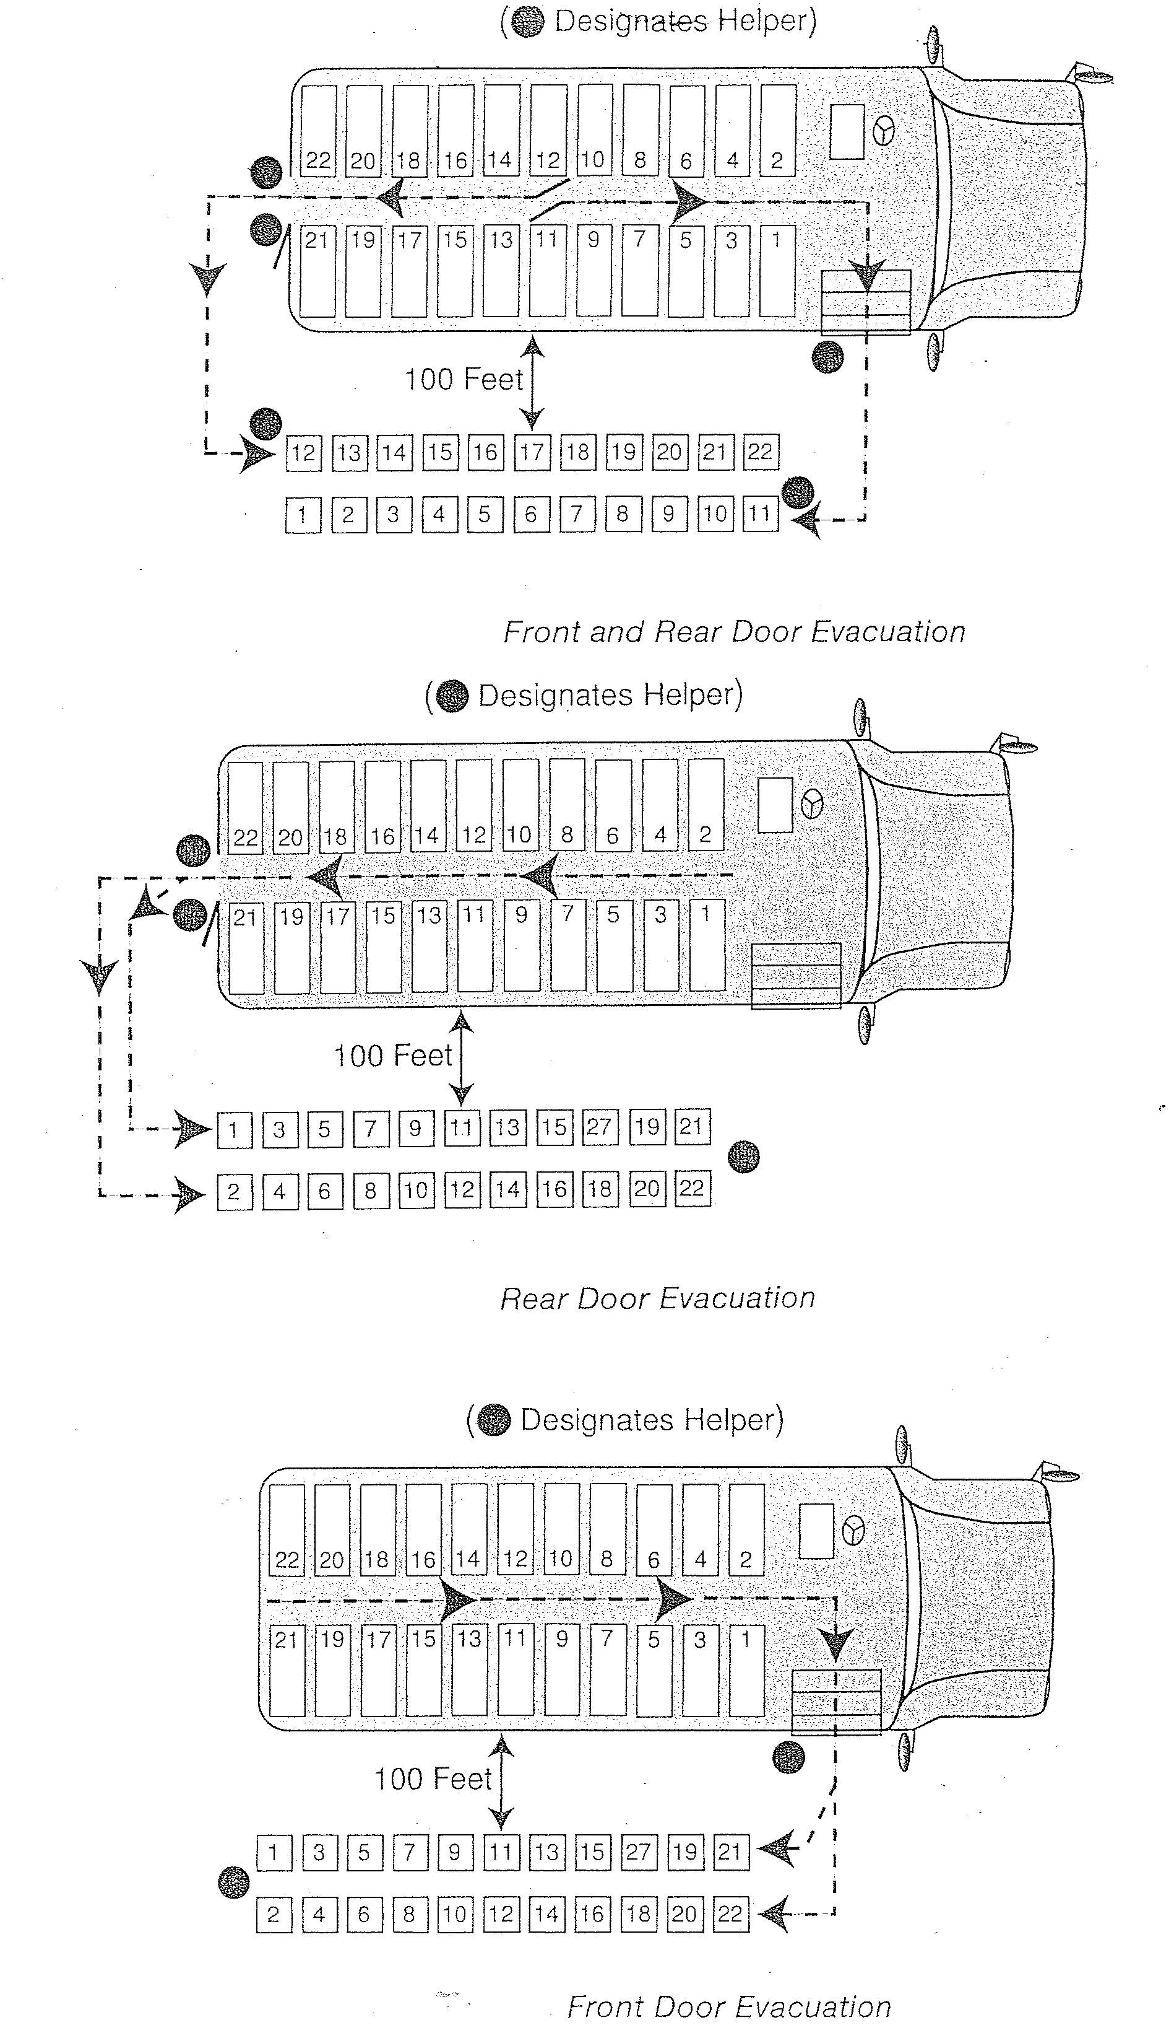
Exhibit J

Exhibit K

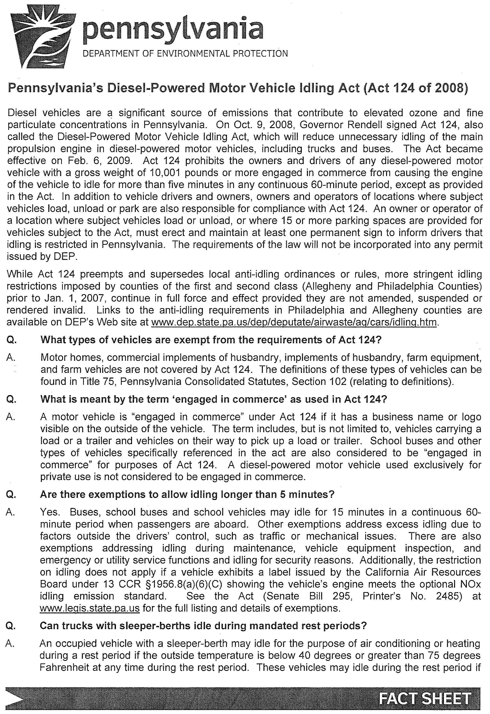
Exhibit L
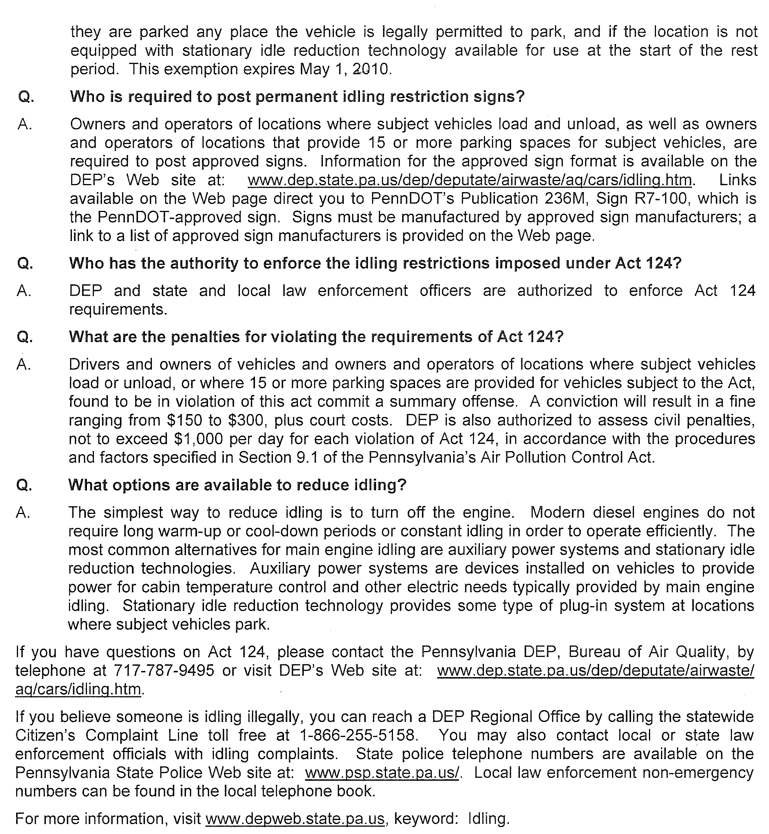

WARREN COUNTY SCHOOL DISTRICT
Exhibit M
185 Hospital Drive
WARREN, PENNSYLVANIA 16365
(814) 723-6900

ON BOARD INSPECTION FORM

Bus No. and Route:_________________________________________________

Date and Road/Weather conditions:___________________________________________________________________

Driver:_______________________________ Contractor:________________________________________________

DRIVER:
_____ Appearance neat and clean
_____ Reported on time
_____ Knows bus route and stops
_____ Is courteous to children
_____ Is comfortable driving bus
_____ Appears knowledgeable in safety rules of the road
_____ Makes no unauthorized stops, pick-ups or discharges
_____ Comes to complete stop at railroad tracks
_____ When approaching designated stop, starts slowing down to make approach
_____ Has schedule of bus regulations posted
_____ Has rosters and seating charts plainly visible
_____ All students are seated while bus is in motion

COMMENTS:______________________________________________________________________________________________
___________________________________________________________________________________________________________

CHILDREN:
_____ Children are orderly at bus stop
_____ Board bus in orderly fashion
_____ Take seats immediately
_____ Are well mannered, and face forward while bus is in motion
_____ Are attentive to driver’s commands
_____ Are not overly loud and misbehave
_____ Do not change seats while bus is in motion
_____ Remain in seats until bus has stopped
_____ Are not smoking or chewing
_____ Are not eating or littering

COMMENTS:_______________________________________________________________________________________________
____________________________________________________________________________________________________________

BUS:
_____ Is clean inside _____ Outside _____ Windows
_____ First Aid Kit, Fire Extinguisher and axe/pry bar are visible
_____ Does not smell of exhaust fumes or gasoline
_____ Seats are not torn, or loose from floor
_____ Tires are not worn or low
_____ The 8 light system appears to be working well
_____ Unsafe conditions noted, or potential hazardous situations observed

COMMENTS:_____________________________________________________________________________________________
__________________________________________________________________________________________________________

Principal:_______________________________________________

School:_________________________________________________

Warren County School District
Exhibit N
Warren, Pennsylvania

DRIVER IDENTIFICATION

Each Driver is required to complete this form and submit it to the Transportation Office for each school year.

Please Print

Driver Name______________________________________________________________________________________________
Last First MI

DOB:________________ M/F__________________ SSN:_________________________________________________

Home Address:____________________________________________________________________________________________

Home Tel#________________________________________ Cell#___________________________________________________

Emergency Contact: _______________________________________________________Phone:_________________________

Address: __________________________________________________________________________________________________

Driver Info:

Contractor:_____________________________________________ Hire Date: _______________________________________

Bus/Van/Route/Sub Assignment: ________________________________________________

DL#:______________________DL Exp Date:________________________Class______Restrictions_____________________

CDL Exp Date:_______________________________Recert Date:______________________________________

Date of Last Physical:_________________________________Special Physical Waivers: _____Y/N______

Clearance Date Submitted to Transportation Y/N

Act 33 Pa Child Abuse History __________________ ____________________

Act 34 Criminal History: __________________ ____________________

FBI Fingerprint: __________________ ____________________

Current DL: __________________ _____________________

Social Security Card: __________________ _____________________
Current CDL __________________ _____________________

Current Physical Form __________________ _____________________

Current Physical Waivers __________________ ______________________

Driver Signature Date
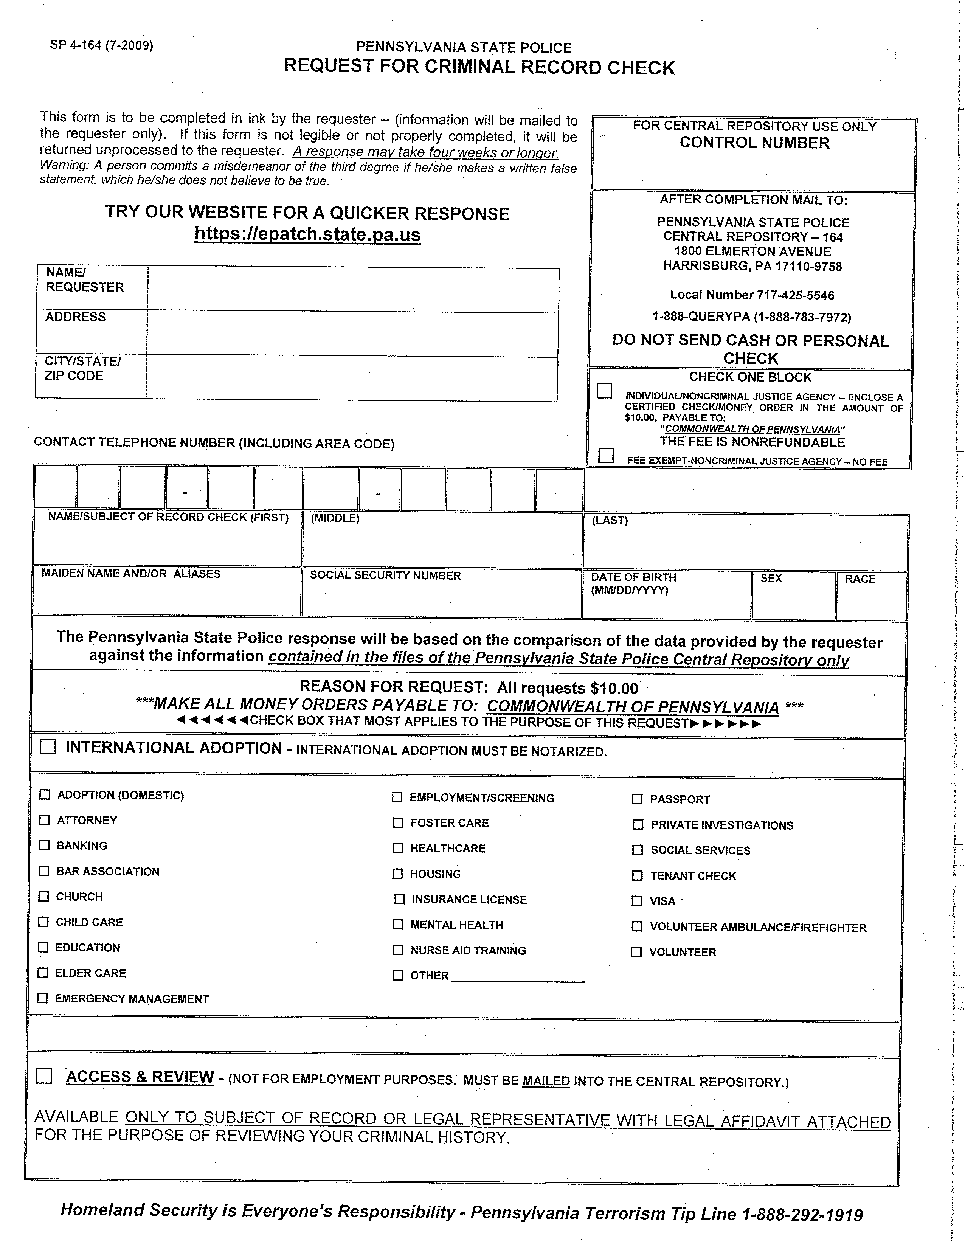
Exhibit O

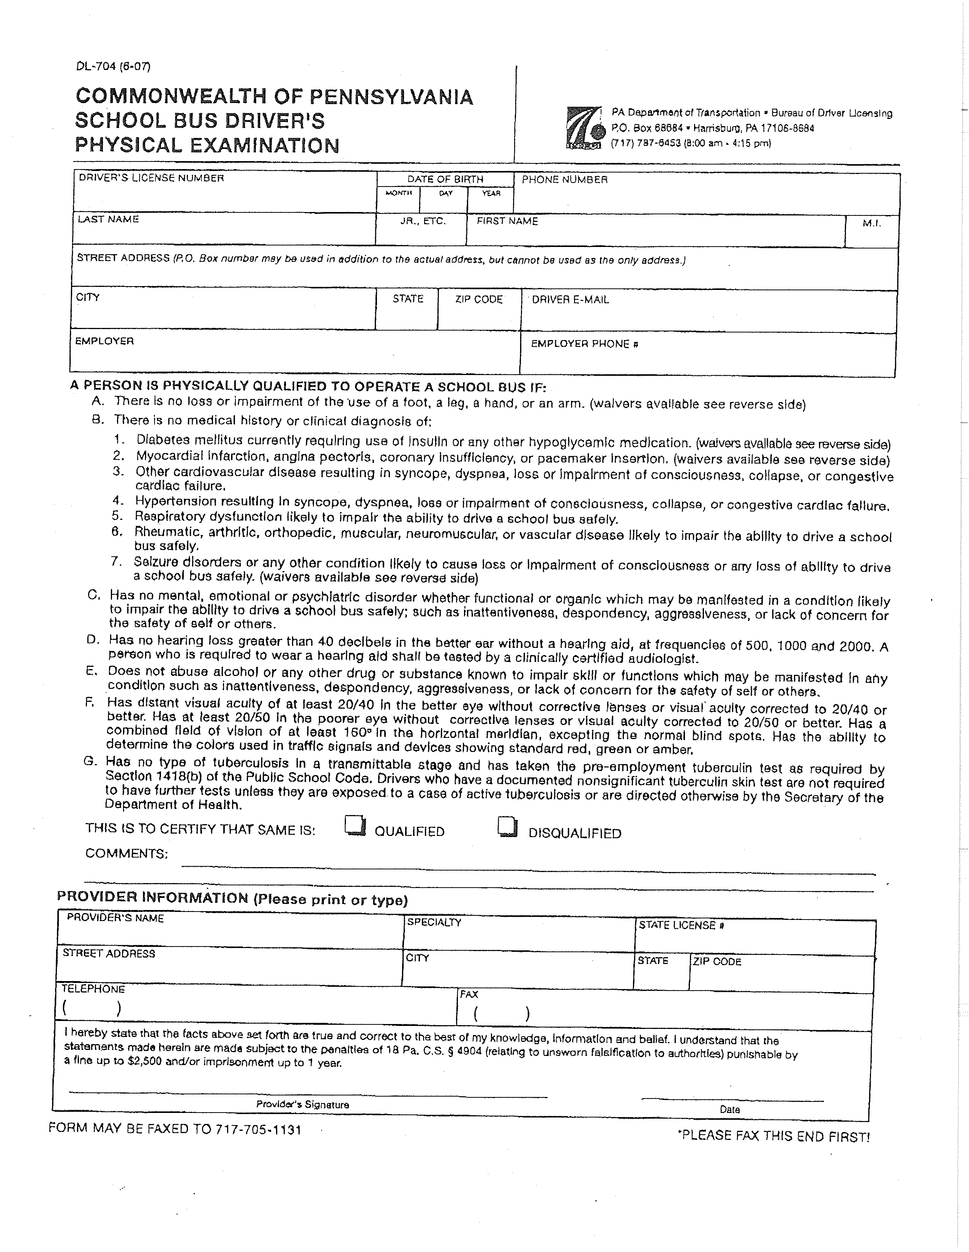
Exhibit P
2010-2011
TRANSPORTATION WOOK SHEET & ODOMETER READINGS
Exhibit Q

Run#: ___________ Driver:____________________________ School(s):______________________

Run: A.M . P.M. Mid-day (Please circle one)

Stop No. | Location/Student  Name= Last/First | Odometer Reading | Miles with |  | Miles W/O | Time | No. Students
 |  |  |  |  |  |  | Boarding | Unloading
Total Mileage With Students: |  |  |  | Total Mileage Without Students:

I hereby certify that the above mileage and student count is accurate

___________________________________________________
Contractor Signature Date
Page____of____
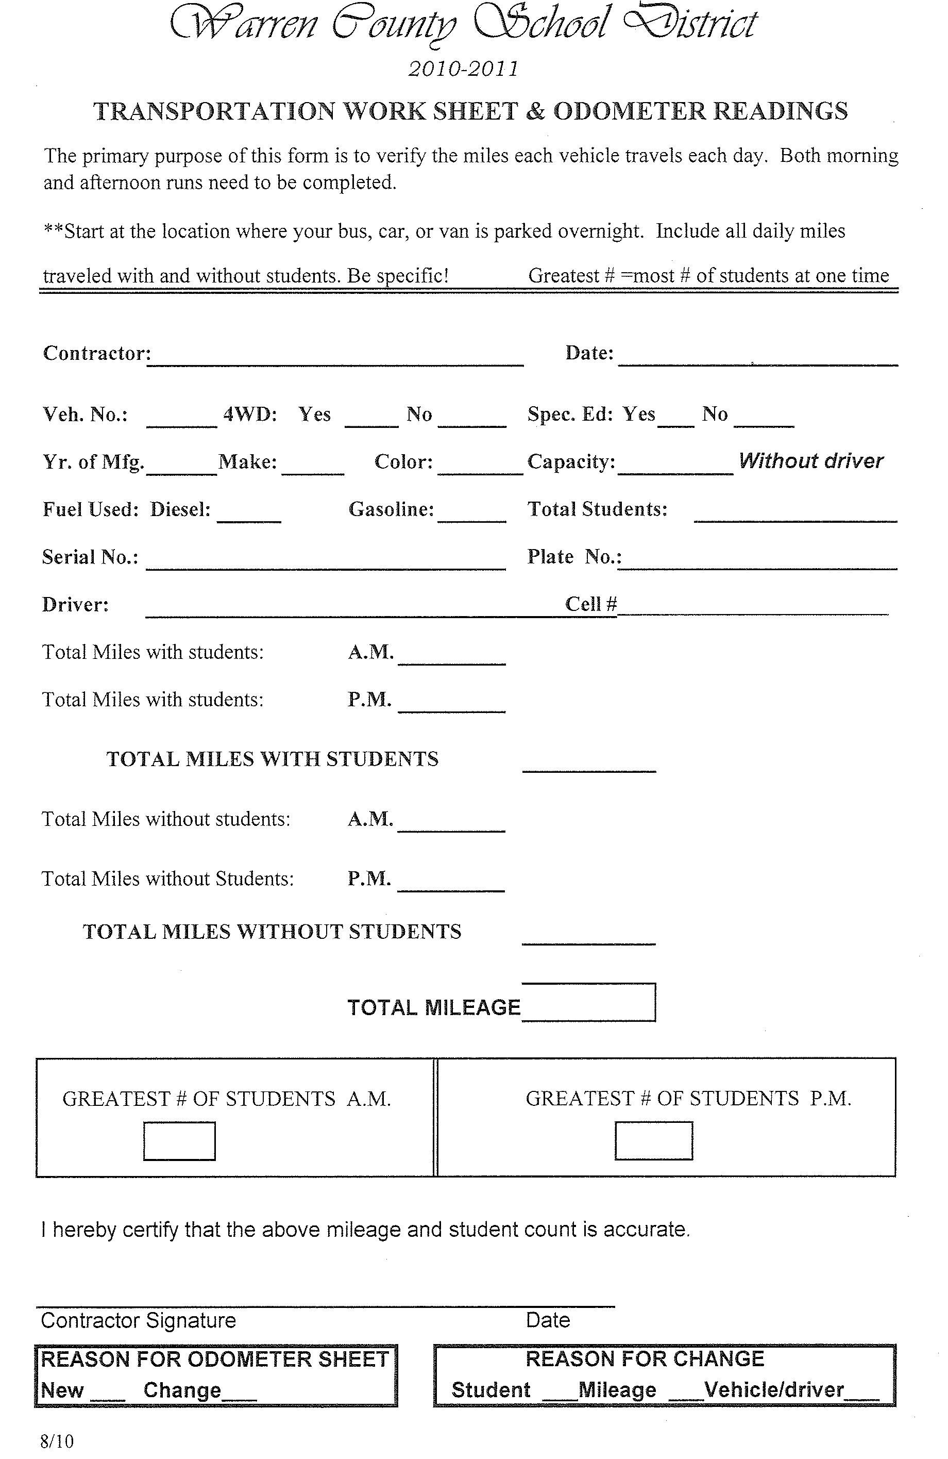
Exhibit R
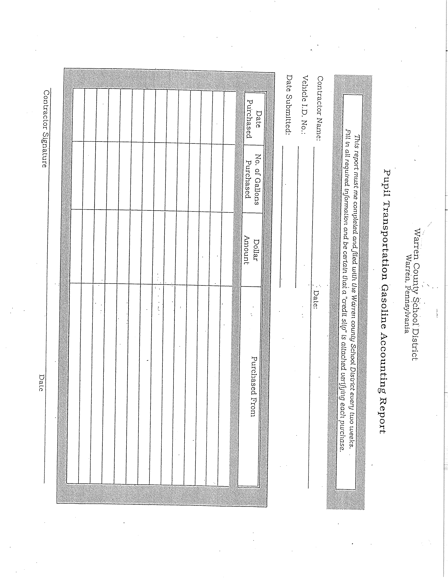
Exhibit S

Exhibit T
Warren County School District
CENTRAL ADMINISTRATIVE OFFICES
Exhibit U
185 Hospital Drive
Warren, Pennsylvania 16365-4885
Telephone: (814) 723-6900

Late Afternoon Activity Bus Request For Payment
(Please submit three copies to the principal)

Vehicle#:______________

Contractor:_______________________Vendor No______________________INV(_ _ _)

Contractor’s Signature:_____________________________________________________
Date
Please Check the appropriate month and days of payment request
 | Aug. | Sept. | Oct. | Nov. | Dec. | Jan. | Feb. | Mar. | Apr. | May | June
1 |  |  |  |  |  |  |  |  |  |  |  | 1
2 |  |  |  |  |  |  |  |  |  |  |  | 2
3 |  |  |  |  |  |  |  |  |  |  |  | 3
4 |  |  |  |  |  |  |  |  |  |  |  | 4
5 |  |  |  |  |  |  |  |  |  |  |  | 5
6 |  |  |  |  |  |  |  |  |  |  |  | 6
7 |  |  |  |  |  |  |  |  |  |  |  | 7
8 |  |  |  |  |  |  |  |  |  |  |  | 8
9 |  |  |  |  |  |  |  |  |  |  |  | 9
10 |  |  |  |  |  |  |  |  |  |  |  | 10
11 |  |  |  |  |  |  |  |  |  |  |  | 11
12 |  |  |  |  |  |  |  |  |  |  |  | 12
13 |  |  |  |  |  |  |  |  |  |  |  | 13
14 |  |  |  |  |  |  |  |  |  |  |  | 14
15 |  |  |  |  |  |  |  |  |  |  |  | 15
16 |  |  |  |  |  |  |  |  |  |  |  | 16
17 |  |  |  |  |  |  |  |  |  |  |  | 17
18 |  |  |  |  |  |  |  |  |  |  |  | 18
19 |  |  |  |  |  |  |  |  |  |  |  | 19
20 |  |  |  |  |  |  |  |  |  |  |  | 20
21 |  |  |  |  |  |  |  |  |  |  |  | 21
22 |  |  |  |  |  |  |  |  |  |  |  | 22
23 |  |  |  |  |  |  |  |  |  |  |  | 23
24 |  |  |  |  |  |  |  |  |  |  |  | 24
25 |  |  |  |  |  |  |  |  |  |  |  | 25
26 |  |  |  |  |  |  |  |  |  |  |  | 26
27 |  |  |  |  |  |  |  |  |  |  |  | 27
28 |  |  |  |  |  |  |  |  |  |  |  | 28
29 |  |  |  |  |  |  |  |  |  |  |  | 29
30 |  |  |  |  |  |  |  |  |  |  |  | 30
31 |  |  |  |  |  |  |  |  |  |  |  | 31

Principal’s Signature:___________________________________________________________________
Date

Number of days transported_______________ Daily Miles ____________

Daily Rate x_______________

Amount Due _______________

0 | 1 | 2 | 7 | 2 | 0 | 0 | 0 | 0 | 0 | 0 | 0 | 0 | 5 | 1 | 3 | 5 | 1 | 3

Payment Approvel:________________________________________________________
Date

Exhibit V
