Warren County Chamber of Business and Industry

https://www.emconsultinginc.com/adreservation/images/bc1.png

Top of Form

|  |  |
| --- | --- |
| https://www.emconsultinginc.com/adreservation/images/cover/wccbicover.png | **Warren County Chamber of Business and Industry 2019 Community Profile and Membership Directory** |

|  |  |  |  |  |
| --- | --- | --- | --- | --- |
| https://www.emconsultinginc.com/adreservation/images/ads/fullpage.png 8" x 10.5" | https://www.emconsultinginc.com/adreservation/images/ads/halfpage.png 7.75" x 5" | https://www.emconsultinginc.com/adreservation/images/ads/thirdpage.png 7.75" x 3.125" | https://www.emconsultinginc.com/adreservation/images/ads/quarterpage.png 3.75" x 5" | https://www.emconsultinginc.com/adreservation/images/ads/businesscard.png 3.5" x 2" |

**8.5" x 11" Publication**

Premium Display Ads

|  |  |  |  |  |  |  |  |  |  |  |  |  |  |  |  |  |  |  |  |  |  |  |  |  |  |  |  |
| --- | --- | --- | --- | --- | --- | --- | --- | --- | --- | --- | --- | --- | --- | --- | --- | --- | --- | --- | --- | --- | --- | --- | --- | --- | --- | --- | --- |
| |  |  |  | | --- | --- | --- | |  | Back Cover | $2299 | |  | Inside Front Cover | $1999 | |  | Inside Back Cover | $1999 | |  | Facing Page to Inside Front Cover | $1899 | |  | Facing Page to Inside Back Cover | $1899 | |  | Page 2 | $1799 | |  | Page 3 | $1799 | |  | Page 4 | $1799 | |  | Page 5 | $1799 | |

|  |  |
| --- | --- |
| B&W Display Ads | Color Display Ads |
| |  |  |  | | --- | --- | --- | |  | Full Page (B&W) | $1299 | |  | Half Page (B&W) | $899 | |  | Third Page (B&W) | $799 | |  | Quarter Page (B&W) | $699 | |  | Business Card (B&W) | $399 | | |  |  |  | | --- | --- | --- | |  | Full Page (color) | $1399 | |  | Half Page (color) | $1099 | |  | Third Page (color) | $899 | |  | Quarter Page (color) | $799 | |  | Business Card (color) | $499 | |

Enhance Your Company Listing in the Classifieds Section   
  
*Note: You must be a member of the Association/Chamber in order to upgrade to an Enhanced Listing.

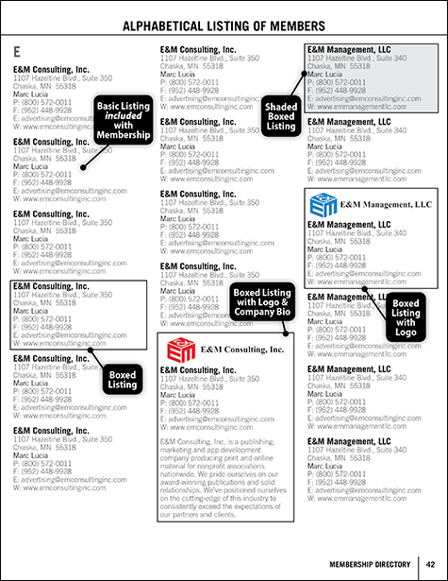

|  |  |  |
| --- | --- | --- |
|  | Boxed Listing (Guide) | $69 |
|  | Shaded Box Listing (Guide) | $99 |
|  | Boxed Listing with Logo (Guide) | $119 |
|  | Boxed Listing with Logo & 50 word bio (Guide) | $169 |

Put Yourself on the Map!   
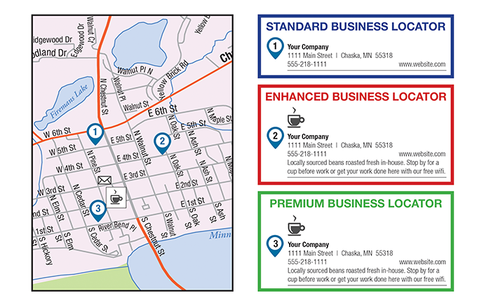

|  |  |  |
| --- | --- | --- |
| Standard Business Locator $199 | Enhanced Business Locator $299 | Premium Business Locator $399 |
| https://www.emconsultinginc.com/adreservation/images/ads/locatorpin1.png | https://www.emconsultinginc.com/adreservation/images/ads/locatorpin2.png | https://www.emconsultinginc.com/adreservation/images/ads/locatorpin3.png |
| Includes business name, address, and pin on map. | Includes **Standard** plus 25-word company description. | Includes **Enhanced** plus business logo next to location on map. |

2019 Community Profile and Membership Directory - Digital Edition   
  
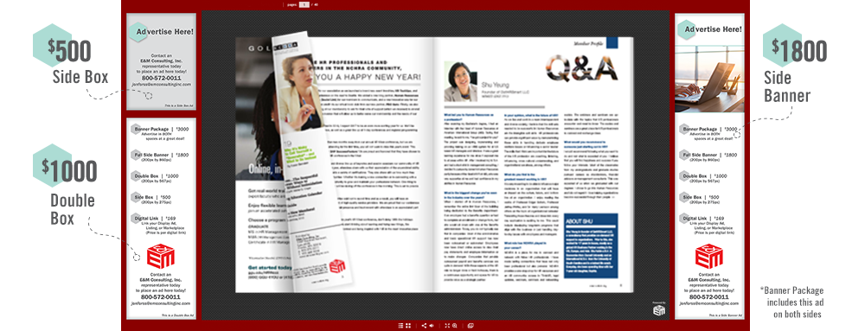

|  |
| --- |
|  |

|  |
| --- |
|  |

|  |
| --- |
| Advertise in an interactive, online copy of this year's publication that is accessible directly from the Chamber website and live 24/7 until next year's edition*. Only 2-6 spots available. The Chamber website typically receives tens of thousands of hits per year.  *Approximately 10-12 months. |

|  |  |  |
| --- | --- | --- |
|  | Double Side Banner Package (Guide) | $3000 |
|  | Full Side Banner (Guide) | $1800 |
|  | Double Box (Guide) | $1000 |
|  | Side Box (Guide) | $500 |

Need help designing your advertisement?  
Our Award-Winning graphics team can help for as low as $29!**\***

|  |  |
| --- | --- |
| Full Page: | $99 |
| Half Page: | $69 |
| Third Page: | $69 |
| Quarter Page: | $49 |
| Business Card: | $29 |

No Yes

*For past advertisers, We have a full graphics team that can help you with any ad changes you may have. However, there is an ad change fee if you need help with these changes. Ad change fees Smaller than 1/2 Page Ads - $29 • 1/2 Page Ads or Larger - $59

**\*** indicates required field

Bottom of Form

Have questions? Need help? Call us at 800-572-0011.

[© 2018 E&M Consulting, Inc.](https://www.emconsultinginc.com)