

12520 Business Center Dr., Unit C, Victorville, CA 92395, 800.943.5638, www.totalcontroltraining.net

November 15, 2019

Norbert Kennerknecht

Warren County School

6820 Market Street

Russell, PA 16345

Dear Sir:

We at the Pennsylvania Motorcycle Safety Program, a state-wide program sponsored by PennDOT, are doing something new this year. Employing a Mobile Unit, we plan to provide Motorcycle Training in never-before-served counties in PA. Warren is one of those counties. This program teaches new and experienced riders to ride safely, skillfully, and responsibly and provides them with a license waiver. We would like to use a parking lot at your school approximately one weekend a month to conduct these classes from April through September. We can vary our schedule to suit your site. We will bring a Mobile Unit in with a fleet of training motorcycles and a self-contained classroom. We will just need to use your parking lot and restroom facilities. We must put some painted lines on the parking lot for our training exercises and licensing tests.

This program is a great service to the community, providing safety awareness beyond motorcycle riders. If you have experienced riders in your school or community who would like to teach others, we would be glad to train them as Instructors for our program. Please let me know if you have any questions that I have not answered. I can be reached any time at 717-497-5134 or at [bobbie@totalcontroltraining.net](mailto:bobbie@totalcontroltraining.net). Thank you for your consideration.

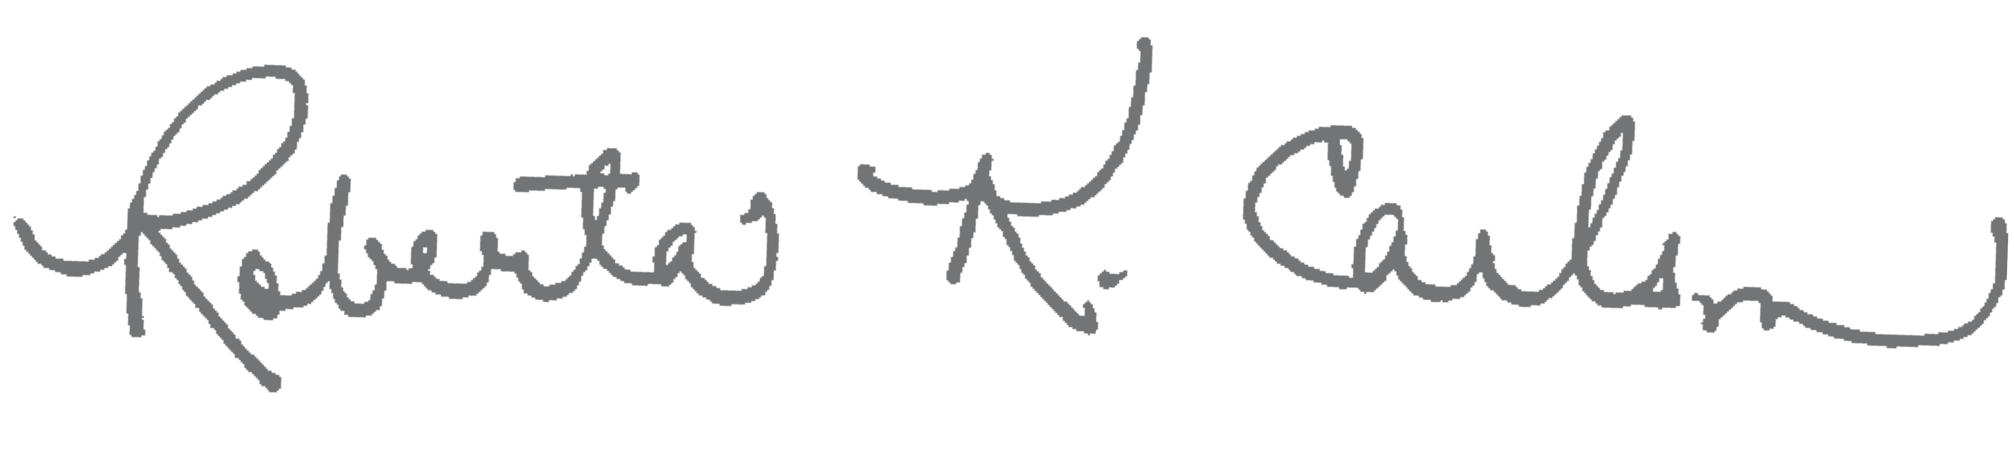Respectfully,  
Bobbie Carlson, PAMSP Director of State Programs  
Total Control Training, Inc.