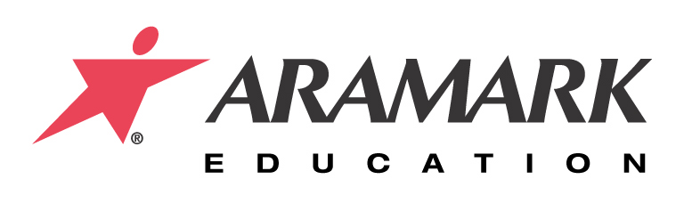
TO: Petter Turnquist

CC: Norbert Kennerknecht

FROM: Justin Tech

DATE: August 23, 2007

SUBJECT: Equipment Request

We are requesting that the District purchases five transportation holding cabinets. This
equipment would be used in the five satellite schools; Allegheny Valley, South Street, Sugar
Grove, Sheffield Elementary, and Russell. With this new equipment it will help to yield an
increase in food quality and food safety, will be able to better utilize the central kitchen and
satellite’s labor, and increase overall service to the satellites. This will lead to an increase in
sales, a happier labor force, and enhance the status of our health inspection reports .

Listed below are quotes on the holding quotes.

Hubert Co.
*Lockwood Insulated Holding Cabinet Full Size $1889.00 each

Metro Holding Cabinet Full Size $2093.00 each

Zesco
*Metro Holding Cabinet Full Size $1800.00 each

LakeSide
Non – insulated Heated Cabinet $4392.00 each

