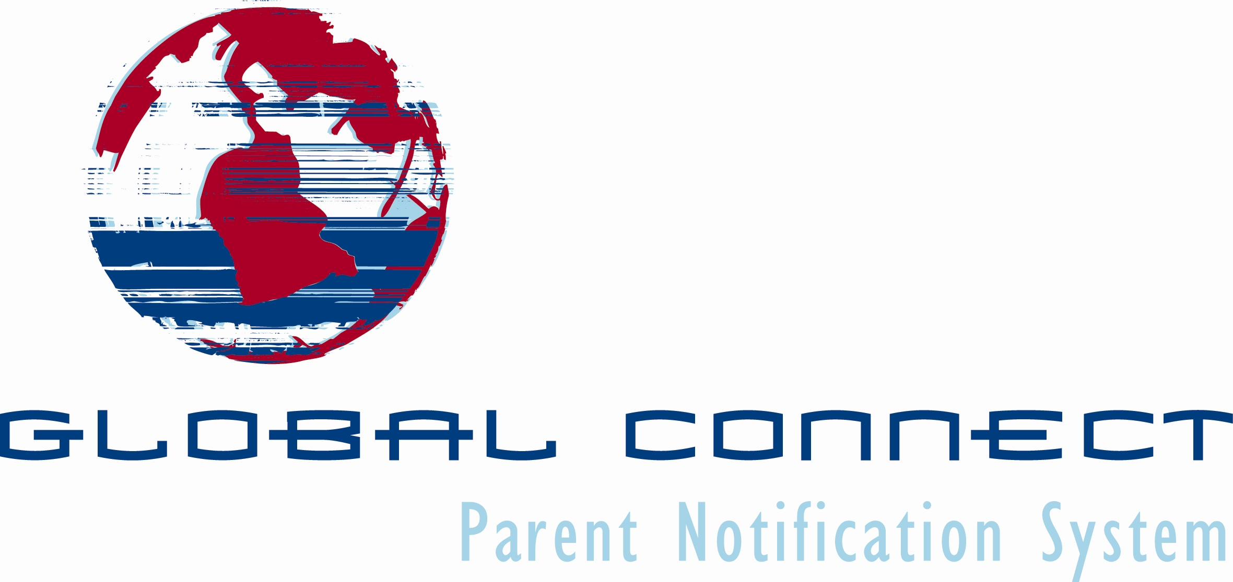

SCHOOL DISTRICT USER AGREEMENT

Global Connect Phone: 609-625-7951
5218 Atlantic Avenue, Suite 202 Toll Free: 888-421-4151
Mays Landing, New Jersey 08330-2003 Fax: 609-625-7689
# of Schools:_______________

Students Population _________________

Date: / /

Contract #:

SID#:

SCHOOL DISTRICT CONTACT INFORMATION

School District Name Contact Name

Street Address City State Zip

Contact’s Phone Number Contact’s Fax Number Contact’s Email Address

888-421-4151 x226
msweeney@gc1.com

jpirzinger@anetdiscount.com

GC Contact Person Phone Number Email Address

TERMS and CONDITIONS

Chargeable rate is $1.80 per student per year based on total student enrollment of the school district or school as applicable at the date of signing and acceptance by both parties as described below. Total charges will be pro-rated based on the 12 month period ending June 30th of the current school year. In the event of renewal, charges will be based on the total student enrollment as of the renewal date. The User Agreement will be renewed yearly on July 1st unless terminated by either party as contained herein.

Either party reserves the right to terminate this agreement and eliminate associated passwords including student accounts with 30 days written notice. Information provided by the school district or school including but not limited to phone lists and data files will remain the exclusive property of the customer. Global Connect agrees not to rent, sell, loan or provide this information to any person or company without written permission by the customer.

Neither party shall be responsible to the other for any losses resulting from the failure to perform any terms or provisions of this Agreement, except for payments of monies owed, if the party's failure to perform is attributable to war, riot, or other disorder; strike or other work stoppage; fire; flood; or any other act not within the control of the party whose performance is interfered with, and which, by reasonable diligence, such party is unable to prevent. Any such occurrence shall be referred to as a "Force Majeure". Nor shall Global Connect be liable for any act or omission of any other person or company furnishing any portion of a product or service.

Global Connect shall defend, indemnify and hold harmless, the District, its officers, employees and agents, for any and all claims, suits, settlements, proceedings, demands, assessments, judgments, losses, costs, damage and expenses including, without limitation, reasonable attorney’s fees, resulting from or arising out of Global Connect's performance of services under this Agreement. Global Connect's duties and obligation in accordance with this provision shall survive the termination of this Agreement and shall cover all claims, regardless of when they are asserted.

District shall defend, indemnify and hold harmless, Global Connect, its officers, employees and agents, for any and all claims, suits, settlements, proceedings, demands, assessments, judgments, losses, costs, damage and expenses including, without limitation, reasonable attorney’s fees, resulting from or arising out of District's performance under this Agreement. District's duties and obligation in accordance with this provision shall survive the termination of this Agreement and shall cover all claims, regardless of when they are asserted.

The parties agree that they conduct completely separate businesses or affairs and are separate entities and are not partners or joint venturers in any sense whatsoever. Further, Global Connect represents and acknowledges that it, and its employees and agents, are independent contractors and are not agents, servants or employees of the District.

Global Connect shall procure from a qualified insurance underwriter and keep in force during the term of this Agreement General Liability Insurance, which insurance covers the services performed by Global Connect in accordance with the terms of this Agreement, in an amount of at least $1,000,000.00. Certificates of insurance evidencing such coverage shall be provided to the District prior to the execution of this Agreement.

This agreement is subject to laws in the Commonwealth of Pennsylvania. This agreement supersedes all prior agreements, representations and understandings of the parties.

This Agreement expresses the sole and entire agreement between the parties with respect to the matter discussed herein and supersedes all prior discussions, representations and understandings regarding the matters herein. This Agreement may only be modified by a writing signed by both parties.

I agree to the terms and conditions including governmental rules and regulations contained herein.
11 11111
1
2007
Effective Date of This Agreement: / / .
Month Day Year

Accepted By:

On This Date: / / .
Month Day Year

By:
Please Print

Signature:

Title:

Accepted By: Global Connect, LLC
11
1
2007

On This Date: / / .
Month Day Year

Michael Sweeney

By:
Please Print

Signature:

Executive Director of Sales
Title:
Revised 05/29/07

