  For Internal Use Only  Depts must provide: |  |  | OES Contract # | ___________________
ESAF # | 1341 |  | Analyst
Area/Org | 303-2668
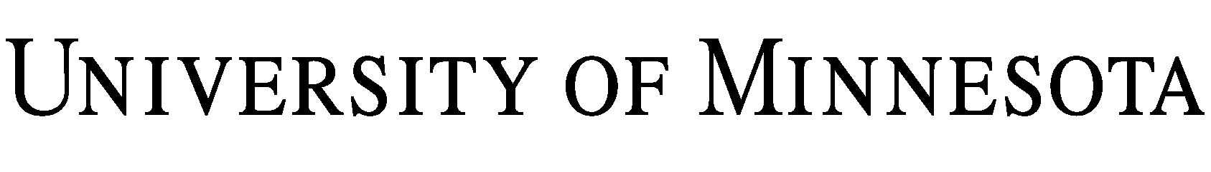
Workshop/Presentation Agreement

The Regents of the University of Minnesota, through its Institute on Community Integration (the “University”), agree to provide a workshop/presentation for Warren County School District, a Public School District (the “Company”), on the following terms and conditions:

1. Description of Workshop/Presentation: Check & Connect: A research-based intervention to increase school completion and reduce the dropout rate for secondary students. Approximately 30 educators/administrators from the Warren County School District will learn how to implement the Check & Connect intervention in their home community.

2. Date, Location, and Time:
Date: August 24 & 25 , 2009
Location: TBA

Time: 9:00 a.m. - 4:00 p.m each day for two days

3. Payment Terms: For the services under Section 1., Company shall pay University Eleven-thousand, five-hundred and seventy-seven and 00/100 dollars ($11,577.00,). Payment is due on the day of the workshop/presentation or upon receipt of invoice. In the event Company cancels for any reason, except for extraordinary causes beyond the reasonable control of Company, Company shall remain obligated for the full amount set forth in this paragraph.

4. Obligations of Company. Company agrees to provide the following accommodations, equipment, and material: N/A

5. Ownership of Materials and Presentation. All materials provided by the University during the presentation shall remain the property of the University. Company is provided a license to use the material in connection with the workshop/presentation, but Company may not copy or distribute the material without the express written consent of the University. University further owns all rights to the workshop/presentation and the workshop/presentation shall not be recorded or taped in any form without the express written consent of the University.

6. Disclaimer. The University makes no claims of any kind with respect to the workshop/presentation and shall not be liable for participant’s reliance on any statements or demonstrations made during the workshop/presentation. University’s maximum obligation to Company for any cause of action arising under this Agreement, including failure to perform, shall not exceed the amount actually paid to University by Company under Section 3.

7. Complete Agreement/Governing Law. This Agreement, including any attached exhibits, represents the complete agreement of the parties. No amendments to this Agreement shall be binding upon the University unless signed by the University’s Director of External Sales. This Agreement cancels, supersedes and revokes all prior negotiations, representations and agreements between the parties, whether oral or written, relating to the subject matter of this Agreement. The terms and conditions of any purchase order or similar document submitted by the Company in connection with the services provided under this Agreement shall not be binding upon the University. This Agreement shall be governed by the laws of Minnesota and any action to enforce this Agreement shall be brought only in Hennepin County, Minnesota.

IN WITNESS WHEREOF, the parties have entered into the Agreement effective / /09.

Regents of the University of Minnesota Warren County School District, Warren, PA

By: By:
Name: Name:
Title: Title:
Date: Date:
Address: Warren County School District
185 Hospital Drive
North Warren, PA 16365
Phone: 814-723-6900 Fax: 812-723-4244

