GOB Q & A’s: An Overview

Intermediate Unit funding is a complex matter. The Northwest Tri-County Intermediate Unit 5 has over 50 individual budgets that make up the funding sources for over 100 programs and services. The General Operating Budget (GOB) is only one of the budgets, but it is important as it provides the foundation for all others to exist. The GOB is unique in that it is the only budget that school districts contribute to, vote on, and must approve. This overview highlights the most often asked questions about the GOB and offers a simple, distilled view of a complex process.



**Total of 50+ IU 5 Budgets = $56,424,255**

**General Operating Budget = $1,792,112**

Q. What makes IU 5’s General Operating Budget (GOB) different from the other budgets?

A. The General Operating Budget (GOB) is the only budget that area school districts contribute to annually AND it is the one budget that by law (Act 102 of 1970) must be voted on and adopted by the 153 school directors in Crawford, Erie and Warren counties.

Q. What percentage of the total of IU 5 budgets is the GOB?

A. The 50+ budgets of IU 5 total over $56 million dollars. The General Operating Budget for 2013-2014 is $1,792,112 representing 3.18% of the total funding sources for IU 5 program and services.



**Out of 370 full time employees, 16 are funded by the GOB**

Q. What expenditures does the GOB cover?

A. The GOB provides for IU 5 administrative costs, board, and school improvement services. Of IU 5’s 370 employees, the GOB provides funding for 16 full-time, or 15.1 “full-time equivalent.” All other employees are funded through other budgets.

Q. What is the effect of school district contributions on the GOB?

A. Funds to support the GOB are received from two major sources: district withholding and other grant funds generated by IU5. The following is the breakdown of revenue for the GOB:

* School district contributions represent 55% of the total General Operating Budget.
* Commonwealth reimbursement of its share of FICA and Retirement is 6%.
* The remaining sources of funds representing 39% comes from administrative fees received for operating various state programs and federal projects, fees charged for services provided to LEAs, interest earnings, and fund balance.

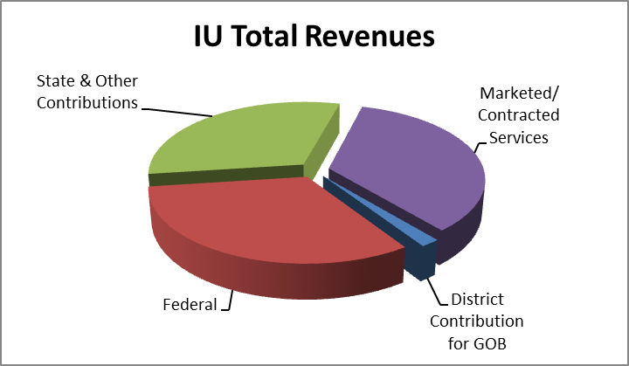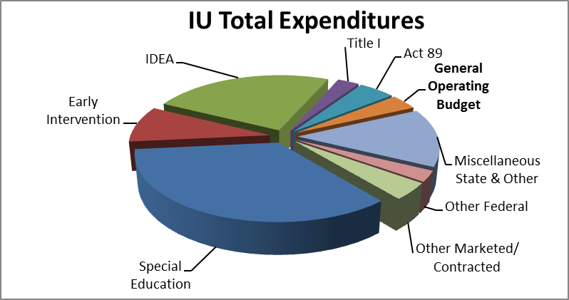

Q. How is each school district’s contribution by withholding determined?

A. The Pennsylvania Department of Education uses a formula to calculate the individual district contribution for $626,000. Simply put, a formula is used to determine a ‘District Weight Factor’ for each school district. The total amount budgeted for district contributions is then divided by the total of all ‘District Weight Factors’ resulting in a ‘Value Per Weight Factor.’ Finally, each ‘District Weight Factor’ is multiplied by the ‘Value Per Weight Factor’ to determine the actual individual district contribution. The remaining $362,929 is based on individual district’s proportionate share of professional staff as of October 1st of the current school year.

Q. What impact is the state funding expected to have on the 2013-2014 GOB?

2011-2012

1996-1997

1992-1993

$206,019

$492,581

**$0.00**

A. **None!** When the 2011-2012 budget was passed, the legislature eliminated intermediate unit operating and capital subsidy completely. Through reallocation of resources, retooling IU 5 programs and services, and expenditure reduction, IU5 continues to meet the needs of our school districts.

To put Commonwealth support in perspective, funding has declined steadily since 1992-1993 with state subsidy reduced by 50% in 1996-1997, and eventually eliminated in 2011-2012.

The good news is that IU 5 has continued to offset the decline in state funding with increasing revenues generated through grants, administrative fees for operation of state programs or federal projects.

Q. Is there an increase in expenditures in the GOB for 2013-2014?

A. **No.** The proposed 2013-2014 GOB totals $1,792,112, a decrease of $75,731 or 4.0% less than last year. Expenditures covers services such as:

|  |  |  |
| --- | --- | --- |
| * Classroom Diagnostic Tool | * Literacy Design Collaborative | * Safe Schools Support |
| * Common Core Transition | * MASTERS Program | * School Performance Profile |
| * CourseWhere | * Math Networking | * School-Wide Positive Behavior Support (SWPBS) |
| * Curriculum Development/Regulations | * Moodle Initiative | * Science Networking |
| * Curriculum Directors’ Meetings | * PAIU Academic Competition | * Secondary Literacy Council |
| * Data Tools & Analysis | * Paraeducators (Special Ed.) Training | * Specialist Effectiveness Technical Assistance |
| * Digital Resource Portal (DRP) | * PBS Kids Go Writers’ Contest | * Standards Aligned System Portal |
| * Distance Learning | * Principal Effectiveness Training | * Stem Education Outreach |
| * Gifted Networking | * Principals’ Networking | * Streaming Media |
| * Higher Education Council & Partnerships | * Professional Development | * Striving Readers Grant (KtO) |
| * Instructional Coaching | * Professional Library | * Teacher Effectiveness Training |
| * ITQ Service and Support | * Progress Monitoring | * Transition to PA Common Core Standards |
| * IU Graduate Course | * Reading Apprenticeship | * Virtual Conferencing |
| * Keystone Exams & Project-Based Alternative | * Response to Instruction & Intervention (RtII) |  |

Q. What is IU 5’s projected fund balance and what purpose does it serve?

A. The 2011-2012 projected ending unassigned general fund balance of $2,300,000 and assigned general fund balance of $884,006 to fund future capital expenditures represents 5.64% of IU5’s approximate 50 individual budgets totaling $56,424,255. The fund balance is the only means available to fund its unfunded accrued liability for other postemployment benefits according to Governmental Accounting Standards Board (GASB) issued Statement No. 45 which stood at $1,413,394 as of July 1, 2013.

In certain cases, such as postemployment benefits (primarily retiree health care), **the fund balance has to cover the liability for all 370 IU staff members, not just the 16 full-time employees in the GOB.**

Q. When is the GOB considered adopted?

A. Traditionally, in the fall of each year, the Superintendents’ Professional Advisory Council reviews and the IU 5 Board of Directors approve the proposed GOB. If approved, a budget document is prepared and distributed to each school district in the IU 5 region and shared with school directors serving 17 member districts. The 17 local school boards act on the proposed budget during their monthly meetings in February and March. Each board member’s vote is weighted according to district enrollment. When approved by a majority of school boards collectively, and by a majority of the individual school directors based on weighted votes, the Executive Director of Northwest Tri-County Intermediate Unit 5 files the budget with the Pennsylvania Department of Education. The General Operating Budget of the Intermediate Unit is due to the state by May 1st of each year.

More information about Pennsylvania’s 29 Intermediate units can be found at [www.paiu.org](http://www.paiu.org).

Northwest Tri-County Intermediate Unit 5

252 Waterford Street

Edinboro, PA 16412