WARREN COUNTY SCHOOL DISTRICT SECTION 10000

10100 STUDENT ATTENDANCE AREAS

10107 School Attendance Areas

The following represent verbal descriptions of the attendance area boundaries. The attached map of the attendance area boundaries is intended to visually represent said descriptions. When making student assignments pursuant to Policy 10102, the Superintendent or his/her designee is authorized to deviate from the attendance area boundaries if the Superintendent or his/her designee determines that it is in the best interest of the District to do so for reasons including, but not limited to, transportation efficiency, to appropriately balance the student population amongst schools, or to relocate students during a construction project. Said decisions shall be made at the sole discretion of the Superintendent or his/her designee as a part of the District’s discretion to assign students to schools within the District pursuant to 24 P.S. §13-1310.

WEST Attendance Area

Includes all of Brokenstraw, Pittsfield, Eldred, Deerfield, Triumph, and Limestone Townships, and the boroughs of Youngsville, Tidioute, and villages of Pittsfield, Garland, and Grand Valley. Also included is Route 62 south, which travels through Pleasant and Watson Townships from the Irvine Exit to Tidioute, Route. 337 in Watson Township from Cobham Hill Road thru Limestone Township to Route 62 and lower Grunderville Road from Route 62 to the old Landfill and the lower section of Lenhart Run Road which is in Pleasant Township.

The southwestern section of Freehold Township, including Route 6 to the Swamp Road, Stoney Run Road, Western Road, Kidder Road, Porter Hill Road, Deadman’s Run Road and Taylor Road.

CENTRAL Attendance Area

Includes the city of Warren, borough of North Warren and the townships of Elk, Glade, and Conewango. Also Pleasant Township with the exception of the lower Grunderville Road from Route 62 to the landfill and the lower section of Lenhart, and Chapman Dam Road from the Chapman Dam to the Mead/Pleasant Township line. Also includes Watson Township from the Pleasant Township line to the Hearts Content Road.

NORTH Attendance Area

Includes all of Pine Grove, Farmington, Sugar Grove and Freehold Township with the exception of Route 6 from the Pittsfield/Freehold Line to the Swamp Road and Porter Hill, Deadman’s Run Western Road, Smith Road, Stoney Run Road and Page Hollow Road from the Township line to the Sheldon Road intersection.

EAST Attendance Area

All areas south and east of the Glade Bridge/Allegheny River, including all of Mead Township, Cherry Grove Township, Sheffield Township and that section of Watson Township from the Hearts Content/Route 337 intersection to those areas east and south including the Hearts Content and Dunham Mills Roads.

Also included is that part of Chapman Dam Road in Pleasant Township from the Mead/Pleasant Township line to Chapman Dam.

Adoption Date - February 24, 2003
Revision Date - September 8, 2003
Review Date -
Legal Reference - 24 P.S. §13-1310.
Cross Reference - Policy 10102 and 10106

Page 3 10107 School Attendance Areas

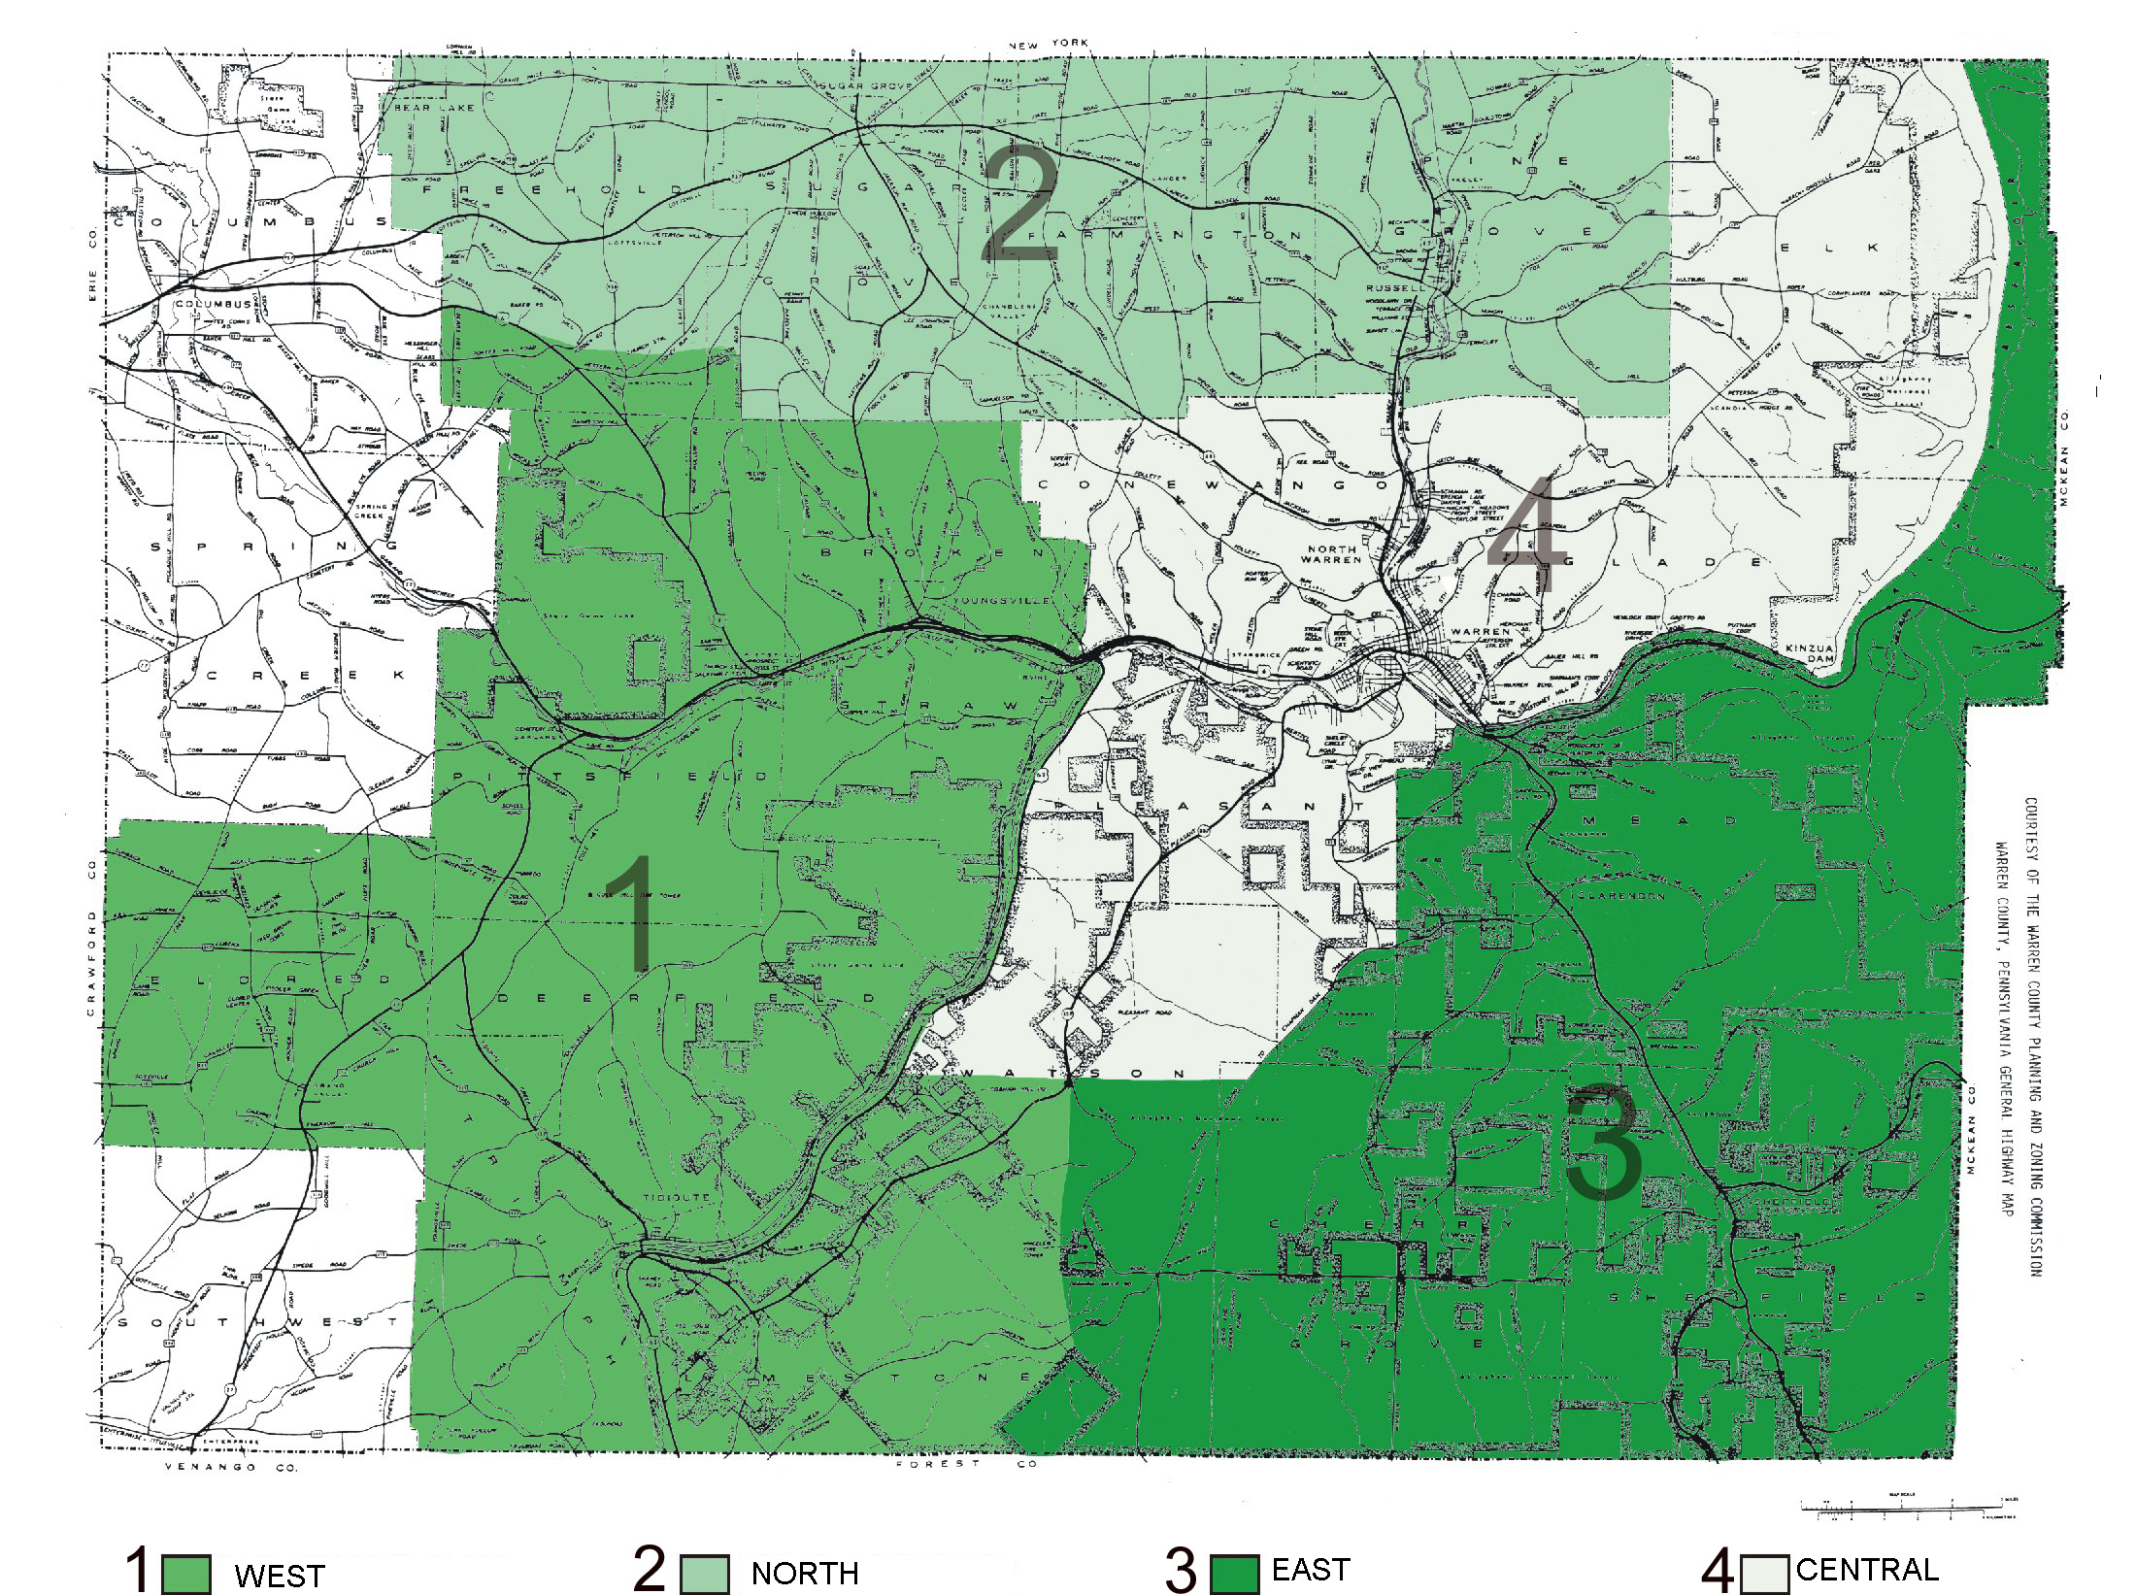

This page can be printed in color and enlarged.

