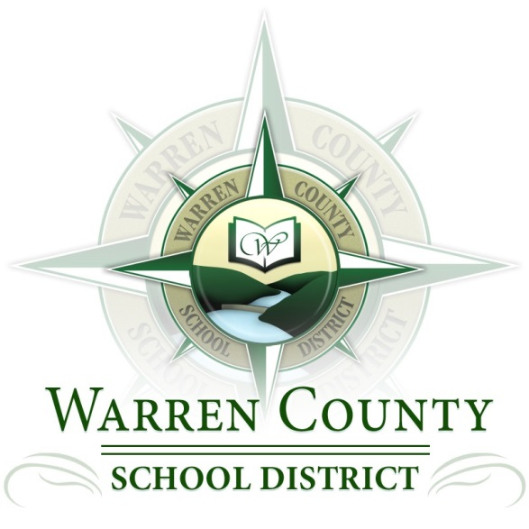

GOALS OUTLINE

2015-2016

**Goal #1: The Warren County School District will continue the long-term continuous improvement plan for academic excellence through focused efforts on:**

1.1 Improved staff effectiveness

1.2 Improved student centered support and services

1.3 Improved curriculum, instruction and assessment

**Goal #2: The Warren County School District continues to implement the Master Facilities Plan including the renovation of Warren Area High School, Warren County Career Center and Youngsville High School; and regularly reviews and upgrades building systems to maintain the facilities at a level that prevents deferred maintenance and improves building security.**

2.1 Adhere to current Master Facilities Plan

2.2 Continue Warren Area High School Renovation

2.3 Continue planning for Warren County Career Center Renovation

2.4 Begin planning for Youngsville High School Renovation

2.5 Develop a maintenance program / continuous seven year plan

**Goal #3: The Warren County School District will work to maintain consistency in staffing, leadership, and governance while actively promoting district purpose.**

3.1 Eliminate barriers to consistent staffing

3.2 Eliminate barriers to consistent leadership and governance

3.3 District leaders will seek opportunities to advocate for the WCSD on the local and state levels

**Goal #4: The Warren County School District will develop a fiscal plan to 1) address the need for increasing non-traditional revenues and maximizing income from traditional sources, 2) continue to control spending, and 3) present a long-term financial plan to address the concerns of the Board of Directors regarding curricular and technology needs, professional development, staffing, declining revenues from the local tax bases and school funding from the State.**

4.1 Continue to develop long range fiscal planning

4.2 Continue to develop long range technology planning

4.3 Develop long range grant planning