SIXTH AMENDMENT
TO
MASTER SERVICES AND LICENSE AGREEMENT
This SIXTH AMENDMENT TO MASTER SERVICES AND LICENSE AGREEMENT (this “6th Amendment”) dated March 20, 2023 between Accelerate Education Incorporated and Warren County School District.

RECITALS

Whereas, ACCELERATE and Customer entered into a Master Services and License Agreement (the “Agreement”) effective as of July 30, 2018 (“Effective Date”); and Whereas, each of the parties now desire to amend the terms of that Agreement.

Whereas, ACCELERATE and Customer entered into a First Amendment to Master Services and License Agreement (the “First Amendment”) dated April 8, 2019; and

Whereas, ACCELERATE and Customer entered into a Second Amendment to Master Services and License Agreement (the “Second Amendment”) dated November 4, 2019; and

Whereas, ACCELERATE and Customer entered into a Third Amendment to Master Services and License Agreement (the “Third Amendment”) dated May 26, 2020; and

Whereas, ACCELERATE and Customer entered into a Fourth Amendment to Master Services and License Agreement (the “Fourth Amendment”) dated May 10, 2021; and

Whereas, ACCELERATE and Customer entered into a Fifth Amendment to Master Services and License Agreement (the “Fifth Amendment”) dated May 9, 2022; and

Now, therefore, the parties hereto hereby agree as follows.

AGREEMENT

- Amendments to the Agreement

Exhibit B of the Agreement is hereby amended and restated to read in its entirety as follows:

Exhibit B
Pricing and Payment Schedule

Personalized Learning Courses on Warren County’s instance of Buzz

Personalized Learning Courses

User License Fees within Warren County School District (Licenses Valid from July 30, 2023 – July 29, 2024)
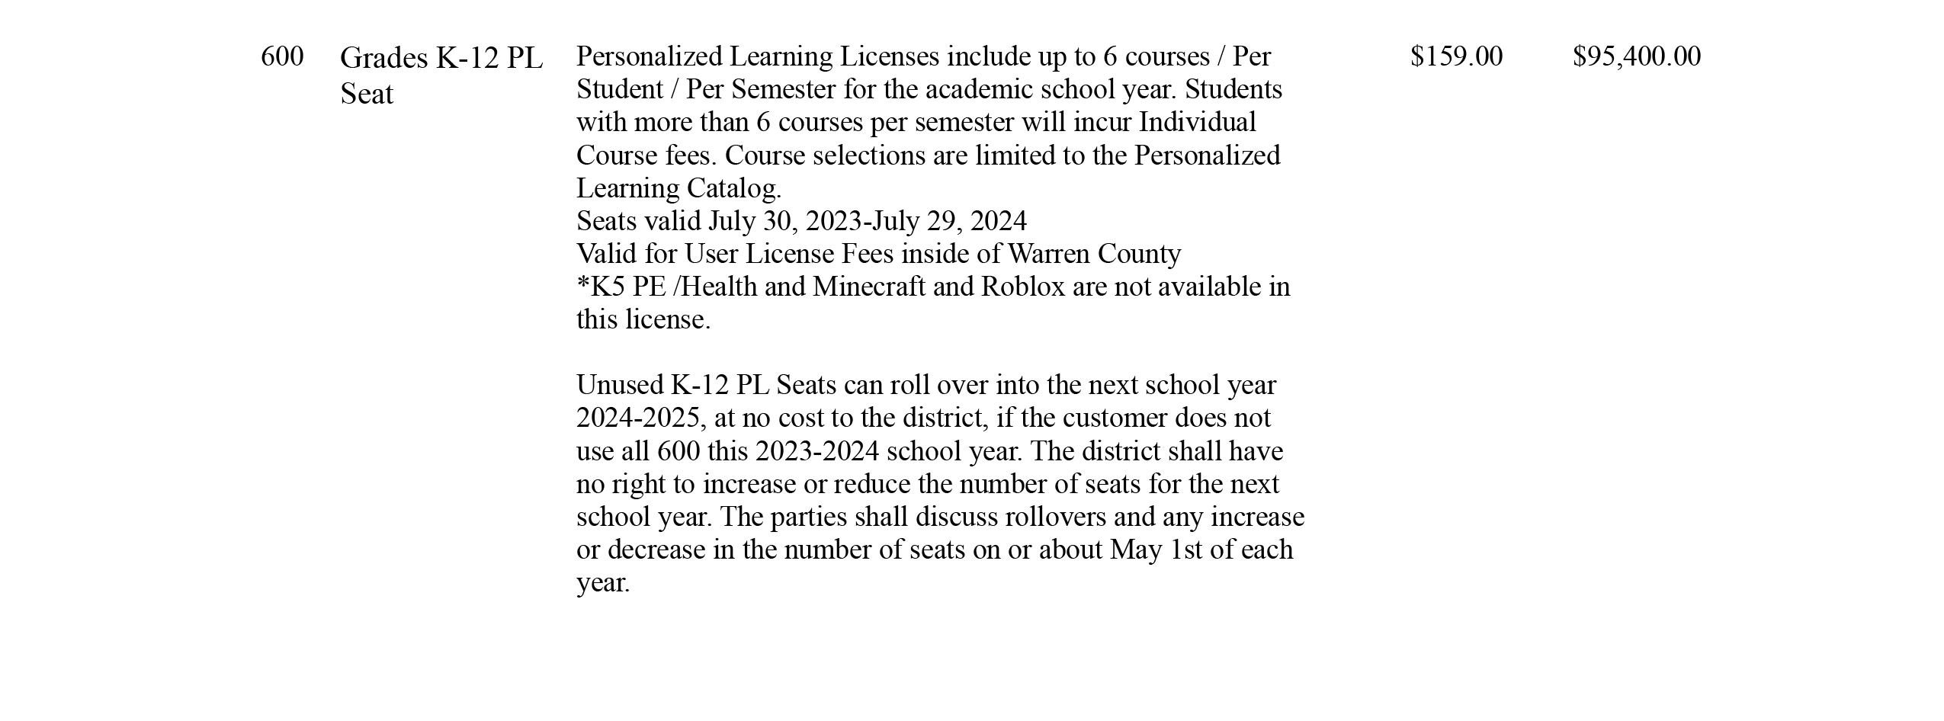
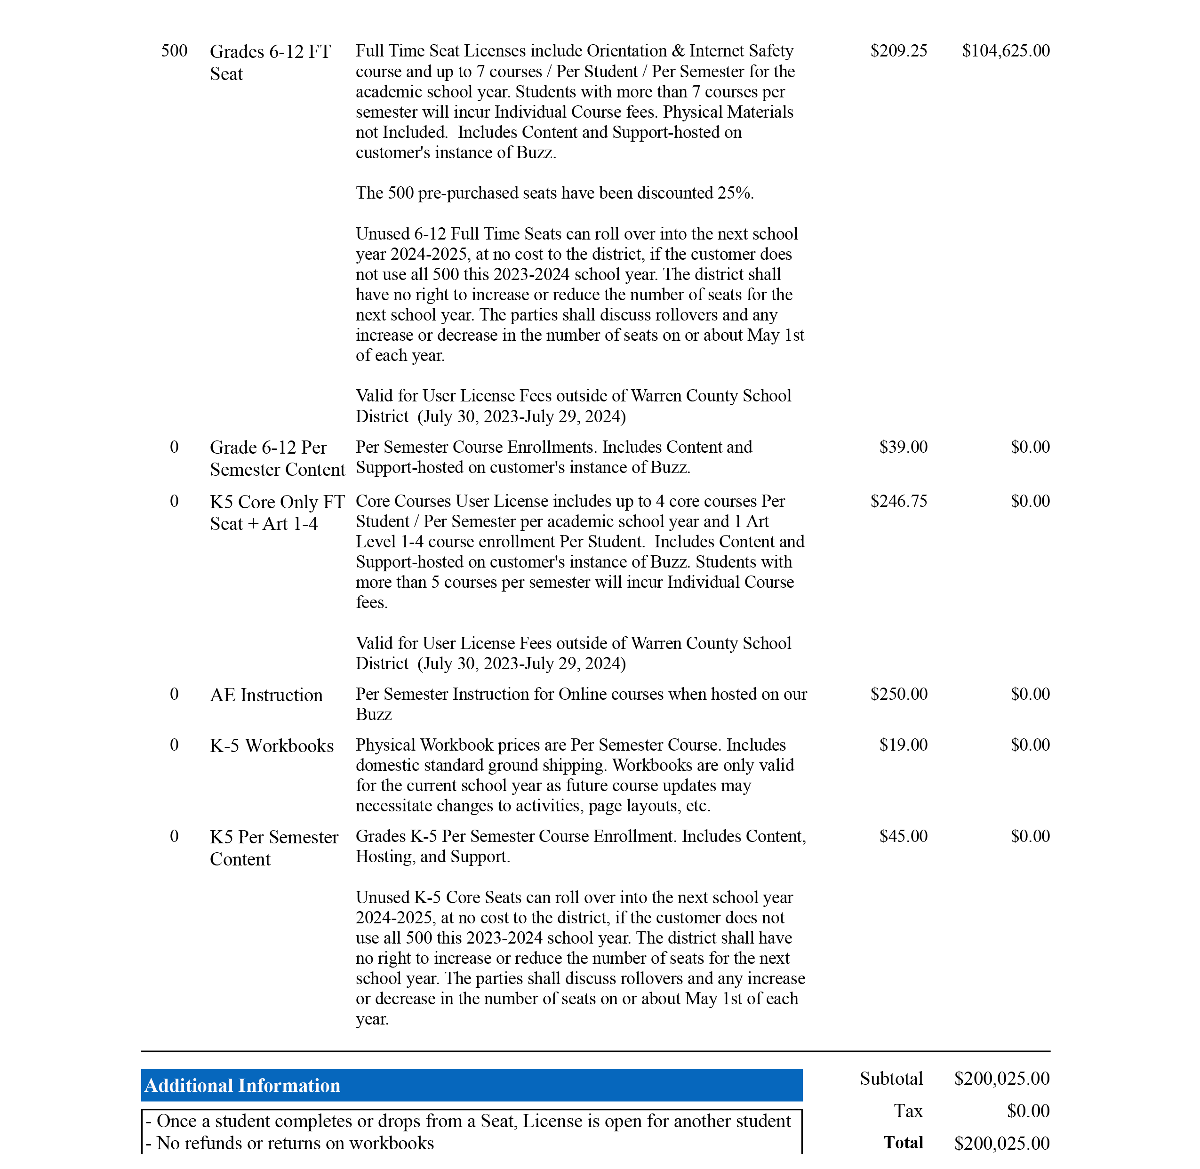
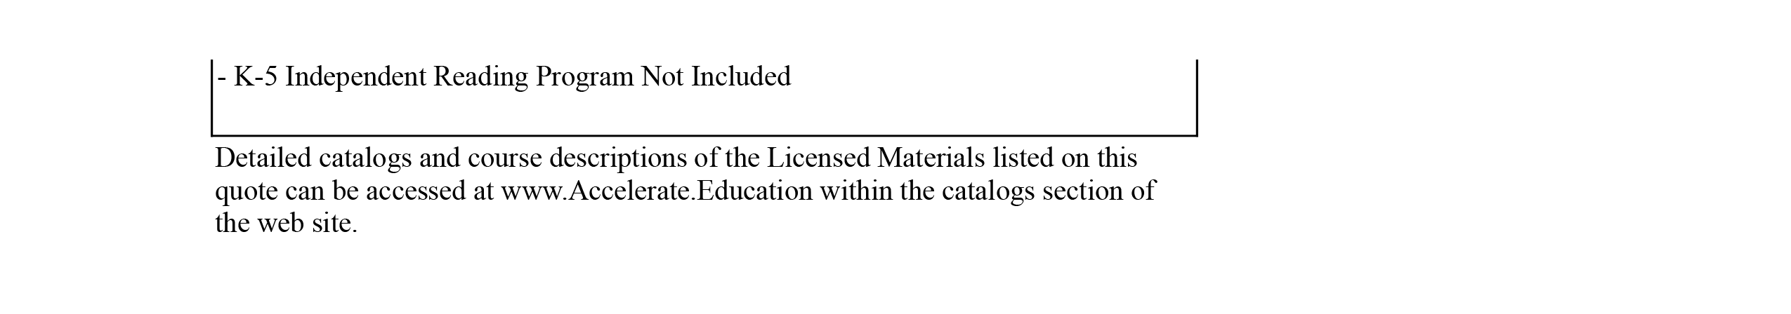

The Amendment to Section 3 of the Agreement (Grant of License), as stated in the Second Amendment shall remain in effect as follows:

License Terms. Accelerate hereby grants Customer a non-transferable, non-exclusive, royalty-free license to access and use the Licensed Materials listed in Exhibit A during the term of this Agreement. All such access and use of the Licensed Materials shall be subject to the terms and conditions hereof.

Customer shall use its best efforts to prevent any improper use of the Licensed Materials or any violation of Accelerate's rights in the Accelerate Intellectual Property, and shall, under no circumstances, sell, lease, assign, sublicense or otherwise transfer the Licensed Materials except however, Customer may resell the Licensed Materials outside of Customer’s school district where Customer’s instructors are teaching the courses to end users outside of Warren County School District. Customer shall not remove any proprietary, copyright, patent, trademark, design right, trade secret, or any other proprietary rights legends from the Licensed Materials. Customer agrees not to disassemble, decompile, translate into human readable form or into another computer language, reconstruct or decrypt, or reverse engineer, all or any part of the Licensed Materials. Further, Customer shall not write or develop any derivative works or computer programs based upon any part of the Licensed Materials.

Special Terms:

Notwithstanding any provision to the contrary, if Accelerate increases the pricing specified above at any time during any Renewal Term that occurs pursuant to Section 4 of the Agreement, Customer shall have 30 days from the date on which Customer is notified of the price increase to provide written notice of the Customer’s termination of the Agreement for convenience.

Warren County School District shall be permitted to use ACCELERATE’s logo for the limited purpose of marketing ACCELERATE and its programs and course offerings to students.

Warren County School District’s License shall include all courses listed on the attached Course Catalog, as well as any additional courses that may later be included as part of ACCELERATE’S 2023/2024 Personalized Learning Course Catalog.

Middle School Workbooks

- No middle school workbooks are available. However, Warren County School District is permitted to print copies of course lessons and other necessary course materials for the purpose of creating its own workbooks for middle school courses, provided however, that Warren County School District will ensure each district created workbook will have an Accelerate Education copyright notice page following the cover as listed in Exhibit D of this Agreement.

Exhibit D of the Agreement is hereby added to read in its entirety as follows:

Exhibit D
Accelerate Education Copyright Page

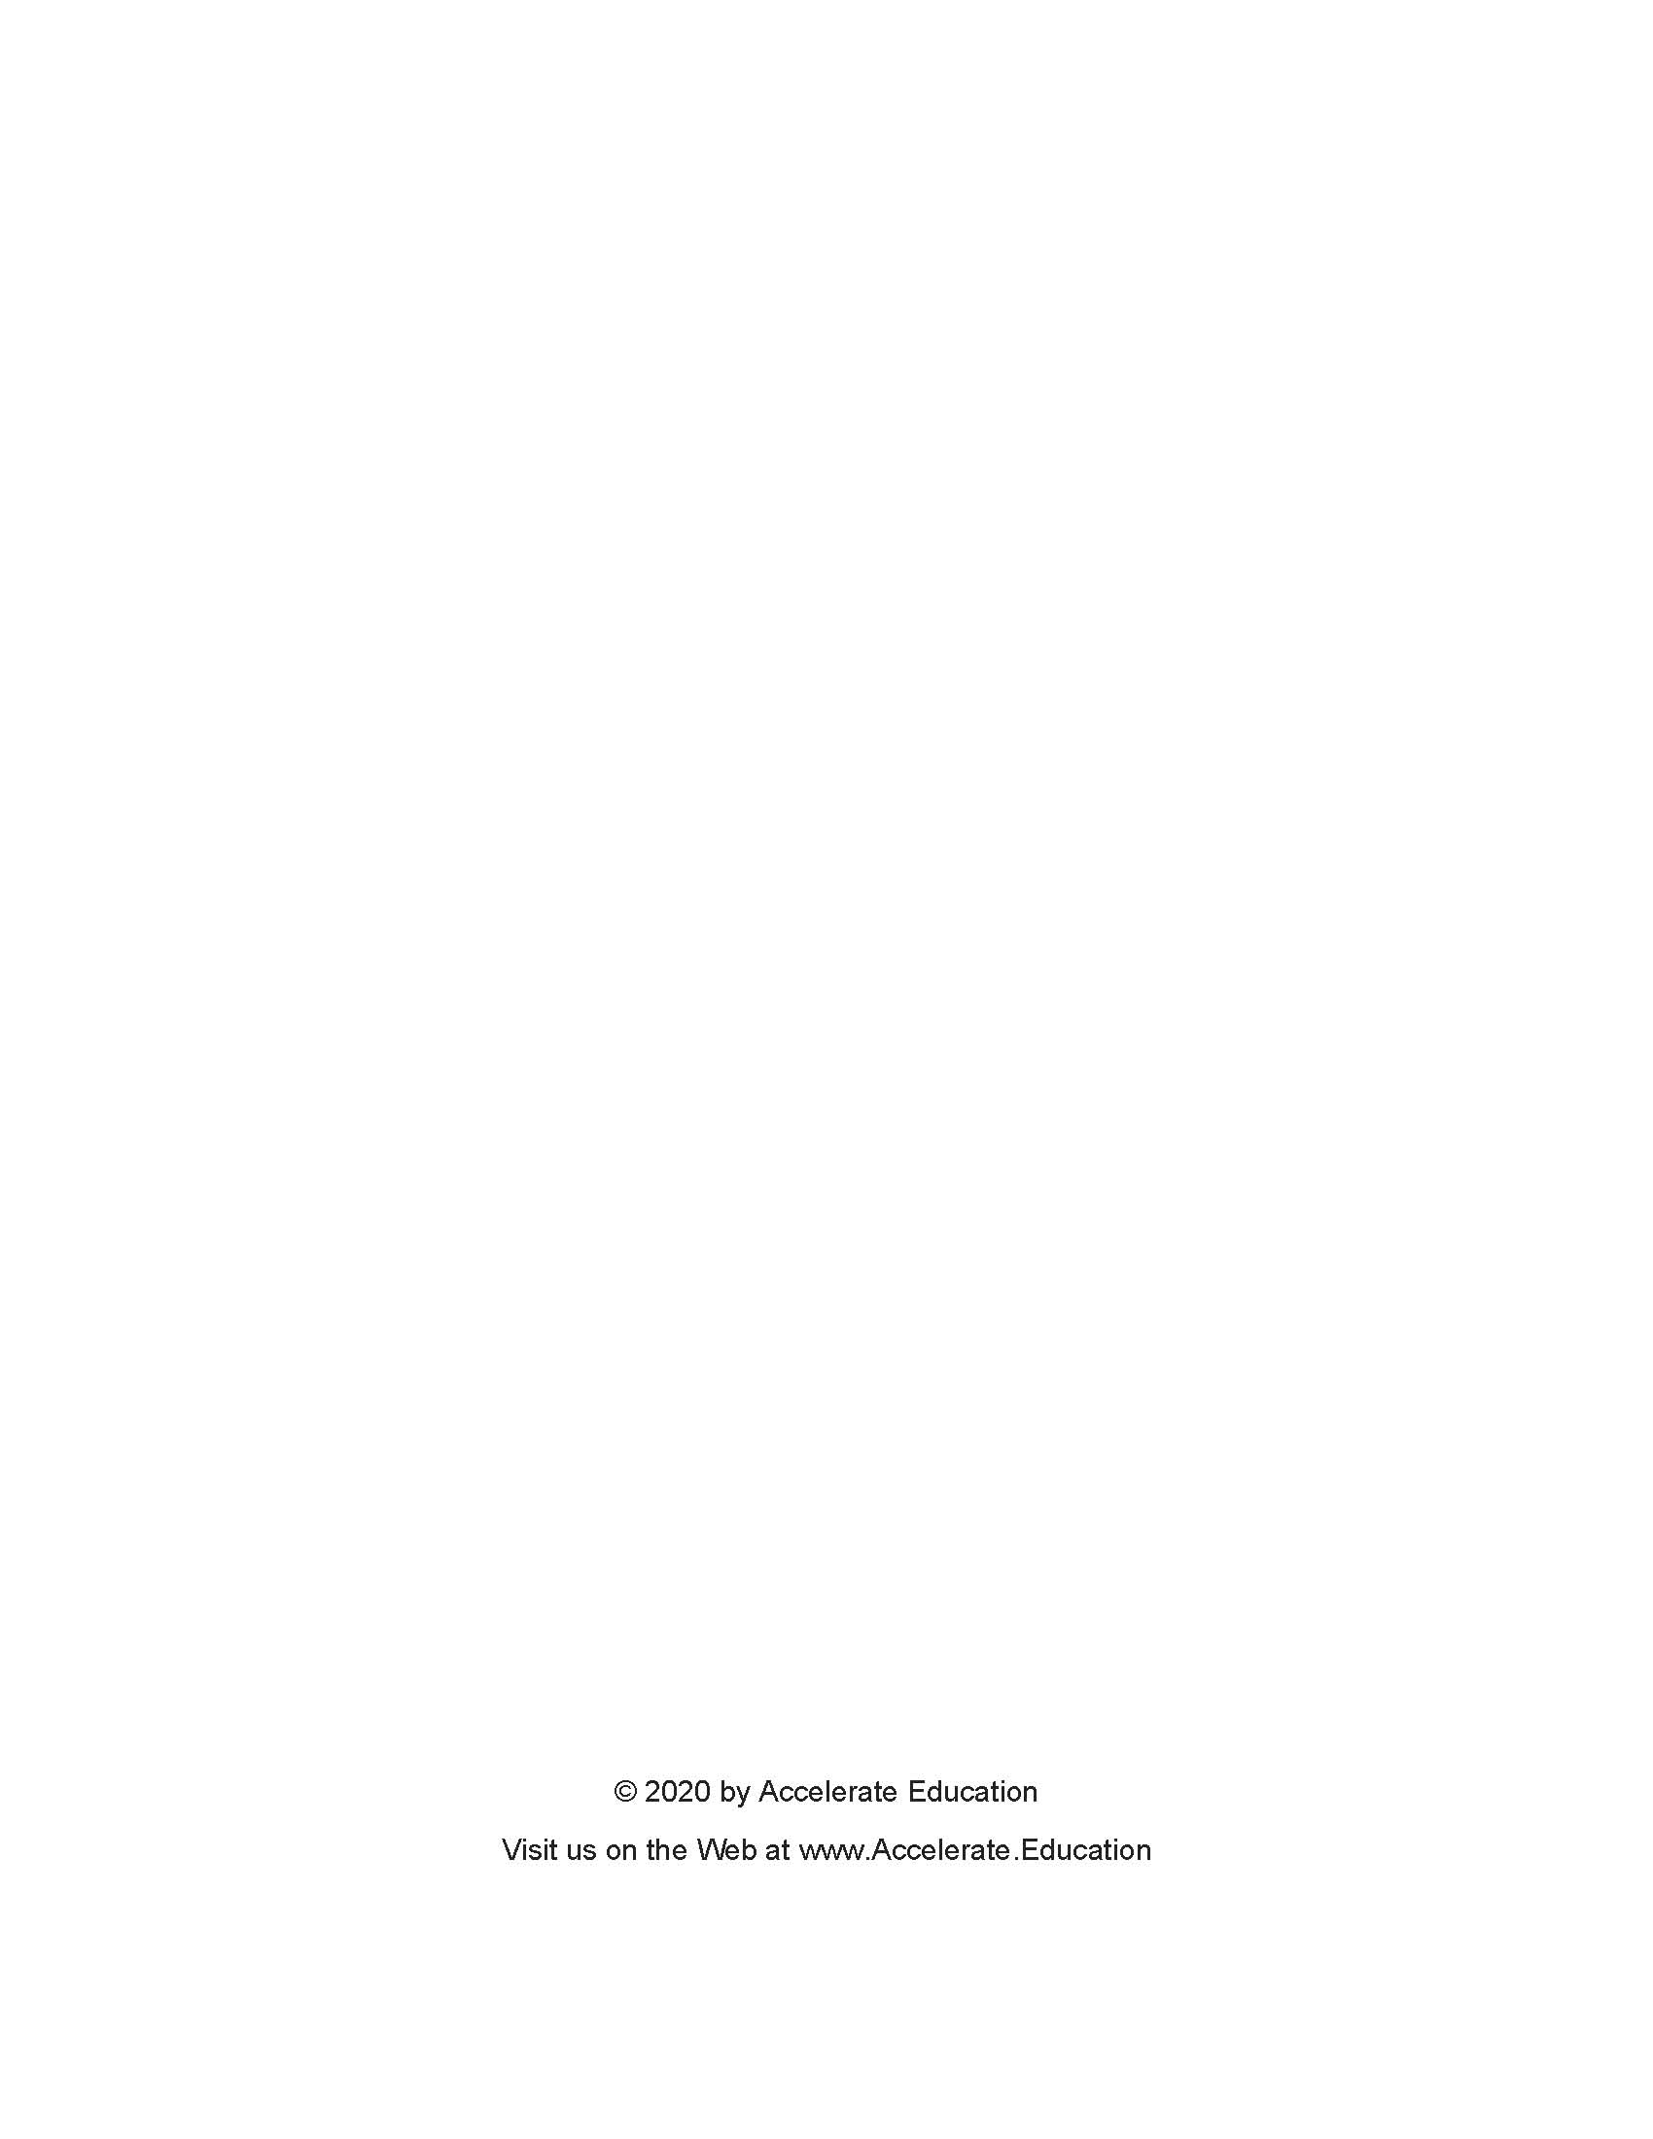

2. Miscellaneous
- The headings contained in this Amendment are for reference purposes only and shall not affect in any way the meaning or interpretation of this Amendment.

(b) All terms and conditions of the Agreement, the amendments that are not in conflict with this Amendment shall remain in full force and effect.

(c) In the event of a conflict between the terms of this Amendment and the terms of the Agreement, the amendments, the parties agree that the term of this Amendment shall govern and control.

IN WITNESS WHEREOF, the parties hereto have entered into and signed this Amendment as of the date and year first above written.
ACCELERATE EDUCATION INCORPORATED

By
Name: Michael Axtman
Title: President/CEO
Date:

WARREN COUNTY SCHOOL DISTRICT

By
Name: Paul J. Mangione
Title: President, Board of School Directors
Date:

By
Name: Ruth A. Huck
Title: Secretary, Board of School Directors
Date:

