**COURSE DESCRIPTION**

**Course Title:** Intro to Aviation

**Course Number:** 00768

**Course Prerequisites:** None

**Course Description:** This course provides the foundation for advanced exploration in flying, aerospace engineering, and unmanned aircraft systems. Students will learn about engineering practices, problem-solving, and the innovations and technological developments that have made today's aviation and aerospace industries possible. Students will look at the problem-solving practices and innovative leaps that transformed space exploration from the unimaginable to the common in a single generation. Students will also gain a historical perspective, from the earliest flying machines to various modern aircraft.

**Suggested Grade Level**: Grades 9-12

**Length of Course:** One Semester

**Units of Credit:** .5

**PDE Certification and Staffing Policies and Guidelines (CSPG) Required Teacher Certifications:**

65 – Technology Education

To find the CSPG information, go to [CSPG](https://www.education.pa.gov/Educators/Certification/Staffing%20Guidelines/Pages/default.aspx)

**Certification verified by the WCSD Human Resources Department:** Yes No

**WCSD STUDENT DATA SYSTEM INFORMATION**

**Course Level:** Academic

**Mark Types:** Check all that apply.

F – Final Average MP – Marking Period EXM – Final Exam

**GPA Type**:  GPAEL-GPA Elementary  GPAML-GPA for Middle Level  NHS-National Honor Society

UGPA-Non-Weighted Grade Point Average  GPA-Weighted Grade Point Average

**State Course Code**: 03209

To find the State Course Code, go to [State Course Code](https://nces.ed.gov/forum/sced.asp), download the Excel file for *SCED*, click on SCED 6.0 tab, and choose the correct code that corresponds with the course.

**TEXTBOOKS AND SUPPLEMENTAL MATERIALS**

**Board Approved Textbooks, Software, and Materials:**

**Title:** N/A

**Publisher:** N/A

**ISBN #:**  N/A

**Copyright Date:** N/A

**WCSD Board Approval Date:** August 28, 2023

**Supplemental Materials:** AOPA Curriculum provided by the Aircraft Owners and Pilot’s Association

**Curriculum Document**

**WCSD Board Approval:**

**Date Finalized:** 7/26/2023

**Date Approved:**  10/9/2023

**Implementation Year:** 2023-2024

**SPECIAL EDUCATION, 504, and GIFTED REQUIREMENTS**

The teacher shall make appropriate modifications to instruction and assessment based on a student’s Individual Education Plan (IEP), Chapter 15 Section 504 Plan (504), and/or Gifted Individual Education Plan (GIEP).

**SCOPE AND SEQUENCE OF CONTENT AND CONCEPTS**

Unit 1: Aviation 101

Pre-Course Exam

Section A – Introduction to Aviation and Aerospace

Lesson 1 Introduction to Aerospace Studies

Lesson 2 Engineering Practices in Action

Lesson 3 Aviation Careers Are For You!

Section B – Overview of Commercial, Military, and General Aviation

Lesson 1 Introduction to Commercial Aviation

Lesson 2 Introduction to Military Aviation

Lesson 3 Introduction to General Aviation

Section C – Introduction to Unmanned Aircraft Systems

Lesson 1 UAS Fundamentals

Lesson 2 UAS Operation and Safety

Section D – Introduction to Space Exploration

Lesson 1 Current and Future Space Exploration

Unit 1 Exam

Unit 2: Taking Flight—Early Aviation Innovations

Section A – Aviation’s Primitive Beginnings

Lesson 1 Flight in Greek Mythology

Lesson 2 Da Vinci and His Flying Machines

Section B – Lighter Than Air

Lesson 1 Hot Air and Gas Ballooning

Section C – Gliders

Lesson 1 From Birds to Gliders

Lesson 2 Glider Flight and Early Innovators

Section D – Powered, Controlled Flight

Lesson 1 The “Wright” Approach

Lesson 2 Build and Test a Wind Tunnel

Lesson 3 The “Wright” Attitude

Unit 2 Exam

Unit 3: From Theory to Practical Reality—Rapid Developments in Powered Flight

Section A – First Practical Applications of Airplanes, Commercial and Military

Lesson 1 Beginnings of U.S. Commercial Airline Service

Lesson 2 Aviation and World War I

Lesson 3 Airmail and the Transcontinental Airway System

Section B – Women in Early Aviation

Lesson 1 Women in Early Aviation

Section C – World War II

Lesson 1 Aviation Innovation and World War II

Lesson 2 One For All, All For One

Unit 3 Exam

Unit 4: To the Stars—Making Jet and Space Travel Possible

Section A – The Jet Age

Lesson 1 Development of the Jet Engine

Lesson 2 Commercial Air Travel

Section B – The Space Race

Lesson 1 The Space Race Begins

Lesson 2 To the Moon

Lesson 3 The Space Race Winds Down

Lesson 4 The Shuttle Program

Unit 4 Exam

Unit 5: Creating the Future—What’s New and Next in Aviation and Aerospace

Section A – Modern Aircraft Design

Lesson 1 Fly-by-Wire and “Glass” Cockpits*

Lesson 2 Aircraft Navigation

Lesson 3 Composites and Structures

Section B – Government and Commercial Space

Lesson 1 Government and Commercial Space

Section C – End of Semester Project

Lesson 1 End of Semester Project

Unit 5 Exam

Post-Course Exam

**Standards/Eligible Content and Skills**

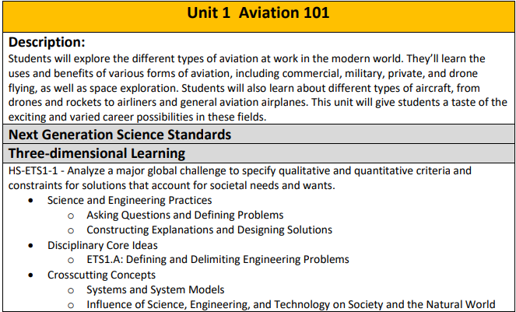

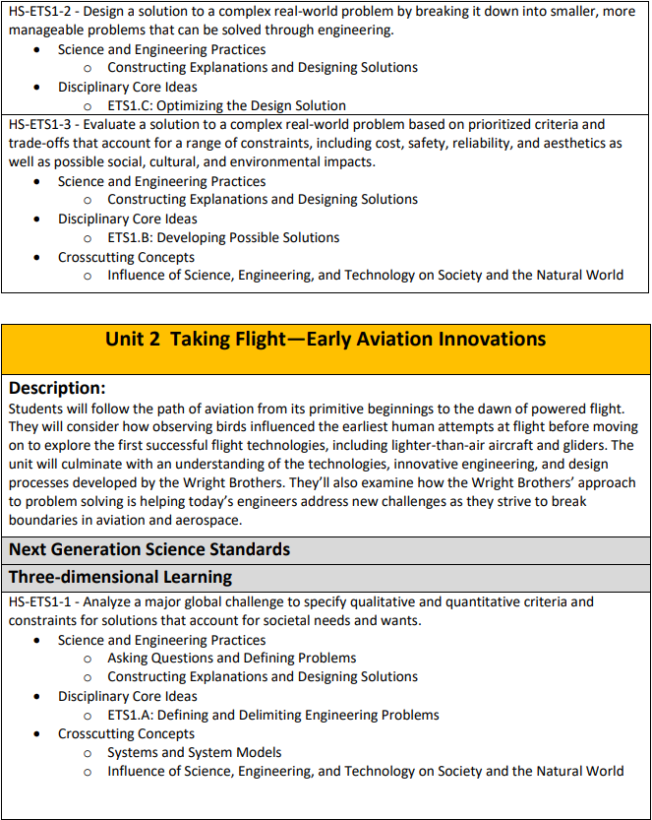

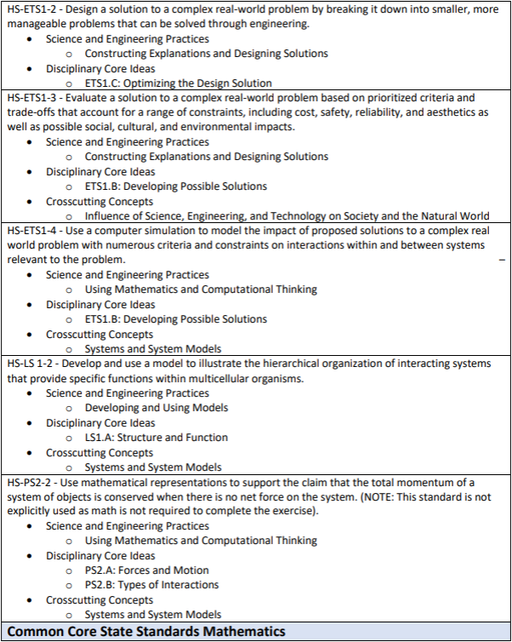

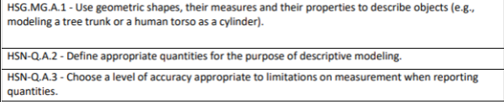

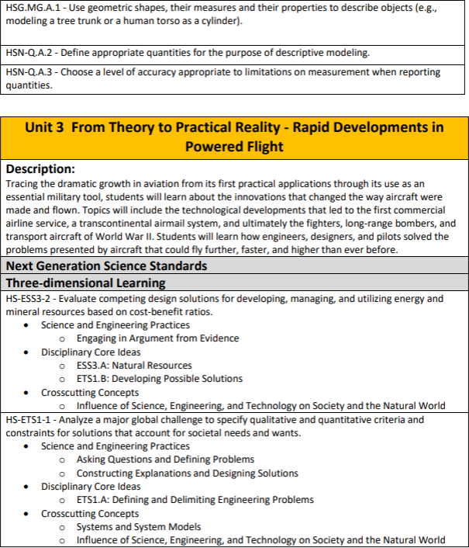

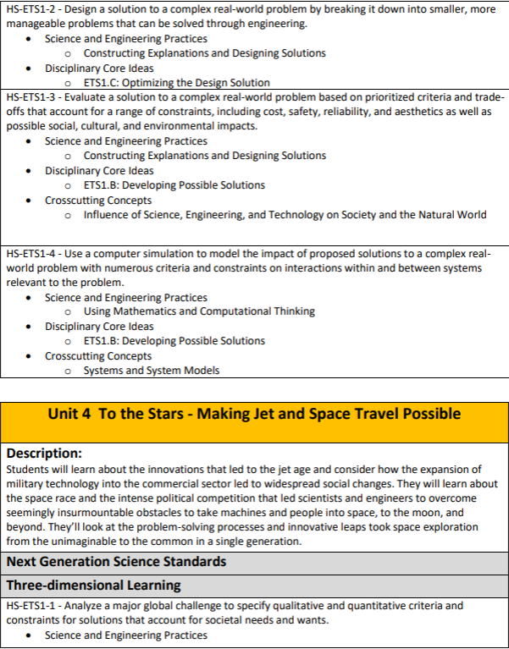

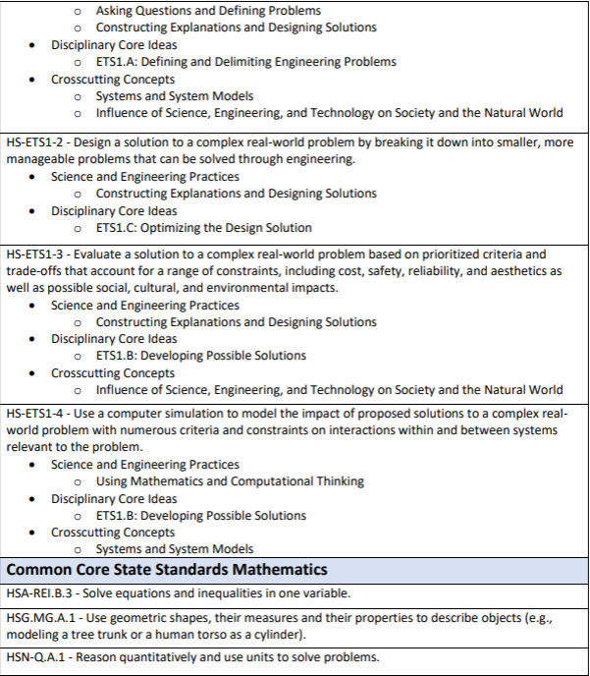

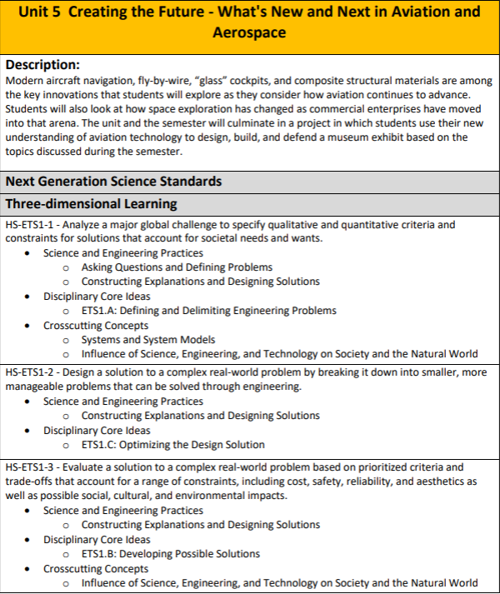

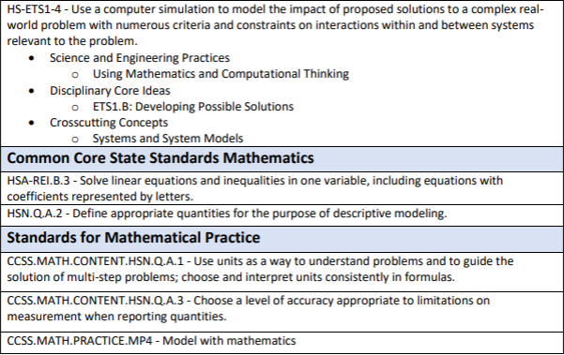

**ASSESSMENTS**

**PDE Academic Standards, Assessment Anchors, and Eligible Content: The** teacher must be knowledgeable of the PDE Academic Standards, Assessment Anchors, and Eligible Content and incorporate them regularly into planned instruction.

**Formative Assessments:** The teacher will utilize a variety of assessment methods to conduct in-process evaluations of student learning.

**Effective formative assessments for this course include: Assignments, Projects, Portfolio Building**

**Summative Assessments: The** teacher will utilize a variety of assessment methods to evaluate student learning at the end of an instructional task, lesson, and/or unit.

**Effective summative assessments for this course include: Unit Exams, Final Exam, Completed Portfolio**