**POSITIVE HAPPENINGS – May 6, 2024, BOARD MEETING**

**Mr. Brian Reynolds – Eisenhower Elementary School**

We had 6 WQLN writing winners at Eisenhower.

2nd Grade Winner

Chase Chamberlin 3rd Place

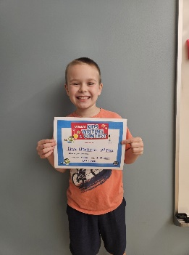

3rd Grade Winners

Grace Jespersen 1st Place Sebastian Cable 2nd Place Avery Bimber 3rd Place

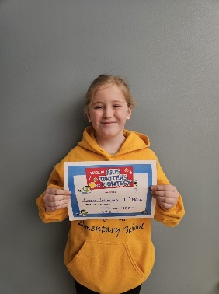 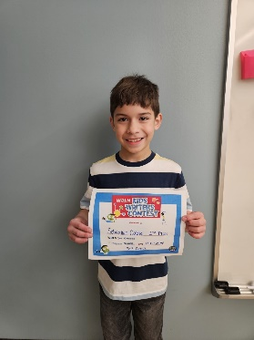 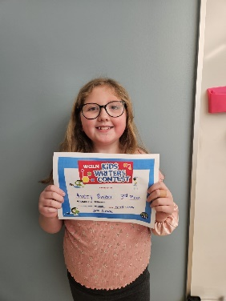

4th Grade Winner 5th Grade Winner

Derek Leach 3rd Place Amolia Jackson 3rd Place

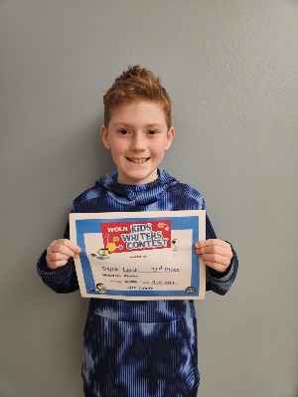 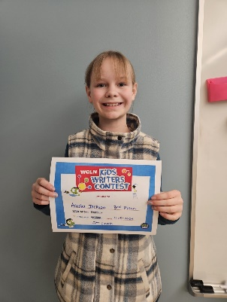

Congratulations to Nora Colvin in 1st grade in placing 3rd in the Warren County Conservation Poster Contest which the theme this year was “May the Forest Be with You Always”.

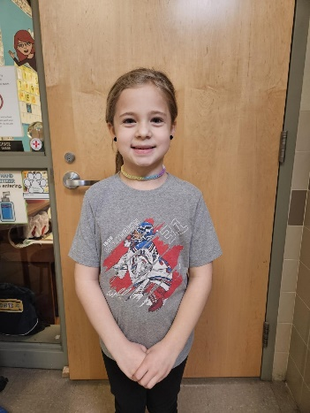

Congratulations to Averyanna Salapeck in 5th grade in placing 2nd in the Warren County Conservation Poster Contest which the theme this year was “May the Forest Be with You Always”.

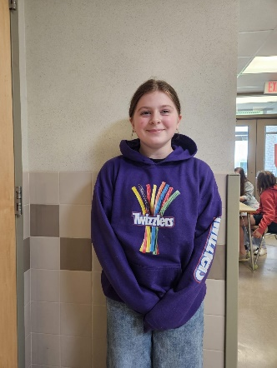

**Mr. Lyle Dosser – Beaty-Warren Middle School**

American Legion Essay Contest "What does freedom mean to you?"

1st place went to Oleksandra (Sasha) Kosmina (5th grade), 2nd place went to Jackson Warner (5th grade) and 3rd place went to Ashton Carrington (6th Grade)

WQLN PBS Kids Writers Contest (Regional)

Madison Tidrick (5th Grade) placed 1st with her story called "The Clown Cat," a heartwarming story about a cat that saved the circus. She is invited to their awards ceremony in Erie on May 2nd.

WPSU Regional Poetry Contest

Nina Woldt (6th Grade) placed first with her poem called "Beautiful Things." She got to record her poem in their studio, to be aired on April 29th and published on their website after that date.

Warren County Conservation Poster Contest "May the Forest be with you Always"

Elsie Woldt (5th Grade) placed 1st and received the People's choice for the 3rd-5th grade category

Nina Woldt (6th Grade) placed 1st and received the People's choice for the 6th-8th grade category

Mrs. Page received the B.L.U.E. award at Autism Acceptance Day hosted by Lakeshore Community Services.

Beaty had a "Purple Up!" Day in recognition of military families and students.

**Mrs. Misty Weber – Virtual Academy**

**Mrs. Kylie Harris – Sheffield Area Elementary School**

As with most schools, April is almost entirely "all about PSSAs" at SAES. Prior to beginning our PSSA focus, though, the school did take time to celebrate the amazing solar eclipse with a special "out of this world" themed lunch by the Nutrition Team and numerous classroom-specific activities including crafts, projects, and even handmade t-shirts for all 5th graders by 5th grade Math/Science teacher Tiffany Hornstrom. Students also enjoyed "Professor Steve's Magic of Science Show" on April 10th kicking off a unique science-focused series of events. PSSA preparations began with a special "Rock the PSSAs" assembly with school-appropriate rock tunes, dancing, and a special "rocking relay". A special video created by Mrs. Sherrard and the 5th grade ambassadors demonstrated for students ways to be successful on the upcoming test and extended well wishes from each teacher. Lastly, in a special surprise, students in kindergarten through 2nd grades created special painted rocks to give to each older student for good luck. As grades 3 - 5 re-entered the elementary pod, they were greeted by younger students holding signs, cheering, and passing their good luck rocks. SAES looks forward to encouraging our students to "rock the PSSA's". We are proud of their hard work and focus on academics throughout this year and excited for the opportunity to showcase their growth!

**Mrs. Misty Weber – Sheffield Area Middle High School**

On February 21 Sheffield Wolverines Lily Benton, Madison Connolly, Madison Hackley & Sarah Hoffman completed the final phases of the TEAMS (formerly known as JETS) national science/engineering competition. The theme for this year’s competition was “Engineering Another World.” Phase 1 began in January, tasking the team to research & write an essay identifying some of the major obstacles to living on another planet or moon. After selecting three obstacles, the team had to develop possible solutions to the problems & identify the critical skills & resources needed to address the challenges. Then on February 21 the team spent the morning completing the second phase of the competition, a multiple-choice exam covering all sorts of science and engineering topics. The third and final phase occurred that afternoon. In this phase the team had to complete and demonstrate a working prototype for the top-secret build project revealed just moments before the timed build phase began. These four very bright & very capable students performed exceedingly well, working as a team in all phases. The results were released the last week of March. Pennsylvania is always one of the strongest, most competitive states with over 60 teams this year in this nation-wide competition. The Wolverine team produced an excellent research essay ranking 14th in the state, a solid exam score ranking 18th along with teams from Warren & Youngsville, and a remarkable design & build score ranking 12th in all of Pennsylvania. The three phases combined resulted in a rank for the Wolverine team of 29th in the state, tied with Palmyra Area High School and besting many teams from much larger schools. Just completing all three phases of this competition is an accomplishment, doing so well is exceptional – way to go Wolverines!

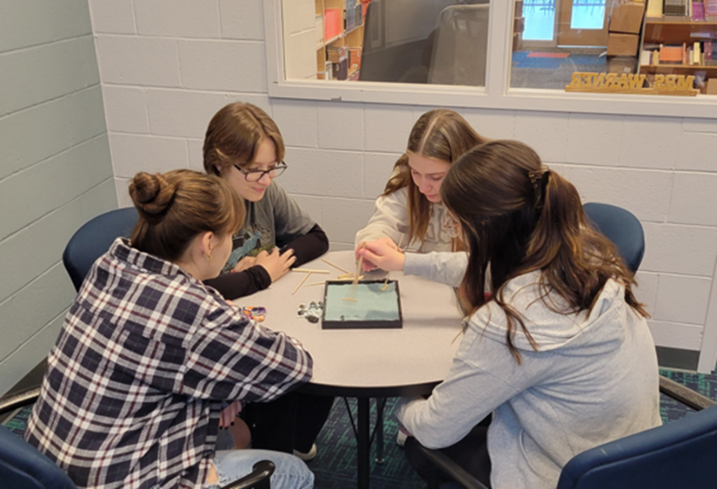

*Getting in the right frame of mind, moments before the competition started.*

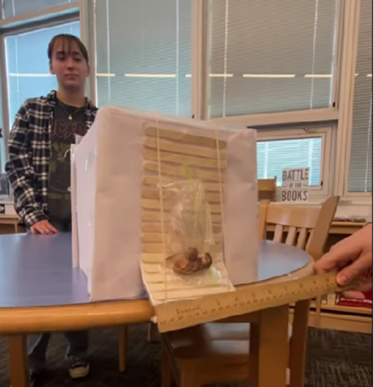

*Maddie* *Hackley at the ready to operate the prototype.*

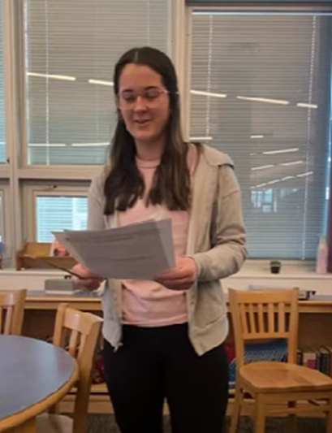

*Maddison Connolly presenting the specs for the design & build.*

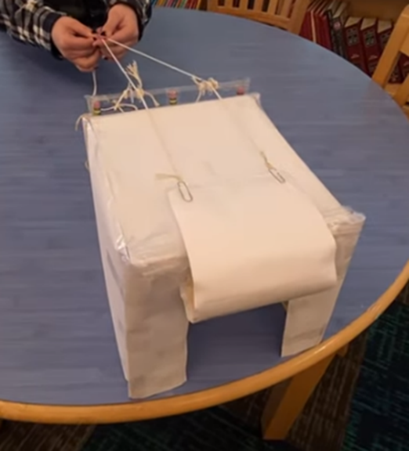

*The prototype for an “airtight” space colony cargo bay in action.*

**Mrs. Liz Kent– Warren Area Elementary Center**

Through the SPEL grant, WAEC has provided training through PaTTAN. 1st grade teachers have been trained to implement ECRI in the 24/25 school year and Kindergarten teachers have been trained in the Vocabulary and Comprehension portion of ECRI. This will allow for implementation across Kindergarten and 1st grade next school year.

The WAEC Title I teachers teamed up with the WAEC PTO to have a night of Literacy which included Literacy take home activities, the Spring Book Fair, snacks, and face painting. This event was very well attended, and this collaboration is something I am very excited for WAEC to have.

This is the first year that WAEC has done online PSSAs for all grades and it has been going very well. The process is much less labor intensive for the School Assessment Coordinator.

The WAEC 4th Grade Spring Concert was held on 4/17. Mr. Parker Neal provided another truly engaging concert experience that stepped out of the "traditional" concert music, got students VERY excited about performing, and engaged the crowd. Mr. Neal works with students to provide what I believe are next level experiences in a way that I have not seen before, including collaboration with a local band to accompany the students singing Pinball Wizard.

The Audubon has been in, providing classroom presentations to all K-4 classrooms. These presentations provide hands on learning opportunities for the students. 1st and 3rd grade will follow up with schoolyard visits in which they explore the WAEC property. 2nd grade students travel to the Audubon for additional hands-on activities at that site.

**Mr. Josh Vincent – Warren Area High School**

The WAHS/BWMS Robotics Team recently competed at the VEX Robotics World Championships held in Dallas, Texas. From Mr. Anderson, Advisor to the Robotics Team:

* 13,679 teams competed this past season
* the top 6% made it to Worlds
* there were 10 divisions of 82 teams
* our division record was 4-6 and we ranked 55 out of 82
* our division ranked 2nd out of 10 before finals
* one team on the winning alliance from another division (a Pittsburgh team) was on the winning alliance that beat us at States
* The guys did great and are ready to do even better next season!

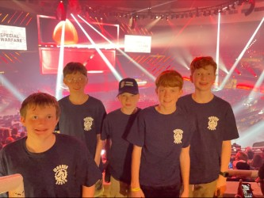

Warren Area High School was recently awarded the PIAA Sportsmanship Award at the Annual D10 Banquet on 4/26/24. The award is based off of the 22.23 athletic year. In order to be eligible, there can be no ejections for athletes or coaches during the athletic year and then the award must be submitted for by the school's athletic director. Warren was one of only 6 schools in District 10 that was awarded the Sportsmanship award for the 22.23 school year.

**Mr. Jim Evers – Warren County Career Center**

During the month of April, the WCCC was actively involved in NOCTI testing - which includes both a written and performance evaluation. All NOCTI testing is complete.

On April 13, 2024, the WCCC was involved in the Passport to Manufacturing day. About 50 students participated in this event. They went to various local industries (Whirley, Betts, Superior and Targeted Pet Treats). The students, along with their parents, finished at the WCCC for a tour of several programs before getting lunch and prizes. We had 6 teachers volunteer to assist with the day's events: Colton Black, Greg Waterman, John Winkelbauer, Michael Noe, Nate McNett, and Scott Burroughs.

The students at the WCCC participated in a Penny Wars to raise money for Early Childhood Developments book fund raising. The students raised over $3,000 to purchase books for pre-school students in Warren County. Our morning Health/Medical Assisting and our afternoon Culinary programs were the winning classes.

The annual 5th grade tours are scheduled for May 2 and 3.

**Mrs. Amy Stimmell – Youngsville Elementary School**

Students at Youngsville Elementary School took part in an ST March Mathness competition. Each week students had to work hard on the program ST Math to complete as many puzzles as possible to beat out other classes in the bracket. Mrs. Renninger's kindergarten class won the whole competition by edging out a 4th grade class in the finals!

On Friday, April 5th, Youngsville Elementary School held their third marking period S.O.A.R. assembly as part of their School-Wide Positive Behavior Interventions and Supports (SWPBIS) system. Students earned tickets throughout the marking period for showing Safety, Ownership, and Always Respect. Tickets were drawn for students to participate in the "plate game" at the assembly. Pictured are students playing the "plate game" at the assembly.

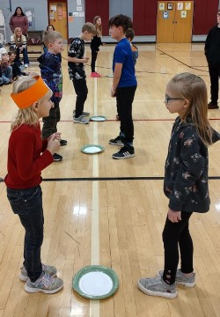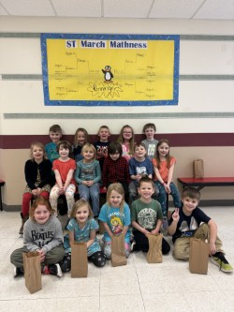

**Mrs. Amy Beers – Eisenhower Middle High School**

We hosted Shamiel Gary for an afternoon at EMHS on April 9th and took trips to the Library Theater (grade 7), Robert H Jackson Center (grade 10), Saint Bonaventure for Media Day (Journalism classes), PSU Behrend (various 10th and 11th grade students), and participated in the county SADD conference, Envirothon, two separate trout stocking opportunities with the SROs, and Student Council meeting with Warren City Council. It was the "month of the field trip" academically, we ended the 3rd marking period and prepared for the PSSAs at the middle level. We are in the last marking period, so the seniors are making their commitments to colleges and careers, which is always an exciting time for them and for us. We are anxiously awaiting the turn of the calendar to May because it is a whirlwind of activities and opportunities to celebrate our accomplishments from the school year.

**Mr. Paul Crider – Youngsville Middle High School**

4/30 and 5/1-Students from Mrs. Olewine's Wildlife Ecology class helped the PA Fish Commission stock Spring Creek, Jackson Run, and Blue Eye Creek.  The students were able to test water temperatures and learn from the PA Fish Commission as several students have an interest in becoming fish warden.

5/8/24- We will celebrate over 150 students who received Merit Honor Roll/Honor Roll will their parents at a catered breakfast at YMHS provided by the Nutrition Group with Mr. Weber Superintendent as a special guest for the event.

4/26/24- students from Mrs. Olewine's Envirothon competed and placed 3rd and 4th for Varsity and 1st and 4th for JV.  Great job!

Middle school student Mackenzie Hodak is competing in the Northeast Regional Wrestling Championship in NY, NJ, and Hershey, best of luck!

Spring sports are underway, and teams are competing and doing a nice job.  Varsity baseball is off to a great start and sitting second in the Region.  Softball picked up their first win against Eisenhower and are competing in each game and getting better.

4/23/24- WCSD SRO's provided a 2.5 hour assembly for students in grades 11 and 12 prior to Prom on making good decisions.

4/27/24- Prom was held at the Conewango Men's Club, great time had by all!  King (Gavin Bundy) and Queen (Konstanze Dell).

State testing for PSSA is in full swing for middle school students.