COURSE DESCRIPTION
Course Title: Personal Fitness I Virtual
Course Number: 10635
Course Prerequisites:

Course Description: Personal Fitness is a one-semester course that will introduce the concepts of exercise and its benefits. Topics range from how exercise impacts well-being and physical health, to learning the body systems that play a major role in a person’s ability to participate in that exercise. As students progress, they will encounter critical thinking questions that help them apply new knowledge to their own lives.

Suggested Grade Level: Grades 9-12
Length of Course: One Semester
Units of Credit: .5
PDE Certification and Staffing Policies and Guidelines (CSPG) Required Teacher Certifications:
CSPG 47
To find the CSPG information, go to CSPG
Certification verified by the WCSD Human Resources Department: ☒Yes ☐No

WCSD STUDENT DATA SYSTEM INFORMATION
Course Level: Academic
Mark Types: Check all that apply.
☒F – Final Average ☒MP – Marking Period ☒EXM – Final Exam

GPA Type: ☐ GPAEL-GPA Elementary ☐ GPAML-GPA for Middle Level ☒ NHS-National Honor Society
☒ UGPA-Non-Weighted Grade Point Average ☒ GPA-Weighted Grade Point Average

State Course Code: 08049
To find the State Course Code, go to State Course Code, download the Excel file for SCED, click on SCED 6.0 tab, and choose the correct code that corresponds with the course.

TEXTBOOKS AND SUPPLEMENTAL MATERIALS
Board Approved Textbooks, Software, and Materials:
Title: Personal Fitness I
Publisher: Accelerate Education
ISBN #: N/A
Copyright Date: N/A
WCSD Board Approval Date: N/A
Supplemental Materials: Word processing software and a pdf reader

Curriculum Document
WCSD Board Approval:
Date Finalized: 7/26/2023
Date Approved: 8/28/2023
Implementation Year: 2023-2024

SPECIAL EDUCATION, 504, and GIFTED REQUIREMENTS
The teacher shall make appropriate modifications to instruction and assessment based on a student’s Individual Education Plan (IEP), Chapter 15 Section 504 Plan (504), and/or Gifted Individual Education Plan (GIEP).

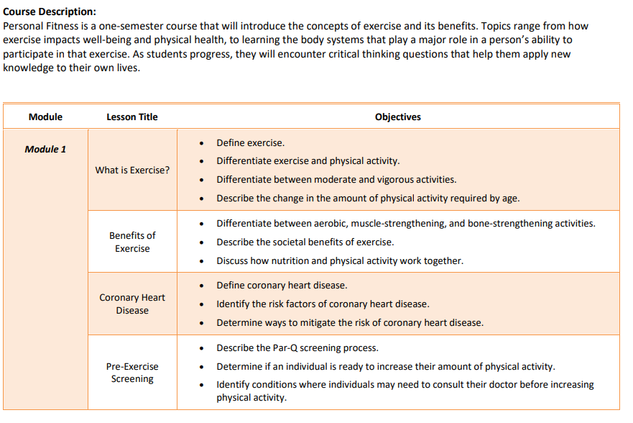
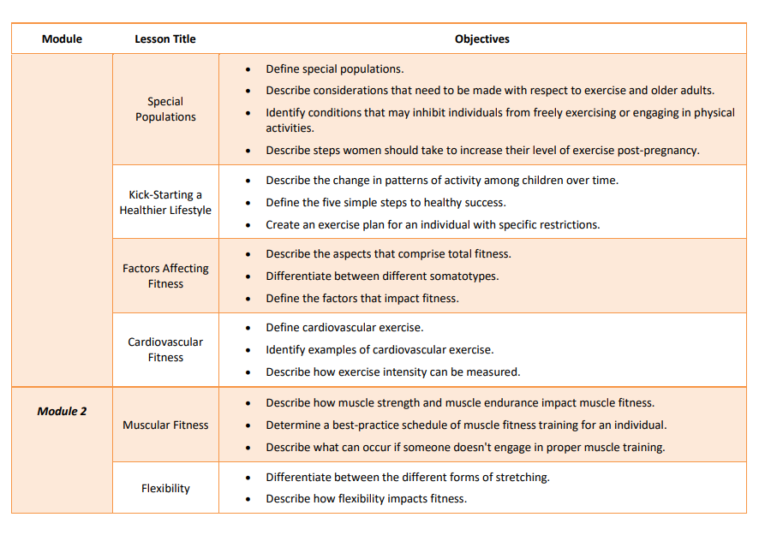
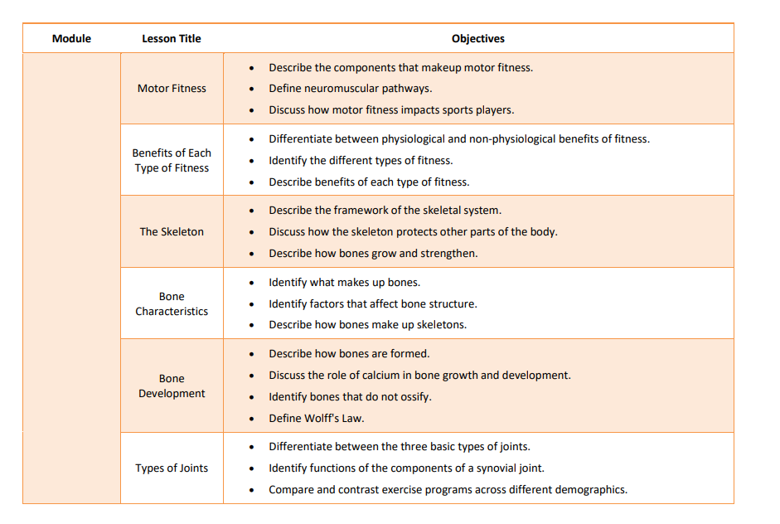
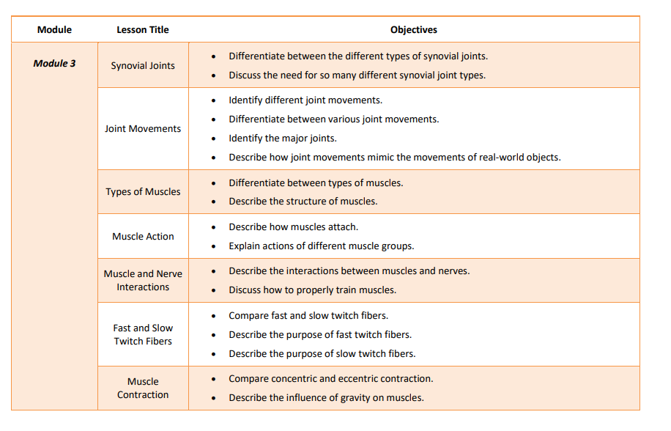
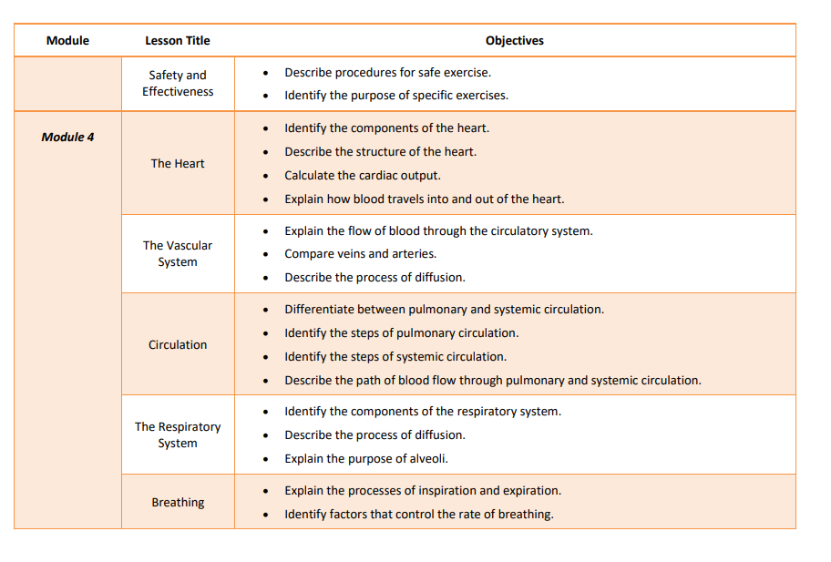
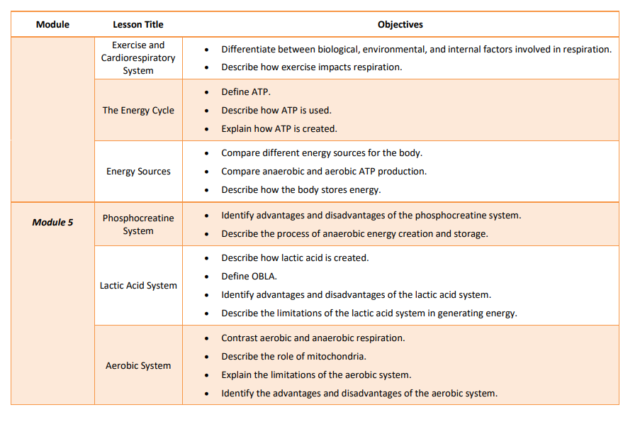
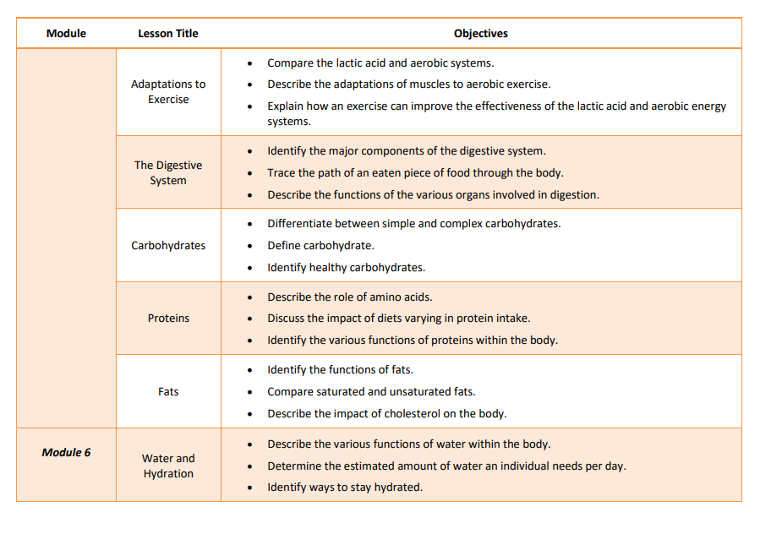
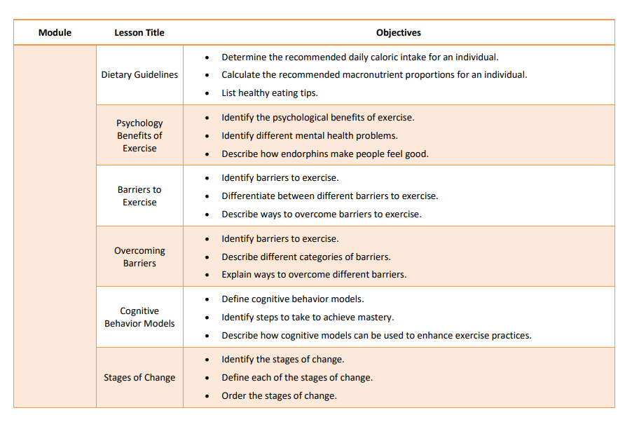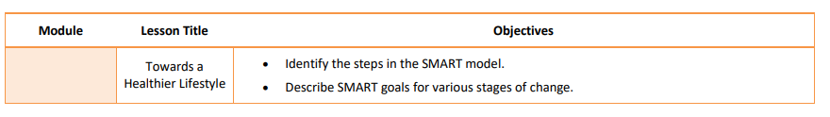

ASSESSMENTS
PDE Academic Standards, Assessment Anchors, and Eligible Content: The teacher must be knowledgeable of the PDE Academic Standards, Assessment Anchors, and Eligible Content and incorporate them regularly into planned instruction.

Formative Assessments: The teacher will utilize a variety of assessment methods to conduct in-process evaluations of student learning.
Effective formative assessments for this course include: quizzes and discussions

Summative Assessments: The teacher will utilize a variety of assessment methods to evaluate student learning at the end of an instructional task, lesson, and/or unit.
Effective summative assessments for this course include: projects, essays, tests, and exams

